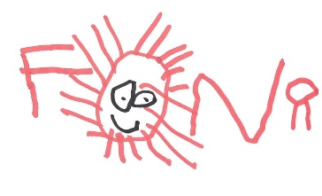
Dear Parents and Carers,
Pears World Book Day Movie Night - Thursday 3rd March (3.30 – 4.30pm)
We invite your child to celebrate World Book day whilst raising funds for school by joining their classmates after school for the TV adaptation of David Walliam’s Mr Stink. Tickets cost £4.50 which includes a movie snack bag for each child. Children are welcome to bring pyjamas/onesies etc (in a named bag please!) to change into at school for the event.
Should you prefer to make an electronic payment, you can use the paypal link below. Please put your child’s name as the payment reference.
https://www.paypal.com/paypalme/FONRPTA
Please complete the reply slip below and return to school by Friday 18th February in order to book your child’s place.
Best wishes
FONR

Pears World Book Day Movie Night - Thursday 3rd March (3.30 – 4.30pm)
I consent to my child ___________________________________________ attending the Pears World Book Day Movie night FONR fundraising event.
Please tick
I enclose £4.50
I have made an electronic payment of £4.50 via Paypal.

I will ensure that my child is picked up promptly at 4.30pm
At 4.30pm my child will go to Red Kite to be collected from there.

Emergency Contact during the event

Name __________________________________________

Number ________________________________________

