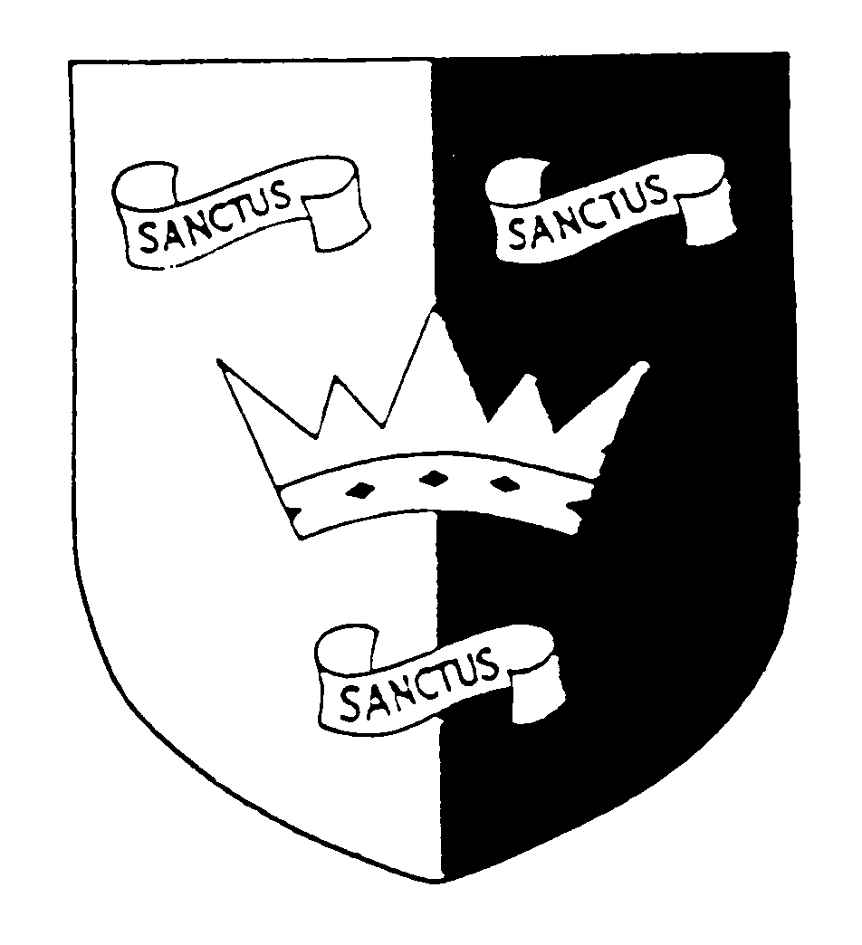 | 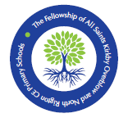  THE FELLOWSHIP OF ALL SAINTS KIRKBY OVERBLOW AND NORTH RIGTON CHURCH OF ENGLAND PRIMARY SCHOOLS  Extraordinary Meeting of the Governing Body  30 June 2022, 6.30pm, at Joanne McCudden’s Home | 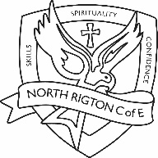
MINUTES - Confidential

Governing Body Core Functions
Ensure the vision, ethos and strategic direction of the school is clearly defined
Ensure the Headteacher performs their responsibilities for the educational performance of the school
Ensure the sound, proper and effective use of the school’s financial resources
Present in school: Rosemary Hunt (RH) Chair; Julia Henry (JH); Helen Laflin (HL); Emma Littlewood (EL); Revd Craig Marshall (CM); Joanne McCudden (JMc); Mark Wilkinson (MW) Vice Chair; Jo Williams (JW)
In attendance: Jane Goodwin CEO YCST
Apologies: Huw Edwards (HE)
The meeting opened at 6.38 pm
 | Item
1 | Welcome & apologies  Apologies were received from HE and these were consented to.
2 | Meeting administration  Declaration of interests: None  Determination of any confidentiality matters: Item 3  Any other business: None
3 | Confidential minutes recorded and filed in each school.
13 | Further items determined for discussion at agenda Item 2:  None.
14 | Meeting dates agreed for 2022/23  LGB1: Wednesday 21st September, 6pm  Res Ctee: Tuesday 8th November, 4pm  SD Ctee: Wednesday 9th November, 2pm  LGB2: Wednesday 30th November, 6pm  Res Ctee: Wednesday 8th March, 4pm  SD Ctee: Thursday 16th March, 2pm  LGB3: Tuesday 28th March, 6pm  Res Ctee: Wednesday 10th May, 4pm  SD Ctee: Wednesday 14th June, 2pm  LGB4: Wednesday 21st June, 6pm  LGB5: Wednesday 12th July, 6pm
15 | Next meetings:  LGB5: Tuesday 12th July, 6pm
16 | What impact have we had since the last meeting on the achievement and wellbeing of pupils and staff in our schools?  - Wellbeing of all staff and pupils at both schools continues to be a high priority

The meeting closed at 8.30pm

