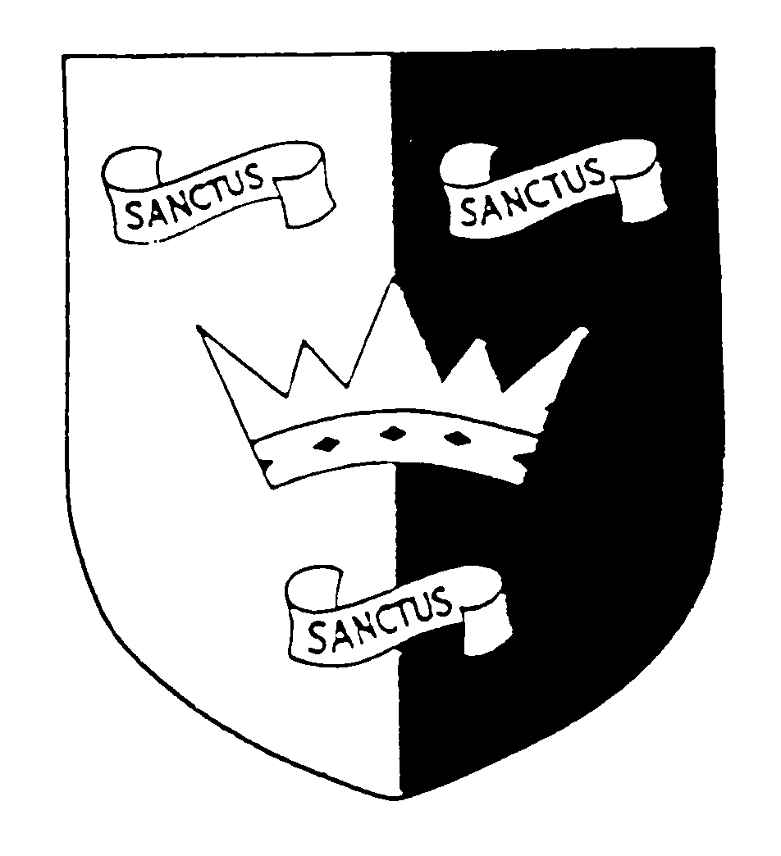 | 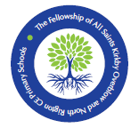  THE FELLOWSHIP OF ALL SAINTS KIRKBY OVERBLOW AND NORTH RIGTON CHURCH OF ENGLAND PRIMARY SCHOOLS  Meeting of the Governing Body  12 July 2022, 5.00 pm, at North Rigton School | 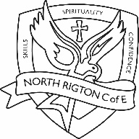
MINUTES – Approved for circulation

Governing Body Core Functions
Ensure the vision, ethos and strategic direction of the school is clearly defined
Ensure the Headteacher performs their responsibilities for the educational performance of the school
Ensure the sound, proper and effective use of the school’s financial resources
Present in school: Rosemary Hunt (RH) Chair; Amber Andrews (AA) Headteacher, Yvonne Methley (YM) Interim Headteacher; Sarah Honey (SH) Head of School, ASKO; Emma Littlewood (EL); Revd Craig Marshall (CM); Mark Wilkinson (MW) Vice Chair;
Present online: Joanne McCudden (JMc); Julia Henry (JH); Helen Laflin (HL);
Apologies: Huw Edwards (HE), Jo Williams (JW)
The meeting opened at 6.00 pm
 | Item
1 | Welcome & apologies  Apologies were received from HE and JW and these were consented to.
2 | Meeting administration  Declaration of interests: None  Determination of any confidentiality matters: None  Any other business: None
3 | Minutes and matters arising from the governing body meeting on 22.06.2022  These were agreed as a true record for RH to sign and a copy to be filed in each school.  Update on actions/matters arising  Page 3  Governor declarations and attendance records still to be updated . Action: TS  Some governors still need to send their pictures and short biographies to Mary Boyd for uploading to the schools website. Thanks to those who have already done it. Action: All  The remaining actions were completed or covered elsewhere on the agenda.  Minutes and matters arising from the governing body meeting on 30.06.2022  These were agreed as a true record for RH to sign and a copy to be filed in each school.  Update on actions/matters arising  Information on meeting passed to AA.  It was decided that Item 3 of the meeting would be confidential.
4 | Headteachers Verbal Updates  SATs results for each school were shared by YM and SH.  At North Rigton considering the absence of the Y5/6 class teacher, Mrs Storey since Christmas the results were mainly above or in line with provisional data, except for writing. Governors wanted to thank the supply teacher Mrs Bhogal for her work with the class and the good results. All Saints results at KS2 were also excellent, showing that the standard of teaching provision in Sun class had been good, even when SH was not in class due to her headship responsibilities.  At North Rigton writing was identified at both Key Stages as an area for the next academic year and TA support for this already allocated for 2022/23. Writing will be focussed on in the SDP for both schools.
5 | YCST Update  No further updates.
6 | Safeguarding  Safeguarding network meetings for safeguarding governors at trust schools happening. EL has made a safeguarding visit into both schools.
7 | Governor visits  Thank you to Govs for ICE undertaken and written up, it is much appreciated. Outstanding ICEs to be sent in for the next meeting. Action: All Governors  Thank you for staff for making Governors feel welcome.
8 | Governor training/ development  Skills audit: strengths and areas for support identified and discussed in relation to training available. Links to NGA Learning Link online courses are available on the skills audit spreadsheet circulated. Action: All Governors  Self-Evaluation Questions: RAG rating viewed for each question and discussed. As a governing body we are green for most areas. We know we need to recruit at least one governor resident in Kirkby Overblow.
9 | Correspondence  RH had received an email from Huw Edwards to say he has to resign from being a governor due to work commitments. Jo Williams has also decided to step back from being a governor. Both were thanked for their work on the board and RH will write letters of thanks to them. We hope to ask a resident of Kirkby Overblow to replace JW as Academy Governor.  JH’s term as a parent governor ended at the end of June 2022. The governors unanimously decided to ask her remain on the board as a co-opted governor to replace HE. All Saints School will need to advertise and run elections for a new parent governor. TS will need to update the various databases with this information. Action: TS, AA, SH
10 | Further items determined for discussion at agenda Item 2:  None.
11 | Meeting dates agreed for 2022/23  LGB1: Wednesday 21st September, 6pm  Res Ctee: Tuesday 8th November, 4pm  SD Ctee: Wednesday 9th November, 2pm  LGB2: Wednesday 30th November, 6pm  Res Ctee: Wednesday 8th March, 4pm  SD Ctee: Thursday 16th March, 2pm  LGB3: Tuesday 28th March, 6pm  Res Ctee: Wednesday 10th May, 4pm  SD Ctee: Wednesday 14th June, 2pm  LGB4: Thursday 22nd June, 6pm  LGB5: Wednesday 12th July, 6pm
12 | What impact have we had since the last meeting on the achievement and wellbeing of pupils and staff in our schools?  - We have a plan for governors moving forward.  - The SATs results have been monitored along with how the schools support pupils moving forward  - Amazing to see Amber at the school and in the meeting again!  Governors thanked YM, SH and AA for doing a great job! (Extra thanks to YM for taking the meeting notes!)

The meeting closed at 8.35 pm

