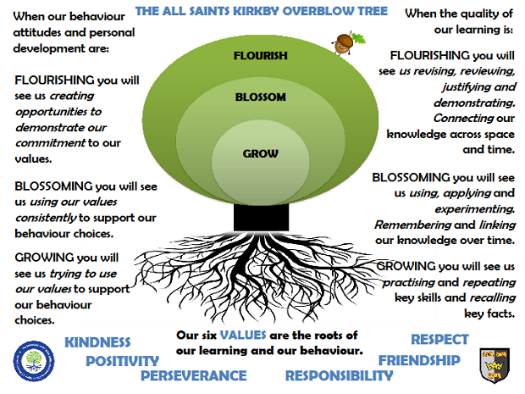MARS CLASSAUTUMN TERM 2023

**Reading:** In Mars class, we enjoy a positive reading environment in which books are enjoyed and shared together. Pupils are given daily opportunities to listen stories and join in with songs and nursery rhymes. Children will take books home once a week, they will be carefully matched to their phonic ability. At the start of the year the books will be pictures only to encourage your child’s story telling abilities. Children will move on to worded books once we have introduced sounds and the individual child is ready.

We encourage you to read with your child every day, this could be them reading their schools books to an adult, or an adult reading a story book to the child. Having a love of reading is a crucial building block to support them in their phonics as they progress through school. We encourage sharing of books so when your child has particularly enjoyed a book, they can bring it in to school to share with the class.

Reading books are swapped every **Tuesday**, please return them to school on **Monday** so that we have time to swap them. You can access further reading eBooks at home through the Oxford Owl eBook Library <https://www.oxfordowl.co.uk/for-home/find-a-book/library-page/> Please ask Miss Brown if you would like the Class Login.

**Phonics:** At All Saints, we follow Read Write Inc to teach Phonics. In Reception, children will be introduced to the set 1 sounds in the autumn term and practise Fred talk. ‘Fred talk’ is sound blending – a crucial first step in both reading and writing, you can find out more information here: [Parent video: Sound blending - YouTube](https://www.youtube.com/watch?v=MNyFikwNQTg)

We will also be looking at the red words: I, the, of, my, to, no, into, your, said, you, he, she

In the spring term, children are introduced to the set 2 sounds.

You can practise the sounds at home using the green book provided to you by school. We encourage you to practise each day for a few minutes. We also encourage you to practise Fred talk each day. For further information on how to support your child with Read Write Inc Phonics at home, please take a look at: [Parent guide to Read Write Inc. Phonics - Oxford Owl](https://home.oxfordowl.co.uk/reading/reading-schemes-oxford-levels/read-write-inc-phonics-guide/)

**Maths:** In Mars Class, we will be looking at numbers 1– 5 this term. We will be learning the numerals, quantities and to subitise (recognise without counting) for these numbers. It is important that the children can recognise that numbers do not always look the same. For example, 3 can be represented in all the ways shown below (and many more).

|  |  |  |  |  |  |  |  |  |  |
| --- | --- | --- | --- | --- | --- | --- | --- | --- | --- |
|  |  | 3 | Three (character)/Gallery | Numberblocks Wiki | Fandom | Best Chocolate Cupcake Recipe - Salt & Baker | 3 Inch Solid Wood Blocks by Sustainable Things : Amazon.co.uk | 2 + 1 |  | How to Make a Triangle in Illustrator (Updated 2022) |  |

We will also be looking at 2D shapes, one more and one less, comparing size, mass and capacity and exploring and continuing simple patterns.

**PE:** In Autumn term, PE will be on a Monday and a Friday. This term we are focussing on Gross motor skills and gymnastics. Please come in PE kit on Mondays and Fridays.

**Understanding The World (science):**

We will be looking at body parts and our 5 senses. We will also be making observations on the seasonal changes that come in Autumn and Winter.

**Art:**

We will be looking at the artist Andy Goldsworthy this term.

**Topic: Protecting our planet**

**The children will be exploring the following areas:**

Read the following stories:

* Please help planet Earth
* The robber racoon
* The last wolf
* The lumberjacks beard
* The odd fish
* Somebody swallowed Stanley
* Captain green and the plastic scene

Discuss why pollution / rubbish may be bad for the planet

Think about some of the ways we can help the world

Think of ways we can spread the message so everybody can help the Earth

The following grid contains some suggestions of activities your child may like to complete at home to support them with the work we do in class. We would love to see any completed tasks and they will have an opportunity to share them in class.

|  |  |  |
| --- | --- | --- |
| **Make a bug hotel**  [Build a bug hotel | The RSPB](https://www.rspb.org.uk/get-involved/activities/nature-on-your-doorstep/garden-activities/build-a-bug-hotel/) | **Go on a litter pick – how many pieces can you find?**  **Can any of it be recycled?** | **Go bird watching**  [Birdwatching for Kids with Bird Spotting Sheet - The RSPB](https://www.rspb.org.uk/fun-and-learning/for-families/family-wild-challenge/activities/go-birdwatching/) |
| **Go on a nature walk.  Don’t forget that respecting nature means leaving it as you find it! Enjoy the trees, wildflowers and birds by looking, observing or even taking photos.** | **Help your family with the recycling!**  **Check the rubbish for plastic, tins and cardboard. Wash it, crush it, recycle it!**  **Did you know you can recycle soft plastics at most supermarkets? Save all your plastic wrappers and take them back to the shop!** | **Help the hedgehogs!**  **Feed them or make a hedgehog hotel. Find out more:**  [How to help hedgehogs in the garden | National Geographic Kids (natgeokids.com)](https://www.natgeokids.com/uk/parents/hedgehogs-in-the-garden/) |
| **Make a bird feeder using a pinecone, lard and seeds!**  [Make a Pine Cone Bird Feeder | Kids Activity - The RSPB](https://www.rspb.org.uk/fun-and-learning/for-kids/games-and-activities/activities/produce-a-pine-cone-feeder/) | **Plant something – flowers, a tree or even some vegetables!** | **Visit a local farm shop and buy something made locally – what treats can you find?** |

**Useful websites for Phonics and Maths**

Home Time Ladybirds game (subitising numbers to 9)

<https://www.ictgames.com/mobilePage/homeTimeLadybirds/>

Teddy Numbers Game

https://www.topmarks.co.uk/learning-to-count/teddy-numbers

Adding to 10

<https://www.topmarks.co.uk/addition/addition-to-10>

Subtraction within 10

<https://www.topmarks.co.uk/subtraction/subtraction-to-10>

Underwater Counting game

https://www.topmarks.co.uk/learning-to-count/underwater-counting

Maths games for 3-5 year olds

https://www.topmarks.co.uk/maths-games/5-7-years/counting

Oxford Owl free Ebooks

https://www.oxfordowl.co.uk/for-home/find-a-book/library-page/

Read Write Inc free Ebooks

https://www.oxfordowl.co.uk/home/reading-site/find-a-book/library-page?view=image&query=&type=book&age_group=&level=&level_select=&book_type=&series=Read+Write+Inc.#

Speed sounds practice sheets

<https://home.oxfordowl.co.uk/reading/reading-schemes-oxford-levels/read-write-inc-phonics-guide/>

*Please scroll down the page – look for Set 1 / Set 2 (downloadable as PDF)*

Phonics play

https://www.phonicsplay.co.uk/

*please ask the Class teacher for the username and password*