**SUN CLASS – AUTUMN 2023**

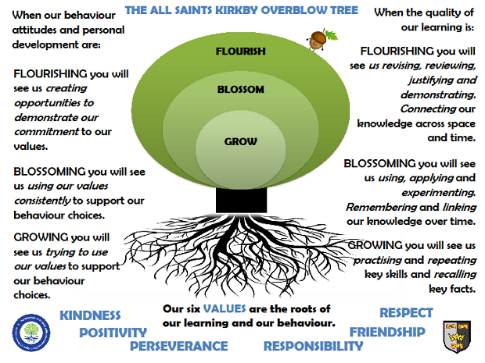

In Sun Class we are taught by Mrs Honey and Mr Rodrigues, supported by Mrs Pilgrim and Mrs Grainger

**Rock Star Maths:** In Sun Class, pupils take part in a daily Rock Star Maths challenge. They have up to 3 minutes to correctly answer as many questions as possible. Classic songs help them keep the pace! The aim is that they improve their time and score during the year. Please encourage your pupils to learn their multiplication tables at home. The multiplication table/s they are learning will be sent out each week on a Friday.

**Reading:** In Sun class, we enjoy a positive reading environment in which books are enjoyed and shared by all. Pupils are given daily opportunities to read independently, and some pupils will read with an adult. Every child will have two 45-minute sessions of guided reading a week. This term our guided reading text will be **The Explorers by Katherine Rundall**.

Please encourage your child to read at home daily although at this age it does not have to be with an adult.

We encourage the sharing of books that have been enjoyed so when your child has finished reading a book, they can bring it in to school to share/swap with another child. We also love to hear about any reading recommendations.

**Spellings:** Spellings will continue to be learned in school, where we can give more support to methods used, allowing the spellings to be more embedded. You will be informed each week which spelling pattern we are focusing on so you can also support your child at home. We will send out an email copy of the spellings each week.

**Writing:**

Narrative: This term we will be focussing on **Modern Twists on traditional tales**; they will explore the key features of a traditional tale and have an opportunity to write their own versions using a range of styles including comic strip and playscripts.

We will also be exploring the genre of **Fantasy**.

Non-Fiction: They will write a range of **non-chronological reports** linked to our topic this term including: An explanation text about how chocolate is made and a recount of the History of Rowntrees.

They will be exploring Persuasive Texts including designing posters to persuade people to make food choices which are good for the planet.

Poetry: Choral and performance poetry

For more detail, please see link to whole school English document.

**Maths:** Our maths topics this term will be:

Number and Place Value

Addition and Subtraction

Multiplication and Division

For more detail, please see link to whole school maths document.

**PE:** In autumn term, PE will be on a Tuesday and Friday. These sessions will be taught by Mr R.

Session 1: Football/Hockey Session 2: Tag Rugby/Gymnastics

On these days, your child should come to school in their PE kit, which should include a waterproof top.

**ART: Sculpture**

Featured artists: Anthony Gormley and Andy Warhol

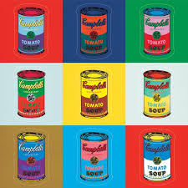

Key focus: Sculpture

**SCIENCE: Animals including humans**

Identify and name the main parts of the human circulatory system, and describe the functions of the heart, blood vessels and blood

Recognise the impact of diet, exercise, drugs and lifestyle on the way their bodies function

Describe the ways in which nutrients and water are transported within animals, including humans

**FRENCH**

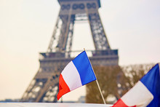**Basic Greetings**

**Days of the Week**

**Counting**

**RE**

In RE this term, we will be exploring what are the differences between organised worldviews and personal worldviews.

**PSHE**

Relationships/ Respecting self and others

Our topic this term: Protecting Our Planet

***Primary provocation:***

***Can you become an Earth Friendly Masterchef?***

We will cover the following learning objectives:

How does the distance our food has travelled effect our environment?

How do our food choices effect the environment?

How does the way we grow and produce food contribute to climate change?

What food choices do we need to make to be healthy?

***The following website has some excellent activities to do at home which would support their learning in class. We would love to see photographs of activities completed at home or bring their projects in to school to share.***

[Activities | NASA Climate Kids](https://climatekids.nasa.gov/menu/make/)

These are also good websites to support your child’s learning.

[Just For Kids | Climate Change Resources](https://climatechangeresources.org/youth/just-for-kids/#:~:text=For%20more%20ideas%20of%20ways,particularly%20good%20page%20on%20recycling.)

[What is climate change: facts for kids | National Geographic Kids (natgeokids.com)](https://www.natgeokids.com/uk/discover/geography/general-geography/what-is-climate-change/)

[Home - BBC Bitesize](https://www.bbc.co.uk/bitesize)

[School resources and activities | WWF](https://www.wwf.org.uk/get-involved/schools/resources)