**C:\Users\s.honey\AppData\Local\Microsoft\Windows\INetCache\Content.MSO\56593CAF.tmp**JUPITER CLASSSUMMER TERM 2024

**Rock Star Maths:** In Jupiter Class, pupils take part in a daily Rock Star Maths challenge. They use the iPads to answer multiplication questions in a format that replicates the end of Year 4 multiplication check. Classic rock songs help them keep the pace! The aim is to answer questions correctly to earn coins and improve their avatars.

**THE YEAR 4 MULTIPLICATION CHECK WILL BE TAKING PLACE IN JUNE.**

**Reading:** In Jupiter class, we enjoy a positive reading environment in which books are enjoyed and shared by all. Pupils are given daily opportunities to read independently and some pupils will read with an adult. Every child will have two 45-minute sessions of guided reading a week. Our guided reading text this term will be:

**The Creakers** **The BFG**

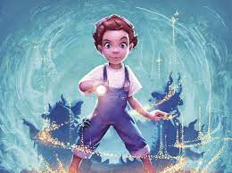 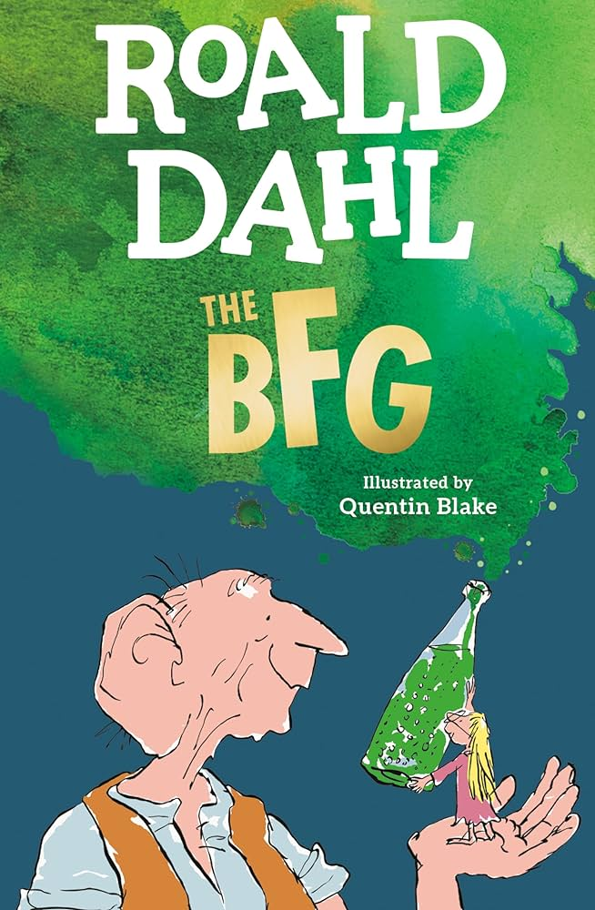

Please encourage your child to read at home daily. Having a love of reading and the ability to read for extended periods of time is the perfect preparation for progression throughout the school.

We encourage the sharing of books that have been enjoyed so when your child has finished reading a book they can bring it in to school to share/swap with another child.

**Spellings:** Spellings will continue to be learned in school, where I can give more support to methods used, allowing the spellings to be more embedded. You will be informed each week which spelling pattern we are focusing on so you can support your child at home.

**Writing:**

Narrative Writing – The Present (Link below)

<https://www.literacyshed.com/the-present.html>

Writing for Sport – Newspaper, online blogs, etc.

Non-Chronological Reports – Based upon our topic of Rivers and Coasts.

Poetry – Rivers and Coasts (personification, metaphors and similes).

SPAG – Determiners, Expanded Noun Phrases, Fronted Adverbials, Prepositions

**Maths:** Our maths topics this term will be:

Fractions

Decimals

Position and Direction

Measurement

**PE:** In spring term, PE will be on a Monday and a Friday

**ART:** We will be exploring the work of French Pointillists George Seurat and Andre Derain.

**SCIENCE: Electricity**

* identify common appliances that run on electricity
* construct a simple series electrical circuit, identifying and naming its basic parts,
* including cells, wires, bulbs, switches and buzzers
* identify whether or not a lamp will light in a simple series circuit, based on whether or not the lamp is part of a complete loop with a battery
* recognise that a switch opens and closes a circuit and associate this with whether or not a lamp lights in a simple series circuit
* recognise some common conductors and insulators, and associate metals with being good conductors.

**SCIENCE: Living Things and Their Habitats**

* recognise that living things can be grouped in a variety of ways
* explore and use classification keys to help group, identify and name a variety of living things in their local and wider environment
* recognise that environments can change and that this can sometimes pose dangers to living things**.**

**RE**

Our school bible story: The Sower

How do parables link to our values?

People of God – What is it like to follow God?

**PSHE**

Mental Health and Wellbeing

**COMPUTING**

Handling Data

**Topic:** The question we will be exploring this term is:

**Where does it come from? Where does it go?**

**The children will be exploring the following areas:**

River Formation

The Water Cycle

Coastal Areas

Use of Rivers for Everyday Life

The following grid contains some suggestions of activities your child may like to complete at home to support them with the work we do in class. I would love to see any completed tasks and they will have an opportunity to share them in class.

|  |  |  |
| --- | --- | --- |
| Investigate two different coasts: 1 from the UK and 1 outside the UK. Include: Images, a map of each coast, interesting physical facts (rock type, beaches etc) and interesting human facts (pollution, tourism etc) | Using the tune of a well-known song of your choice make up your own river song. | Create a geography dictionary on coastal key words that could be used to teach a future class. |
| Produce a fact file (this could be a PowerPoint or Google Slides presentation) on 3 world rivers. Include as many interesting facts as you can. | A river’s depth relies on rainfall. Make a rain gauge and keep a record of how much rain falls over 3 weeks. Produce a graph or table to show your results. | Label the longest river in each continent on a map of the world. |
| Create an awareness campaign to encourage people to stay safe at the coast. It can be a leaflet, video or radio advert. | Draw or paint a picture of a river scene. You could use water colours or any medium you choose. | Write a story with a river theme. Maybe there is a river monster or a creature which comes to life! |

**Useful websites to support learning about Rivers and Coasts:**

BBC Bitesize: <https://www.bbc.co.uk/bitesize/topics/z849q6f/articles/z7w8pg8>

Stretton Handley: <http://www.strettonhandley.derbyshire.sch.uk/oldwebsite/riversandcoasts.html>

**Places you might like to visit:**

Scarborough, Whitby, Filey or any seaside!

Walk along the River Ouse in York (Rowntrees Park play area nearby!).

River Wharfe