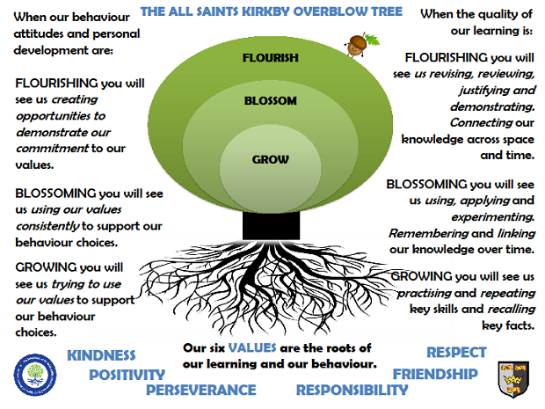
SUN CLASSSUMMER TERM 2024
In Sun Class we are taught by Mrs Honey, Mrs Pilgrim and Mr Rodrigues
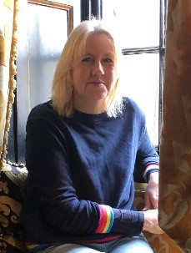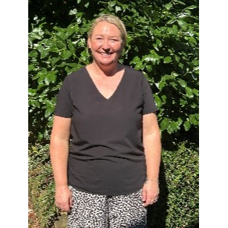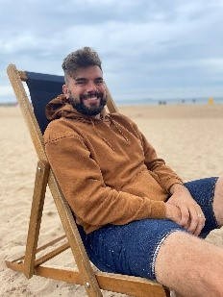

Rock Star Maths: In Sun Class, pupils take part in a daily Rock Star Maths challenge. They have up to 3 minutes to correctly answer as many questions as possible. Classic songs help them keep the pace! The aim is that they improve their time and score during the year. Please encourage your pupils to learn their multiplication tables at home.

Reading: In Sun class, we enjoy a positive reading environment in which books are enjoyed and shared by all. Pupils are given daily opportunities to read independently, and some pupils will read with an adult. Every child will have two 45-minute sessions of guided reading a week.
Please encourage your child to read at home daily although at this age it does not have to be with an adult. Having a love of reading and the ability to read for extended periods of time is the perfect preparation for the ‘reading SATs’.
We encourage the sharing of books that have been enjoyed so when your child has finished reading a book, they can bring it into school to share/swap with another child. I also love to hear about any reading recommendations.
Guided Reading:
Poetry and non-fiction texts.
Stories from diverse cultures

Spellings: Spellings will continue to be learned in school, where we can give more support to methods used, allowing the spellings to become embedded. You will be informed each week which spelling pattern we are focusing on so you can support your child at home. I will send out an email copy of the spellings each week.
Writing:
Narrative: stories from other cultures, contemporary stories and comic strips
Non-Fiction: persuasion text – leaflets encouraging visitors to the local area, report – key historical sites in Harrogate, letters to the local council encouraging them to make changes to the local area.
Poetry: Structured poetry e.g. Haiku

Maths: Our maths topics this term will be:
Area, Perimeter and Volume
2D and 3D shape including calculating and measuring angles
Ratio
Algebra
Position and Direction including translation and reflection
Coordinates in four quadrants
Problem Solving and applying
We will also be revisiting topics covered in previous terms including statistics to link with our work on data collection in the local area.

PE: In spring term, PE will be on a Thursday and Friday. These sessions are taught by our PE specialist Mr Rodrigues
Session 1: Rounders/Cricket Session 2: Athletics/Tennis

ART:
Featured artist: David Hockney
We will be exploring his Splash series of paintings and those of the local landscape including Garrowby Hill and using mixed-media to create our own landscapes. We will also be taking part in an art project with Ripon Cathedral focusing on illuminated lettering.
Key focus: Landscapes

SCIENCE:
Living things and their habitats
Describe the differences in the life cycles of a mammal, an amphibian, an insect and a bird
Describe the life process of reproduction in some plants and animals.
Describe how living things are classified into broad groups according to common observable characteristics and based on similarities and difference, including micro-organisms, plants and animals.
Give reasons for classifying plants and animals based on specific characteristics.

Electricity

Understand the voltage of cells used in a circuit
Compare and give reasons for variations in how components function including the brightness of bulbs and the loudness of buzzers
Use recognized symbols when representing a simple circuit

RE
Review of our learning about different religions and beliefs
People of God – how Christians live their life in serving God, for example, loving others, caring for them, bringing health, food and justice and telling the story of Jesus.
Exploring how we could make our local environment (village and town) a more respectful place.
PSHE
Healthy lifestyles
Computing
E-Safety and Technology in our lives
Multi – media
Music
Looping an remixing
Musical theatre
Personal Study
After half term, your child will be able to choose a topic to research. They will be given time each week to contribute to their personal study book, which they will then bring home at the end of term
Topic: Our local area and the wider world
The children will be exploring the following areas:
Name and locate counties and cities of the United Kingdom
Identify the position and significance of latitude and longitude, the Tropics of Cancer and Capricorn, the Prime/Greenwich Meridian and time zones
Key topographical features of the local area and land use patterns – how some of these have changed over time
Using maps, atlases, globes and digital mapping including using six figure grid references, symbols and keys
Undertake surveys to collect data about their local area and then analyse and present statistics using graphs, charts and digital technologies
Use different types of fieldwork sampling to observe, measure and record the human and physical features in the local area
Understand the structure of the earth including plate boundaries.
Natural disasters and understanding how they occur e.g. earthquakes and volcanoes.

The following grid contains some suggestions of activities your child may like to complete at home to support them with the work we do in class. I would love to see any completed tasks and they will have an opportunity to share them in class.

Plan a route using an Ordnance Survey Map of our local area | Make a ‘working’ model of a volcano. Label | Practise using a compass
Design a poster encouraging visitors to Kirkby Overblow | Research examples of natural disasters from around the world | Make a model to show how an earthquake happens
Research what happened at Pompei | Make a video about our local area | Design a game based on Harrogate

Useful websites to support learning
Google Maps
www.ordnancesurvey.co.uk/mapzone/map-skills
Geography - BBC Bitesize
National Geographic
Local walks and visits to villages and towns will help their learning. Encourage your child to read a map when out and about - ask questions, take photographs and be curious.

