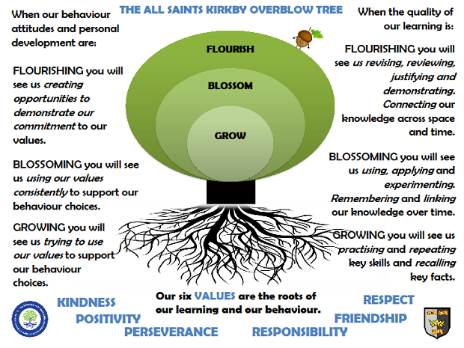Jupiter ClassAutumn Term 2024

**Reading**

In Jupiter class, we enjoy a positive reading environment in which books are enjoyed and shared by all. Pupils are given daily opportunities to listen to stories and read independently with an adult. Every child takes part in Whole Class Guided Reading sessions. Please encourage your child to read at home daily and complete the reading record. Having a love of reading and the ability to read for extended periods of time is the perfect preparation for progression throughout the school. All children have a Home Reading Book pack and will choose a reading book to enjoy at home and in school. For children on Book Bands, reading books will be changed weekly on a Monday. These books are closely matched the reading ability/Phonics level each child is working at. We encourage the sharing of books that have been enjoyed so when your child has finished reading a book they can bring it in to school to share/swap with another child.

You can access further reading eBooks at home through the Oxford Owl eBook Library (<https://www.oxfordowl.co.uk/for-home/find-a-book/library-page/>). Please ask Mr Anderson if you would like the Class Login.

**Spellings**

In Jupiter Class we follow Read Write Inc Spelling. Spellings will continue to be learned in school. You will be informed each week which spelling pattern we are focusing on so you can support your child at home.

**Writing**

**Our Key Books:**

How to Wash a Woolly Mammoth, Marcy and the Riddle of the Sphinx, Bill’s New Frock and Secrets of a Sun King

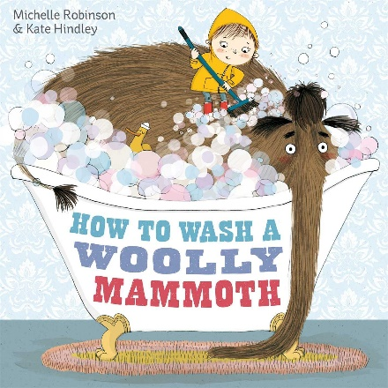

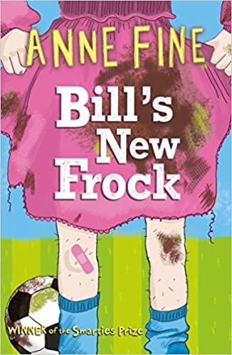

This term we will be exploring the above books. We will be writing instructions inspired by the story ‘How to Wash a woolly Mammoth’ and creating fiction writing based on the story ‘Marcy and the Riddle of the Sphinx’. Through our Whole Class Guided Reading, we will be exploring Bill’s New Frock by Anne Fine and Secrets of a Sun King by Emma Carroll. We will also be writing our own narrative poetry inspired by Ancient Egypt.

**Maths**

Our maths topics this term will be:

Number and Place Value, Addition and Subtraction, Measure (Length, Perimeter and Area) and Multiplication.

***Times Table Rock Star Maths***

In Jupiter Class, pupils take part in a daily Times Table Rock Star Maths challenge. They use the iPads to answer multiplication questions in a format that replicates the end of Year 4 multiplication check. Classic rock songs help them keep the pace! The aim is to answer questions correctly to earn coins and improve their avatars.

**Science**

**Light**

* Recognise that we need light in order to see things and that dark is the absence of light
* Notice that light is reflected from surfaces
* Recognise that light from the Sun can be dangerous and that there are ways to protect our eyes
* Recognise that shadows are formed when the light from a light source is blocked by a solid object
* Find patterns in the way that the sizes of shadows change

**Sound**

* Identify how sounds are made, associating some of them with something vibrating
* Recognise that vibrations from sounds travel through a medium to the ear
* Find patterns between the pitch of a sound and features of the object that produced it
* Find patterns between the volume of a sound and the strength of the vibrations that produced it
* Recognise that sounds get fainter as the distance from the sound source increases.

**PE**

In Autumn Term, PE will be on a Wednesday and Thursday. We will be doing football, hockey, tag rugby and gymnastics. Please come in PE kit on these days. In cold weather, please make sure PE kit includes a warm outdoor top and waterproof.

**Art**

We will be exploring colour, pattern and shape with a focus on the work of Diego Rivera who was a Mexican Muralist.

**Computing**

To Connect – *Technology in our lives*

**French**

Ma famille et moi - *Moi*

Les fêtes - *Les couleurs*

**RE**

* Creation/Fall - *What do Christians learn from the creation story?*
* What does it mean to be a Sikh?

**PSHE**

Families and Close Relationships

Friendships and management - hurtful behaviour

**Music**

Traditional Instruments (Theme: India)

Rock and Roll

**Topic**

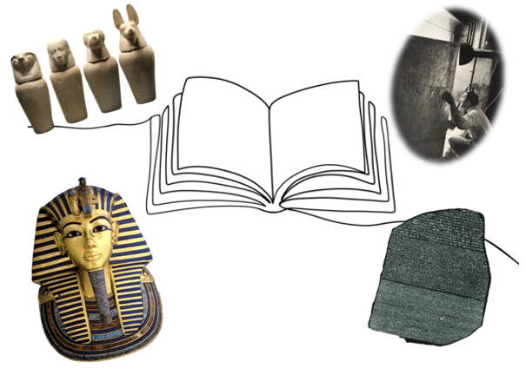Our provocation this term is:

What’s the Story?

School Branch – From the Past into the Future (Continuity and Change)

**The children will be exploring the following areas:**

* How do we know about Ancient Egypt today?

(Archaeology including discoveries by Jean-François Champollion and Howard Carter)

* Ancient Egyptian civilisation and its place within history
* Life and the social structure of Ancient Egypt
* Ancient Egyptian Mythology

The following grid contains some suggestions of activities your child may like to complete at home to support them with the work we do in class. I would love to see any completed tasks and they will have an opportunity to share them in class.

|  |  |  |
| --- | --- | --- |
| Write some maths questions or word problems to solve using Egyptian number symbols. | Use hieroglyphs to write a message. | Find out some interesting facts about Ancient Egypt and create a multiple-choice quiz. |
| Write 10 questions that you would ask Tutankhamun. | Design and make an Egyptian cartouche or jewellery. | List ten things that we would see in Ancient Egypt. |
| Write an explanation for how the pyramids were constructed. | Create a fact file on a famous Ancient Egyptian. | Make a pyramid model. Could you show what it might look like inside? |

**Useful websites to support learning about Ancient Egypt:**

BBC Bitesize:

<https://www.bbc.co.uk/bitesize/topics/zg87xnb>

BBC Teach:

<https://www.bbc.co.uk/teach/class-clips-video/history-ks1-ancient-egypt/z2vmjsg>

National Geographic Kids:

<https://www.natgeokids.com/uk/discover/history/egypt/ten-facts-about-ancient-egypt/>

Britannica Kids:

<https://kids.britannica.com/kids/article/Ancient-Egypt/353087>

DK Find Out!:

<https://www.dkfindout.com/uk/history/ancient-egypt/>