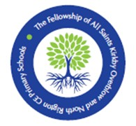

**NORTH RIGTON**

**CHURCH OF ENGLAND PRIMARY SCHOOL**

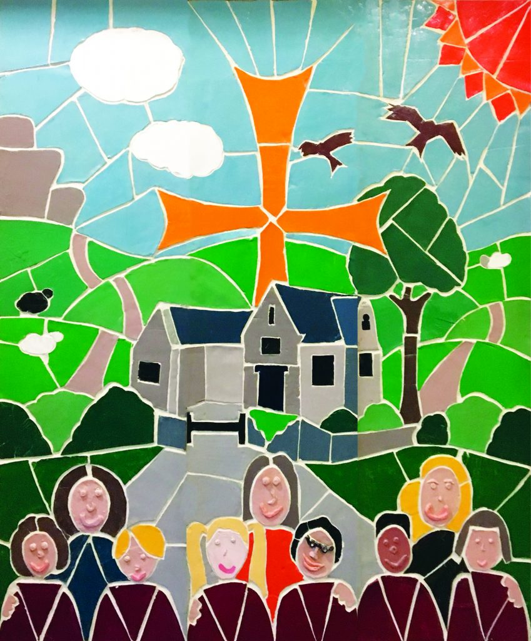

**SCHOOL PROSPECTUS**

**2025/2026**



Dear Parents,

Welcome to the Fellowship of All Saints Kirkby Overblow and North Rigton CE Primary Schools - a nurturing, caring, inspiring partnership - with a strong commitment to the personal development of each and every pupil in our schools.

Mrs Andrews leads an excellent team of staff, who all work very hard to ensure our children receive a safe, healthy and balanced education in a strong and inclusive family atmosphere. No schools are better than the teachers that work in them, and there is a clear and sharp focus on the constant quest to raise the standards of teaching and learning.

In September 2018 our two village schools entered into a formal collaboration, known as ‘The Fellowship’, with Mrs Andrews as the Headteacher. Whilst both schools’ benefit from working closely together and share many members of staff, resources and a common ethos they retain their individuality and a commitment to the local community that they serve. All Saints and North Rigton are happy, busy, fun and friendly places and we are very proud of our wonderful facilities in lovely surroundings.

Underpinned by an ethos of Christian love and care, wholeness of the learning experience is paramount. Every child is valued, and we are always looking at ways of making education relevant to each individual pupil. We pride ourselves on achieving the best possible outcomes for a broad range of abilities. Expectations are high, as we aim to ensure that all children leave All Saints and North Rigton with a genuine sense of creativity and confidence. However, the children progress at a pace that is appropriate to them and develop 'a love of learning because their teachers are kind, helpful and patient'. Pupils' personal development is 'outstanding' as we seek to create the right conditions for young people to grow. There is strong, supportive provision for those with learning difficulties as well as for the gifted and talented.

As you look through the prospectus, I hope it gives you some idea of the quality and breadth of education offered. We look forward to meeting all parents and children so they can see for themselves what we believe makes our schools a special place.

Yours sincerely,

Joanne McCudden

Chair of the Governing Body

**Introduction**

North Rigton is an integral part of the local community and parish, where Christian values are at the centre of all that we do. We provide the children in our care with an inspiring and caring environment where all children can develop the skills needed for their future as a member of the wider community.

We are proud of the strong relationship between children, staff and parents and we believe this is the key to the success of our school. Every child is treated as an individual and encouraged to show respect for others.

**Our School Tree**

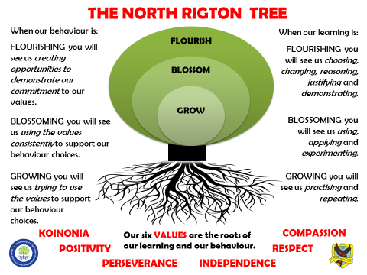

**Mission Statement**

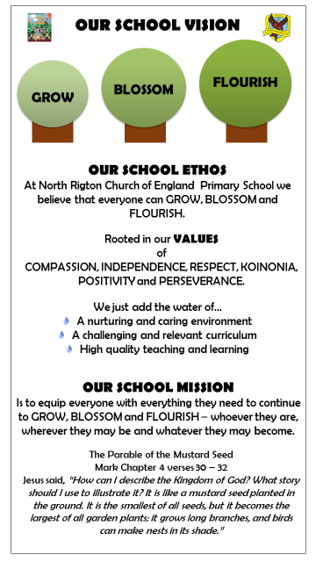

**Our Staff**

|  |  |
| --- | --- |
| **Teaching Staff:** |  |
| Mrs A Andrews | Head teacher |
| Mrs S Gardiner | Assistant Head teacher |
| Miss K Burrow / Mrs L Jackson | Reception teachers |
| Miss M Ellis | Year one and year two teacher |
| Miss K Ellis / Miss C Lewis | Year three and year four teachers |
| Mrs V Graham / Mrs S Gardiner | Year five and year six teachers |
|  |  |
| **Teaching Assistants:** |  |
| Mrs L Hudson | HLTA |
| Mrs J Butler | HLTA |
| Miss C Lewis | HLTA |
| Mrs K London | GTA |
| Miss F Bayman | GTA |
| Miss C Vickers | GTA |
| Miss K Bruno | GTA |
| Mrs H Holder | Supply GTA |
| Mrs C Naylor | Supply GTA |
|  |  |
| **SENDCo:** |  |
| Mrs E Porter | SENDCo Administrator |
| Mrs S Gardiner | SENDCo In School Link |
|  |  |
| **Office staff:** |  |
| Mrs R Hamill | Office Manager |
| Mrs J Dibb | Fellowship Clerical Assistant |
| Ms A Foster | Fellowship Business Manager |
|  |  |
| **Pastoral Support:** |  |
| Mrs L Jackson |  |
| Mrs S Gardiner |  |
|  |  |
| **Cleaner:** |  |
| Mrs K Simpson |  |
|  |  |
| **Caretaker:** |  |
| Mr A Fletcher |  |

**Class Organisation**

|  |  |
| --- | --- |
| Apples | Reception |
| Pears | Years 1 & 2 |
| Busy Bees | Years 3 & 4 |
| Teamwork Tigers | Years 5 & 6 |

**OFSTED Inspection Report**

The school’s last OFSTED Inspection took place in May 2022. If you would like to see the full report, one is available in school and on our school website. Also, you can download it from [www.ofsted.gov.uk](http://www.ofsted.gov.uk) following the links on the website. The school was judged as good overall, with many features of achievement and teaching and learning towards outstanding.

The school’s last SIAMS (Statutory Inspection of Anglican and Methodist Schools) Inspection took place in July 2015. As an Aided School we have to have a SIAMS Inspection as well as an OFSTED Inspection. This covers Collective Worship, R.E. and the ethos of the school. A copy of the inspector’s report is included in the Appendix. In July 2015, the school was judged as an outstanding church school.

**Yorkshire Causeway Schools Trust**

**Yorkshire Causeway Schools Trust**

Yorkshire Causeway Schools Trust (YCST) was founded in March 2015 with the aim of bringing together a family of Schools that share common values, interests and purpose. Based in and around Harrogate this Multi Academy Trust (MAT) is outward looking, built on the strength gained from every school in the MAT being a valued and significant part of the organisation. YCST includes both Church of England and Community Schools and places our pupils at the heart of everything we do.

North Rigton became an academy school on 1st December 2017 and joined YCST. Other Schools in the Trust are St Aidans CofE High School, Richard Taylor CofE Primary School, St Peters CofE Primary School, Oatlands Infant School, Pannal Primary School, Hampsthwaite CofE Primary School and All Saints CofE Primary School.

On 1st September 2018 North Rigton CE Primary School entered into a formal collaboration with All Saints CE Primary School. The two primary schools work together very closely and share a Headteacher. This partnership is known as The Fellowship of All Saints Kirkby Overblow and North Rigton CE Primary Schools.

**Admissions**

Children start in the reception class in the academic year in which they are five.

Our usual maximum limit for admission to the reception group is 15. The school has adopted the North Yorkshire admissions policy which is available to view at [www.northyorks.gov.uk/admissions-statistics-and-policies](http://www.northyorks.gov.uk/admissions-statistics-and-policies). To apply for a place at school parents need to fill in the North Yorkshire preference form which is available online at [www.northyorks.gov.uk/primaryadmissions](http://www.northyorks.gov.uk/primaryadmissions)

In the half term prior to admission, arrangements are made for children to spend time in Apples to familiarise themselves with the school. A new starters Parents Evening will be held for parents of children joining Foundation stage. This will provide information about the class and the school and give opportunities to parents to ask questions.

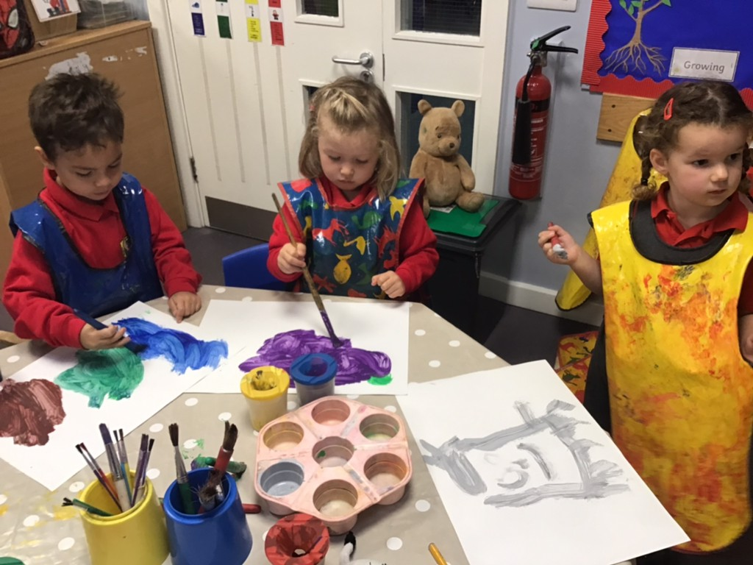

**Our School Day**

08:50 Whistle blows for children to line up

09:00 Learning session 1

10:15 Playtime (KS1)

10.30 Playtime (KS2)

10:30 Learning session 2 (KS1)

10.45 Learning session 2 (KS2)

12:00 Lunch

13:00 Learning session 3

14:30 KS1 playtime

14:45 Learning session 4

15:30 End of school day

**Teaching and Learning**

At North Rigton, we believe that all children are entitled to high quality and teaching learning experiences so that they can flourish and achieve to the highest standard.

We aim to:

* Encourage children to become independent and creative thinkers so that they become confident to share their ideas, thoughts and questions
* Develop a child’s spiritual, moral, social and cultural development so that they can fully understand their role within a modern Britain.
* Make learning fun, meaningful and challenging for all children, including those with special educational needs.
* Develop a range of teaching methods giving children opportunities to work independently, as a class and part of a group.
* Have high expectations of all children by matching work appropriately.
* Have a broad and balanced curriculum with opportunities to develop knowledge and skills across a range of subjects and make appropriate links.
* Support children to take responsibility in their learning, take on board feedback from the teacher and work on their next steps and targets.
* Help to make all children feel special as a child of God, a member of the school community and develop their self-esteem to see a purpose in the world.

**The Curriculum**

**Foundation Stage**

Children in their first year of primary school follow the Early Years Foundation Stage. The curriculum is divided into seven areas of learning, although we recognise that, in practice, many of these areas overlap.

The three prime areas are

* Communication and language
* Physical development
* Personal, Social and Emotional Development

Schools must also support children in four specific areas of

* Literacy
* Mathematics
* Understanding of the World
* Expressive arts and design

Children in the Reception year of school are taught in small group activities, through structured play activities and some short bursts of whole class activities.

**Key Stage 1 and 2**

Our curriculum is carefully planned around ‘branches’ of learning. We engage our children at the beginning point of a project by offering ‘primary provocation’ which builds to a ‘final flourish’ where they can then demonstrate everything they have learned.

**English**

English consists of reading (word reading and comprehension), writing (spelling and handwriting and composition), grammar and punctuation and speaking and listening. In Early Years and Key Stage 1 phonics is also taught on a daily basis.

Phonics is taught in small groups across Early Years and KS1 in a lively, fun, engaging and challenging way. The focus is on hearing sounds, blending and segmenting sounds to aid reading and writing. This synthetic phonics approach is supported by the ‘Read, Write, Inc’ programme and is planned to meet the needs and abilities of all children.

English lessons are generally taught on a daily basis, but is also threaded through other subjects to encourage consolidation and transferring of skills.

**Maths**

In mathematics we encourage children to become fluent in the fundamentals of maths, reason mathematically and solve problems. Maths is made up of the following areas:

* Number and place value
* Number operations (addition, subtraction, multiplication and division)
* Fractions, decimals, percentages, ration and proportion, algebra
* Measurement
* Geometry – properties of shape, position and direction
* Statistics

Mathematics is taught daily and where appropriate within other subjects so that links can be made to consolidate learning and transfer skills.

**Science**

Building on from Early Years work on understanding the world, we support children to develop their scientific knowledge and conceptual understanding in the different elements of Science and equip them with enquiry based skills to investigate, compare, classify and research concepts. This is achieved through work on plants, animals (including humans), everyday materials, seasonal changes, rocks, light, forces and magnets, electricity; all under-pinned by working scientifically.

**Computing**

Computing education focuses on the principles of information and computation, digital systems and programming. Computing skills are also used to enhance other areas of the curriculum.

**Geography and History (Humanities)**

We develop a child’s geographical and historical understanding through engaging and meaningful projects.

In Geography, children gain an understanding of different locations (locally, nationally and internationally) as well as investigating human and physical geography.

In History, children gain an understanding of Britain’s past and the wider world. In Key stage 1, children are taught to consider changes within living memory, events beyond living memory and lives of significant individuals in the past. In Key Stage 2, children develop their sense and understanding of chronology through local, British and world history.

**Physical Education**

In PE, class teachers individually or alongside specialist coaches, plan a broad curriculum to ensure competence in physical activities, encourage children to engage in competitive sports and competitions and to lead a healthy and active lifestyle. This is taught through a series of activities based on gymnastics, multi-skills, dance, competitive games (e.g. hockey, football, tag-rugby, tennis, rounders, cricket), athletics, outdoor and adventurous activities and swimming (year 3/4).

**Art and Design**

Art and Design work encourages children to be creative, inspired and challenged as well as to think critically. Children are taught to use a range of materials to draw, paint and sculpt whilst developing techniques in using colour, texture and pattern. Art and Design is taught in a cross-curricular way and often focuses on works of famous artists as an inspiration.

**Design and Technology**

DT encourages children to develop their practical skills whilst being creative and productive. Design and Technology work focuses on designing products, making products and evaluating them. They will also learn fundamental skills of cooking, nutrition and hygiene.

**Music**

Music is taught throughout the school developing a child’s critical engagement with music through composition, performance and the understanding of pitch, duration, tempo, duration, texture, structure and notation.

**RE**

As a Church of England School the Diocesan Agreed Syllabus is followed supported by ‘Understanding Christianity’. Work in RE is centred around the Christian faith with Key stage 1 children also studying Islam and Key stage 2 children studying Islam and Judaism in addition to Christianity. RE is taught weekly as a discrete subject. Thinking skills are a key strategy used to develop a child’s enquiry based thinking and questioning skills.

**Personal, Social and Health Education**

PSHE is taught across the school through circle time, PSHE lessons and as part of the wider school curriculum. We believe that with a supportive and considerate environment, children are able to discuss issues relating to healthy relationships, health and well-being and being a member of the wider world. We strongly feel that we need to equip children with a good level of empathy, understanding and key skills to become a full member of society. Parents may request that their child is withdrawn from RHE (Relationships and Health Education) lessons

**French**

French is taught in the Key Stage Two classes, with the emphasis placed on oral skills.

**Collective Worship**

Collective worship has a special place in the whole curriculum of our school. It is conducted in accordance with the principles and practice of the Church of England, this has been the tradition in our school since its Foundation. We aim to enable children to be open to love, to life, to commitment and vision.

A time of worship takes place each day and the Rector or a member of the parish regularly leads an act of worship. There is a strong link between the Church and the school. The children participate in Family Services, Harvest Thanksgiving, Christmas Carol Service, Christingle Service, Mothering Sunday Service and others.

Parents have the right to withdraw their children from Religious Education and collective worship, but governors expect that in choosing a Church school parents will support their children in taking a full part in the religious activities of the school, including Religious Education and the daily act of worship.

**Special Educational Needs**

Our school actively supports and promotes equal opportunities for all children, regardless of disability, race, gender or background. We aim to meet the needs of all our children in school and for every child to achieve their full potential.

Parents will be informed and consulted whenever there are concerns about children's academic or personal progress. In the same way, if parents have any concerns about the development of their child in school, we will be grateful to be advised.

Within the school we continually monitor all children (particularly on admittance). Children who have been assessed as having particular academic concerns will generally have their needs met in school through individual programmes of work. The Pupil Support Services are consulted when necessary, either on a formal or informal basis. The School Special Needs Policy is available in school.

We also provide additional learning opportunities for children who are highly skilled in a particular subject or area.

**Behaviour**

Our care of the children at North Rigton Primary School is characterised by kindness, respect and understanding of their needs. We encourage the development of self-discipline and teach that courtesy and good manners are good qualities to have. The children’s behaviour choices are supported by the promotion of the North Rigton Behaviour Tree which encourages the children to grow, blossom and flourish through the use of our values: friendship, positivity, perseverance, responsibility, kindness and respect.

Copies of our policies on Behaviour Management and Bullying are available on our website.

**Homework**

Our school seeks to foster a ‘Learning Partnership’ between pupils, teachers and parents. This learning partnership can grow whilst following our ’Homework and Enjoying Learning Together at Home’ document.

We do not routinely set the following types of homework; worksheets, spellings and maths tests, learning logs. Instead class teachers share with parents details of projects that are taking place in school and ley learning in maths and English. Reading is encouraged daily and specific tasks may be given when appropriate or to individual children.

A full copy of our Homework document is available from school.

**Transfer to Secondary Education**

At the end of Year 6 children generally transfer to a secondary school in Harrogate, many in the past have transferred to St Aidan’s CofE High School and Harrogate Grammar School. Parents and children have the opportunity to visit all the Harrogate Secondary Schools in the Autumn Term prior to their transfer.

The Head of Year 7 from the secondary schools visits the children at North Rigton and the children spend a day at their new school in the Summer Term.

**Before and After School Care**

Before and after school care for both Fellowship schools is provided at North Rigton by ‘Rigton Red Kite’.

The club was rated outstanding by OFSTED in June 2019, a copy of the report can be viewed on our website.

Red kite is open from 7.15am in the morning and until 6.00pm in the evening. Holiday provision is also provided at the central hub in Otley.

Contact details: 07517895881 or email rigtonredkiteclub@hotmail.com

**Educational Visits**

From time to time, our teachers organise special trips and events to enrich the children’s learning. We ask parents to make voluntary contributions to meet the cost of such trips.

We know that some families find it difficult to meet this cost in one payment and therefore arrangements can be made to pay for trips over an extended period of time. Whilst we recognise that the cost of school trips can be expensive, we believe it is important for all of our children to experience residential / out of school visits and would very much like to ensure that every child has the opportunity to take part. There are bursaries/subsidies available for a limited number of trip places.

**Residential Visits (Every two years)**

The Y5&6 children have the opportunity to take part in a residential visit on alternate years. On the year when the residential is not taking place, alternative activities are arranged in the form of an exciting activity week.

**School Uniform**

Uniform (including book bags, drawstring bags and sports hoodies) is available to buy all year round from:

Emblazon Outfitters

60 Tower Street

Harrogate

North Yorkshire

HG1 1HS

01423 529935

[www.emblazon.biz](http://www.emblazon.biz)

Or

Online at [www.myclothing.com](http://www.myclothing.com/)

**Our Uniform**

* Red school sweatshirt/cardigan
* Red polo shirt
* Grey trousers/shorts/skirt/pinafore
* Optional Summer – red checked dress

**PE Kit** (should be kept in a named drawstring bag which remains in school):

* Named pumps or trainers: slip on or Velcro fastening
* Red T-shirt
* Black shorts/leggings/jogging bottoms

Unbranded items, in the correct school colours, can be purchased from supermarkets and high street stores.

**School Meals**

Our school lunches are delicious, nutritionally balanced and cooked on site by the Aspens catering team. Every day children have a choice of two main courses (a hot meal or pasta / jacket potato) and a pudding. From September 2014, all children in reception and Key Stage 1 became eligible for free school meals. If your child has any special dietary requirements please let us know – the kitchen is fully experience in cooking for children with allergies and other dietary needs.

Meal selection and payment of school lunches should be made via the Aspens Select portal. Parents who think they may be entitled to free school meals should contact the Area Education Office, Ainsty Road, Harrogate, HG1 4XU (Tel: 01423 700100) for further information.

Children may also bring a packed lunch from home. Supervision is provided throughout the lunch-time period. All drinks brought to school should be in a carton or plastic container. All children have a water bottle and have access to chilled drinking water throughout the day.

Children may bring fruit or vegetables from home for morning break. Sweets or crisps are not allowed at any time. All Key Stage 1 children have a free piece of fruit or vegetable every afternoon as part of the government’s School Fruit and Vegetable Scheme.

**Child Protection**

North Rigton Primary School is committed to ensuring the welfare and safety of all children in school. All North Yorkshire schools, including North Rigton Primary School, follow the North Yorkshire Safeguarding Children Board procedures. The school will, in most circumstances, endeavour to discuss all concerns with parents about their child/ren. However, there may be exceptional circumstances when the school will discuss concerns with Social Care and/or the Police without parental knowledge (in accordance with Child Protection procedures). The school will, of course, always aim to maintain a positive relationship with all parents. The school’s child protection manual is available on request.

**Children in Care (Looked After Children)**

We are committed to providing quality education for all our pupils, based on equality of access, opportunity and outcomes. We aim for every child, whatever their background or their circumstances, to have the support they need in order to

• Be healthy

• Stay safe

• Enjoy and achieve

• Make a positive contribution

• Achieve economic well-being

We embrace our duty to safeguard looked after children, to promote their educational achievements and to ensure they are able to achieve and reach their full potential.

**Insurance**

The Governors have an Insurance Policy that covers pupils for accidents resulting in death or permanent disability when taking part in all school activities and visits. Details of this policy are available in school.

There is no insurance cover for personal property in school, whether lost or damaged. It would, therefore, be wise to make sure that expensive items which need to be brought to school are covered on home insurance policies. It will also be helpful if parents make sure that toys and games are not brought to school.

**Parents and School**

At North Rigton School we recognise and value the considerable practical support given to our children in so many ways. We feel that it is very important that attitudes, values and expectations of home and school are in tune with each other. We all develop and learn at different rates but there is research evidence which stresses that children are more likely to do well if their parents support them. Parents are always welcome to come into school to discuss their child's progress at any mutually convenient time. There are consultation evenings in the Autumn and Spring Term, and in the Summer Term a report will be sent home with an invitation for parents to attend a meeting to discuss progress if necessary.

If you have any worries, problems or concerns relating to your child please arrange to see the Teacher/Head Teacher as soon as possible. We would be pleased to understand and help resolve any child-related anxiety. We are aware that children at our school have differing family units, we would welcome parents to share any anxieties or difficulties with us to enable us to support all our children.

We value and welcome parental help in school in a variety of ways - on visits, after school activities, in the classroom - cooking, sewing, reading - art and craft activities, making and repairing school resources. Please ask if you would like to offer your help. The main way to help your child at school is to let him/her see that you take a real interest in what he/she does at school and that you are keen for your child to achieve their best. Please praise progress and build up the self-confidence in his/her own ability.

**Access to Information**

Under the ‘Freedom of Information Act 2000, schools are required to provide access to certain information on request. The classes of information that we undertake to make available are organised into the following broad topic areas –

Information published in this School Prospectus.

Governors’ Documents.

Pupils and Curriculum – Information about policies that relate to pupils and the school curriculum.

School Policies and other information related to the school – information about policies that relate to the school in general.

Copies of the full Publication Scheme and details about how to request the information are available from the school office or can be accessed on our website.

**If You Have a Concern**

Most of the concerns that arise about children and their schooling can be dealt with quickly in an informal way.

If there is something you are not happy about, please follow this procedure:

1. Raise the matter with your child’s class teacher and arrange a time to discuss the matter.

2. If the problem remains, arrange to see the head teacher.

3. If you have a complaint that you do not feel is being dealt with effectively, please follow the school’s complaints procedure available from the school website.

**The Governors**

Joanne McCudden – Chair (Co-opted Governor)

Rosemary Hunt – Co Vice-Chair (Foundation Governor)

Mark Wilkinson – Co Vice-Chair (Co-opted Governor)

Amber Andrews – Headteacher (Ex-officio)

Sarah Honey (Staff Governor)

Sophia Gardiner (Staff Governor)

Emma Littlewood (Co-opted Governor)

Jules Henry (Co-opted Governor)

Helen Laflin (Parent Governor)

Rebecca O’Connell (Parent Governor)

Fiona Parish (Co-opted Governor)

Rev’d Stroma McDermott (Ex-officio)