**SUN CLASS – AUTUMN 2024**

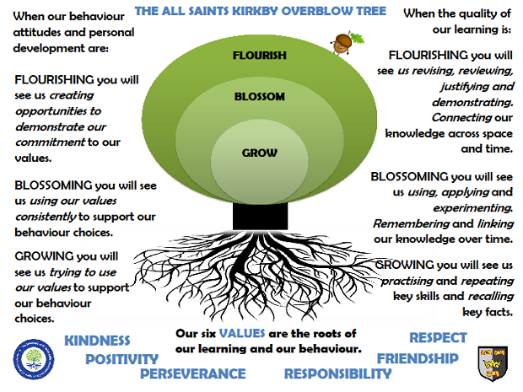

In Sun Class we are taught by Mrs Honey, Mrs Pilgrim and Mr Rodrigues

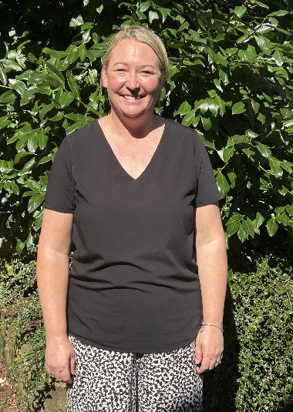

**Rock Star Maths:** In Sun Class, pupils take part in a daily Rock Star Maths challenge. They have up to 3 minutes to correctly answer as many questions as possible. Classic songs help them keep the pace! The aim is that they improve their time and score during the year. Please encourage your pupils to learn their multiplication tables at home. The multiplication table/s they are learning will be sent out each week on a Friday.

**Reading:** In Sun class, we enjoy a positive reading environment in which books are enjoyed and shared by all. Pupils are given daily opportunities to read independently, and some pupils will read with an adult. Every child will have two 45-minute sessions of guided reading a week. This term our guided reading text will be **Percy Jackson and the Lightning Thief**.

Please encourage your child to read at home daily although at this age it does not have to be with an adult.

We encourage the sharing of books that have been enjoyed so when your child has finished reading a book, they can bring it into school to share/swap with another child. We also love to hear about any reading recommendations they may have.

**Spellings:** Spellings will continue to be learned in school, where we can give more support to methods used, allowing the spellings to be more embedded. You will be informed each week which spelling pattern we are focusing on so you can also support your child at home. We will send out an email copy of the spellings each week.

**Writing:**

Narrative: This term we will be focussing on **Ancient Greek Myths**; they will explore the key features of myths and have an opportunity to write their own. They will also be writing their own versions of popular myths using a range of styles including comic strip and playscripts.

Non-Fiction: They will write a range of **non-chronological reports** about key areas of Ancient Greece including: The Olympics, The Greek Underworld, Architecture and Theatre.

**Poetry:** They will be exploring the following features: alliteration, simile, metaphor, and personification.

For more detail, please see link to whole school English document.

**Maths:** Our maths topics this term will be:

Number and Place Value

Addition and Subtraction

Multiplication and Division

Fractions

**PE:** In autumn term, PE will be on a Monday and Friday. These sessions will be taught by Mr Rodrigues.

Session 1: Football/Hockey Session 2: Tag Rugby/Gymnastics

On these days, your child should come to school in their PE kit, which should include a waterproof top.

**ART: Inspired by Ancient Greece**

Mythical beasts – pattern and mark making

Batik

Cardboard relief work - temples

Featured artist: Henri Matisse (Fauvism)

We will be exploring the different areas of this artist’s work including still life and cut-outs

Key focus: Colour, pattern, and shape

**SCIENCE: Light and Sound**

**Light:** To recognise light travels in straight lines and to use this to explain that objects are seen because they give out or reflect light into the eye.

To understand why shadows, have the same shape as objects that cast them.

**Sound**: To recognise that sounds can be high or low pitched.

To describe how sounds are made when objects vibrate.

To recognise that not all objects can be seen to vibrate.

To recognise that vibrations can travel at different speeds.

**MUSIC**

Dynamics, pitch and texture (Theme: Coast and study of the composer Mendelssohn)

Film music

**FRENCH**

Greetings and phrases

**RE**

In RE this term, we will be exploring what are the differences between organised worldviews and personal worldviews.

They will also be studying the following units:

Creation/Fall – exploring whether Creation and science are conflicting or complementary and understanding that people hold different views

God – what does it mean if God is loving and holy?

**PSHE**

Relationships: Families and friendships

**COMPUTING**

E-Safety and Technology in our lives

**HISTORY SUBJECT BRANCH: CONTINUITY AND CHANGE**

**KEY LINE OF ENQUIRY: HOW DID THE ANCIENT GREEKS INFLUENCE THE WAY WE LIVE TODAY?**

**KEY KNOWLEDGE**

* **Know and describe the connection between time-periods studied and how they may have been influenced by previous events/people.**
* **Know and explain why changes have happened over time using evidence from a range of sources.**

**KEY SKILLS**

* **Use a range of primary and secondary sources to collect evidence from the past.**
* **Investigate own lines of enquiry by posing questions to answer.**
* **Plan and present a self-directed project or research about the studied period.**
* **Use a variety of ways to communicate knowledge and understanding including extended writing.**

**During the enquiry, we will be exploring the following areas of Ancient Greece history and legacy:**

* **Sport**
* **Architecture**
* **The arts including drama, music, culture and literature**
* **Democracy**
* **Language, Mathematics, Science, Philosophy (chosen by pupil)**

***The following grid contains some suggestions of activities your child may like to complete at home to support them with the work we do in class. I would love to see any completed tasks and they will have an opportunity to share them in class.***

|  |  |  |
| --- | --- | --- |
| **Plan a holiday to Greece – which islands will you visit? How will you get there? How much will it cost?** | **Explore the British Museum Website**  **Can you find out more about Lord Elgin and the ‘Elgin Marbles’?** | **Design your own maze to hold a mythical creature like the Minotaur**  **Use coding to create a virtual maze** |
| **Design a poster encouraging visitors to visit Greece, remembering to use persuasive language** | **Make a model of an Ancient Greek Theatre**  **Label the different parts of the theatre and explain their function** | **Make a set of Top Trumps for the Greek Gods and Goddesses**  **Challenge a family member to play with you** |
| **Create a timeline of key events from the Ancient Greek period** | **Label a map of Europe showing all the major countries** | **Research what Ancient Greek ships looked like – can you draw and label one?** |
| **Research traditional Greek food and have a go at cooking one of the recipes** | **Make a fact sheet about the Parthenon**  **Use the British Museum Website to find out the different ways it was used over time** | **Turn one of the Greek Myths into a playscript – perhaps you could perform it at home** |

**Useful websites to support learning**

[Ancient Greece - KS2 History - BBC Bitesize](https://www.bbc.co.uk/bitesize/topics/z87tn39)

[Ancient Greece | British Museum](https://www.britishmuseum.org/learn/schools/ages-7-11/ancient-greece)

[Ancient Greek History for Kids - Fun Facts to Learn](https://www.historyforkids.net/ancient-greece.html)

[Parthenon (ancient-greece.org)](https://ancient-greece.org/architecture/parthenon.html)

[Curriculum / Primary / Historical Association (history.org.uk)](https://www.history.org.uk/primary/categories/curriculum)

[Ancient Greek Games - Free Interactive Online Games for Kids - Ancient Greece for Kids (mrdonn.org)](https://greece.mrdonn.org/games.html)