ENGLISH

at

ALL SAINTS CE PRIMARY SCHOOL

Sarah Honey
NOVEMBER 2023

English at All Saints CE Primary School

English is a flourishing subject in our school because….
We promote a love of reading and a curiosity for language. Pupils are given the opportunity to read in a variety of contexts including: 1:1 reading, guided reading, listening to stories, independent reading, paired reading and reading with other classes. Staff choose stories, poems, rhymes and non-fiction for reading to develop pupils’ vocabulary, language comprehension and love of reading.
We follow a systematic approach to the teaching of phonics using Read Write Inc. We assess and track children’s phonetic development throughout EYFS and KS1 and we use this information to inform our teaching and provide immediate additional support. Reading books are carefully matched to the phonics that are being taught and the sequence of reading books shows a cumulative progression in phonics. Teachers ensure pupils have sufficient practice in reading and re-reading books.
Our school has teachers, who are experts in early reading.
There is a determination that every pupil will learn to read, regardless of their background, needs or abilities. We provide our pupils with the skills to become a confident and fluent reader, allowing them to access all areas of the curriculum.
Teachers plan a termly sequence of learning for writing, which cover the skills and knowledge needed. As pupils move through the school, the skills and knowledge they acquire shows progression. Pupils are given regular opportunities to revisit learning so that knowledge is embedded.
Our writing curriculum is organised around the audience and purpose. Children are taught to write in a range of styles, including stories, poems, information, letters, newspaper reports and instructions. Much of the writing is linked to something the children have experienced or books they have read. Sometimes the writing is linked to other curriculum areas, such as history or science. We provide meaningful writing opportunities for the children.
Opportunities are given for children to show case how they have progressed and flourished as part of their learning including sharing assemblies, project flourishes, writing projects for a wider audience and presentations.
We recognise the importance of talk and place it at the heart of our school culture.
Our English curriculum is made up of 3 elements:
Speaking and listening

Early reading and phonics/ reading

Writing

Our curriculum covers the following areas:
NARRATIVE | NON FICTION | POETRY
Traditional tales  Myths  Fables  Fairy stories  Stories from other cultures  Adventure  Science Fiction  Fantasy  Historical  Contemporary  Dilemma  Play scripts  Film scripts  Comic strips  Diary*  Letter writing* | Recount  Discussion  Explanation  Instructions  Persuasion  Non-chronological report  Newspaper article  *Diary  *Letter writing | Structure:  Shape poems/ calligrams/ kennings/haiku/sonnet/cinquain  Classic/narrative/ballads  Choral/performance poetry  Free Verse:  Description  Conversation  List  Monologue  Riddles  Rhymes

GROW BLOSSOM FLOURISH TEACHING FOR LEARNING MODEL
What are the adults doing? | What will the teaching and learning look like in the classroom? | What are the children doing?
FLOURISH:  affirmation  challenge  active listening  observing  checking understanding  anticipating the project outcome | CREATION FROM LEARNING: | FLOURISH:  formative mistakes  justifying reasoning demonstrating  choosing and explaining  reviewing and reflecting  cooperation  taking the initiative
BLOSSOM:  variation of learning  strengthening connections  exploring misconceptions  hypothesising  setting challenges  recapping | APPLICATION OF LEARNING: | BLOSSOM:  independent learning  grappling  experimentation  problem solving  application  making links between learning  supported reasoning
GROW:  Modelling discussion  verbalising thinking  checking understanding/learning reviews  success criteria and scaffolding  worked examples/ concrete models  anticipating misconceptions | (SMALL STEPS IN) GUIDED LEARNING: | GROW:  guided practice in groups, pairs, solo  knowledge retrieval  using vocabulary  answering using stem sentences  acting on feedback  over-learning
TRUNK:  transfer of knowledge, revisiting learning  vocab identification, identifying purpose of learning  classroom organisation, subject knowledge | LEARNING PREPARATION: | TRUNK:  following routines  active listening  being prepared and organised  ready for learning  engaged in the process  commitment to the learning
ROOTS (OF TEACHING):  Responsibility  Kindness  Respect  Positivity  Perseverance  Friendship | PRE-REQUISITES FOR TEACHING FOR LEARNING:  constant feedback from all adults  discussing thinking between adults and children, between children  continuous questioning and hypothesising  high expectations for all and valuing every person and every contribution  learning from mistakes and recognising and celebrating achievements  willingness to be brave | ROOTS (OF LEARNING):  Responsibility  Kindness  Respect  Positivity  Perseverance  Friendship

ENGLISH LONG-TERM PLAN

 | YEAR A |  |  | YEAR B
 | AUTUMN | SPRING | SUMMER | AUTUMN | SPRING | SUMMER
School Branches | From the past into the future | What a wonderful world | People who make a difference | Protecting our planet | Our changing world | Outside our door
REC  1 YEAR PROGRAMME |  |  |  | Superheroes  How to save the world! | All about me
 |  |  |  | Key Books:  George Saves the world by lunchtime by Jo Readman  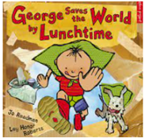  Michael Recycle by Ellie Bethel  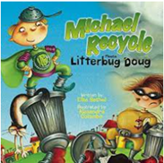 | Key Books:  Once There Were Giants by Martin Waddell  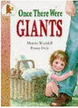  A Chair for Baby Bear by Kaye Umansky and Chris Fisher.  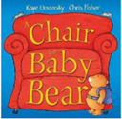  One Hundred Steps: The Story of Captain Sir Tom Moore by Captain Tom Moore  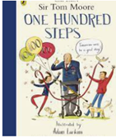  Little people, Big Dreams, Captain Tom More  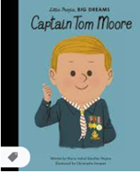  Poetry:  Oi Cat by Kes Gray  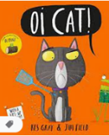
1/2 | Communication  The Fire of London | Whistle Stop World Tour  Celebrations | The Victorians  Florence Nightingale  Mary Seacole | Looking after our local area | Castles | On the Move
 | Key Books:  Vlad and the Great Fire of London  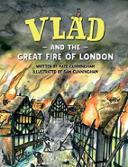  The Day the Crayons Quit  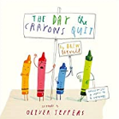  Writing Focus:  Lists and Captions  Descriptive writing  Non-Fiction Writing:  Diary  Letters  Poetry:  Calligrams and Shape Poetry – Fire and Bonfire Night | Key Books:  Poles Apart  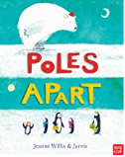  Handa’s Surprise  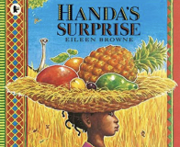  Writing Focus:  Stories from other cultures  Non-Fiction Writing:  Non-Chronological Reports  Poetry:  Rhyme | Key Books:  Alice in Wonderland  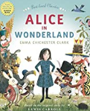  Vlad and the Florence Nightingale Adventure  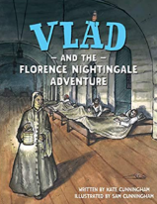  Writing Focus:  Fantasy story writing  Non-Fiction Writing:  Recounts  Poetry:  Performance – poems from the Victorian era | Key Books:  Jack and the Jellybean Stalk  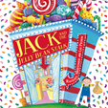  On Sudden Hill  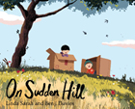  Writing Focus:  Traditional tales  Twisted tales  Lists and captions  Non-Fiction Writing:  Persuasion - recycling  Poetry:  Autumn Acrostics – Linked to the book ‘The Lost Words’ | Key Books:  Sir Scallywag and the Golden Underpants  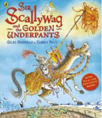  Dragon Post  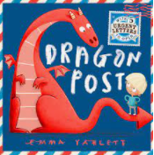  Writing Focus:  Adventure stories  Letter writing  Non-Fiction Writing:  Explanation and Recount  Poetry:  Dragon poems – based on the book | Key Books:  Mrs Armitage on Wheels  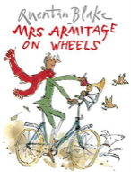  Journey  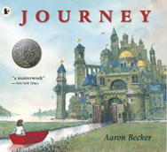  Writing Focus:  Fantasy story writing  Non-Fiction Writing:  Instruction writing  Poetry:  Classic Poems of Edward Lear – The Owl and the Pussycat
3/4 | Ancient Egypt | Africa – Breaking Stereotypes | Romans  Boudicca | Plastic Pollution | Vikings | Rivers and Coasts
 | Writing Focus  Fiction Writing  Descriptive writing and adventure stories  Marcy and the Riddle of the Sphinx  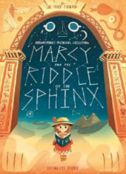  Non-Fiction Writing  Instruction Writing: Based upon the book ‘How to wash a Woolly Mammoth’.  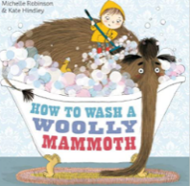  Poetry  Narrative poetry inspired by Ancient Egypt  Reading Focus  Bill’s New Frock by Anne Fine  Secrets of a Sun King by Emma Carroll  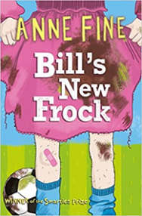  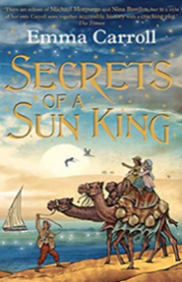 | Writing Focus  Non-Fiction Writing  Biographies: Children to write a biography about a family member/famous person.  Non-Chronological Reports: Based upon our topic of Africa.  Poetry  Reading Focus  Dinosaur Trouble by Dick King Smith  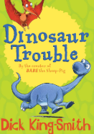  Running Wild by Michael Morpurgo  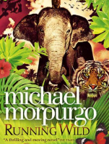 | Writing Focus  Taking Flight.  Narrative writing – adding description to a short video. Includes writing speech.  https://www.literacyshed.com/takingflight.html  Non-Fiction Writing  Newspaper writing: based upon a traditional fairy tale.  Persuasive writing: based upon a school improvement – e.g., no uniform.  Poetry  Reading Focus  Billionaire Boy by David Walliams  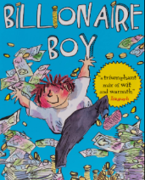 | Writing Focus  The Clocktower. Narrative writing – adding description to a short video.  https://www.literacyshed.com/the-clock-tower.html  Non-Fiction Writing  Letter writing: How was your summer holiday?  Instruction Writing: How to get ready for school.  Poetry  Christmas Acrostic Poems  Reading Focus  Jack Slater Monster Investigator by John Dougherty  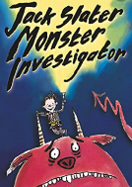 | Writing Focus  The Saga of Biorn. Narrative writing – writing linked to our topic.  https://www.literacyshed.com/the-myths-and-legends-shed.html  Non-Fiction Writing  Non-Chronological Reports: Based upon our topic of Vikings.  Poetry  New Year Poetry  Reading Focus | Writing Focus  Non-Fiction Writing  Poetry  Reading Focus
5/6 | How did the Ancient Greeks influence the way we live today? | Contrasting Locations  From the Antarctic to the Rainforest | American Civil Rights Movement  Martin Luther King | How do our food choice affect the planet? | What was life like during World War 2? | Our local area
 | Writing Focus  Reading Greek Myths and retelling in their own words/ writing their own myths using key features  Descriptive writing of a mythical creature  Script writing: adapting a Greek myth into a play to perform to school  Non-fiction writing: Comparing Ancient Olympics and Modern Olympics  An explanation text about Greek democracy making links with modern day democracy  A non-chronological report about the Greek underworld  Instructions: how to train a mythical creature  Poetry  Exploring the Greek myth, Pandora’s box  Shape poems/calligrams  Reading Focus  Percy Jackson and the lightning thief by Rick Riordan  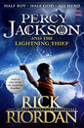 | Writing Focus  The Northern Lights by Phillip Pullman  Descriptions of main characters  Narrative: using a scene from the film as a stimulus for their own action narrative  Script writing: adapting a scene in the book into a film script  Diary writing – Lila  Non-fiction writing:  Explanation text based on ‘The March of the Penguins’ film  Information text about a chosen penguin  The Rainforest:  Explanation/persuasion text: endangered animals/ deforestation  Instructions: how to make a rainforest themed drink  Discussion text: should tourists be allowed to visit Antarctica?  Poetry  Rainforest poetry: exploring personification, metaphor and simile  Reading Focus  Skellig by David Almond  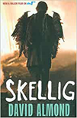 | Writing Focus  Historical narrative using a fictional account of a real event in the Civil Rights Movement (e.g. Little Rock)  Script: re-enactment Rosa Parks demonstration  Non-fiction writing:  Biography: family member, Barak Obama, Martin Luther King  Recount the events of The Greensboro Four protests  Discussion text: exploring the changes made to American society by the Civil Rights Movement and the inequalities remaining today. Links to ‘Black Lives Matter’  Poetry  Narrative poetry  Protest poetry  Reading Focus  Bird by Crystal Chan  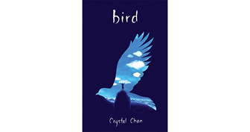 | Writing Focus  Modern twists on traditional tales  Author Study: Lauren Child. Making their own books to read to reception class  Fantasy narrative: Writing their own version of the picture book ‘Where the Wild things are’  Non-fiction writing:  Persuasive texts:  Adverts  Posters to persuade people to make food choices which are good for the planet  Recount: History of Rowntree’s  Explanation text: how chocolate is made  Fairtrade – how it works  Instructions – writing an ‘earth friendly’ recipe  Poetry  List poetry  Choral/ Performance poetry  Reading Focus  Explorers by Katherine Rundall  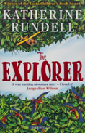 | Writing Focus  Goodnight Mr Tom:  Diary and letter writing from the perspective of an evacuee  Narrative using a flashback technique – remembering an event in the war  (The Piano)  Script writing: Evacuees  Non-fiction writing:  Explanation text: 1940s house  Home Front  Recount:  Events of The Blitz  Discussion text: ‘Germans in the Woods’ Is it right to kill in time of war?  Poetry  War poetry; free verse/metaphor  Reading Focus  Hitler’s Canary by Sandi Toksvig or  The Silver Sword by Ian Serralier or  War Torn Sky  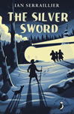 | Writing Focus  Contemporary narrative  Mystery narrative  Comic Strip  Stories from other cultures  Non-fiction writing:  Persuasion text:  Leaflets/posters encouraging visitors to the local area  Recount:  Fashion through the ages  Non-chronological report: key historical sites in Harrogate  Instructions  Letter writing to persuade  Poetry  Structured poems including Haiku  Reading Focus  A Million Shades of Grey by Cynthia Kadhata  