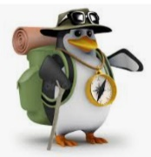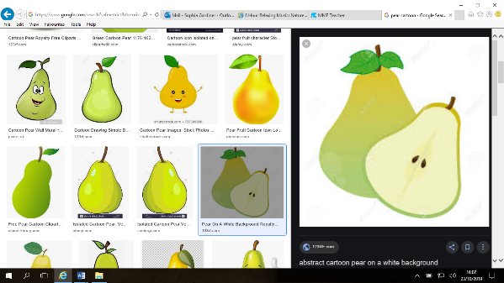

**Pears Class**

**Spring Learning Opportunities**

**“We are Explorers: Lego is the best toy ever!”**

Here are a variety of different activities which you may wish to do with your child out of school; **please keep this book at home to enjoy as a family.**

This page is designed to help families to *Enjoy Learning Together at Home*. However, if your child would like to share any of these tasks with me, I’d be delighted to see their efforts and pictures should be posted on Tapestry.

|  |  |  |  |  |
| --- | --- | --- | --- | --- |
| **Phonics/Spelling:**  You could help your child at home by using the RWI Sound/Spelling Book for the sounds/spelling rules we are covering this term. These will always be dated for your information so you know when we have covered each one. In Year 2, speed spell words will be noted and posted on Tapestry so you can see the sorts of words we are learning in school. | **Mental Maths:**  Y2: You could help your child at home by allowing them to play on TTRockstars. This will help them with their fluency of times tables.  Y1: You could help your child at home by playing on these place value games <https://www.topmarks.co.uk/Interactive.aspx?cat=20> | **Reading:**  Please try to read as often as you can at home with your family.  Books are changed weekly in school. Please send these in on a Friday and new books will be allocated the following Monday.  All children will continue to have a reading chart provided by school. | **Writing:**  You could help your child at home by writing lists such as items for a shopping list, or a birthday wish list.  Y2: Can you use commas to separate these items in your lists? | **Maths:**  You could help your child at home by taking note of shapes around your home. How many circles, squares, triangles or rectangles can you spot? |
| **Project:**  You could help your child at home by visiting the library and allowing them to research more about the Victorian era. | **Project:**  You could help your child at home by investigating what school was like in the Victorian times. Did children play the same games as you do? What did Victorian toys look like? | **Project:**  You could help your child at home by writing letters on a blackboard! How is this different to writing on paper? | **Project:**  You could help your child at home by reading the book ‘Dogger’ by Shirley Hughes. This can also be found on YouTube. | **Free Websites:**  There are some fantastic free interactive websites for English and Maths which can be used on the iPad or computer. You may wish to enjoy using them together:  Topmarks  <https://www.topmarks.co.uk>  ICT Games  <https://www.ictgames.com>  BBC Numberblocks  <https://www.bbc.co.uk/cbeebies>  /shows/numberblocks |