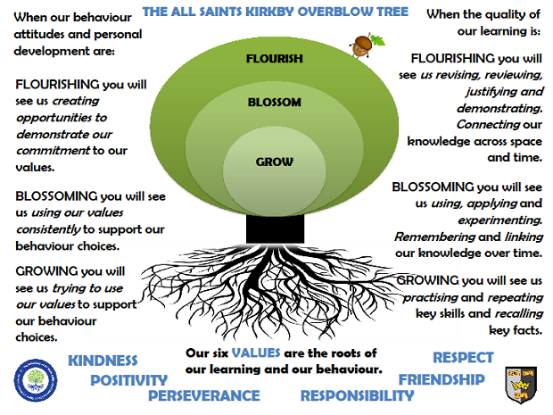MARS CLASSSUMMER TERM 2025

**Reading:** In Mars class, we enjoy a positive reading environment in which books are enjoyed and shared together. Pupils are given daily opportunities to listen to stories and join in with songs and nursery rhymes. Children will take books home once a week, they will be carefully matched to their phonic ability. At the start of the year the books will be pictures only to encourage your child’s story telling abilities. Children will move on to worded books once we have introduced sounds and the individual child is ready.

We encourage you to read with your child every day, this could be them reading their school books to an adult, or an adult reading a story book to the child. Having a love of reading is a crucial building block to support them in their phonics as they progress through school. We encourage sharing of books so when your child has particularly enjoyed a book, they can bring it into school to share with the class.

Reading books are swapped every **Tuesday**, please return them to school on **Monday** so that we have time to swap them. You can access further reading eBooks at home through the Oxford Owl eBook Library <https://www.oxfordowl.co.uk/for-home/find-a-book/library-page/> Please ask Miss Brown if you would like the Class Login.

**Phonics:** At All Saints, we follow Read Write Inc to teach Phonics. In Reception, children will be introduced to the set 1 sounds in the autumn term and practise Fred talk. ‘Fred talk’ is sound blending – a crucial first step in both reading and writing, you can find out more information here: [Parent video: Sound blending - YouTube](https://www.youtube.com/watch?v=MNyFikwNQTg)

We will also be looking at the red words: I, the, of, my, to, no, into, your, said, you, he, she, are, me, go, like, all, was

In the spring term, children are introduced to the set 2 sounds.

In the summer term, children revisit all the sounds to consolidate their learning. We also look at multisyllabic words and double sounds such as ‘ff’ ‘ll’ ‘ss’ ‘ck’

You can practise the sounds at home using the green and yellow books provided to you by school. We encourage you to practise each day for a few minutes. We also encourage you to practise Fred talk each day. For further information on how to support your child with Read Write Inc Phonics at home, please take a look at: [Parent guide to Read Write Inc. Phonics - Oxford Owl](https://home.oxfordowl.co.uk/reading/reading-schemes-oxford-levels/read-write-inc-phonics-guide/)

**Maths:** In Mars Class, we will be recapping numbers 1– 10 and looking at teen numbers this term. We will continue to practise subitising, number bonds to 5 and 10, adding, taking away doubling and halving.

It is important that the children can recognise that numbers do not always look the same. For example, 3 can be represented in all the ways shown below (and many more).

|  |  |  |  |  |  |  |  |  |  |
| --- | --- | --- | --- | --- | --- | --- | --- | --- | --- |
|  |  | 3 | Three (character)/Gallery | Numberblocks Wiki | Fandom | Best Chocolate Cupcake Recipe - Salt & Baker | 3 Inch Solid Wood Blocks by Sustainable Things : Amazon.co.uk | 2 + 1 |  | How to Make a Triangle in Illustrator (Updated 2022) |  |

We will also be looking at 2D & 3D shapes, one more and one less, comparing size, mass and capacity, ordering and sequencing time and exploring and continuing simple patterns.

**PE:** In Spring term, PE will be on a Monday and a Friday. This term we are focussing on circuits and athletics. Please come in PE kit on Mondays and Fridays.

**Understanding The World (science):**

We will be looking at minibeasts and habitats.

We will also be making observations on the seasonal changes that come in Summer.

**Art:**

We will be looking at the artist Giuseppe Arcimboldo this term.

**RE:**

We will be looking at:

Which places are special and why?

Being special: where do we belong?

**Topic: When I grow up…**

**The children will be exploring the following areas:**

* Talk about the lives of people around them and their roles in society

We will be reading the following stories:

* Awesome ambulances
* The Jolly Postman
* When you’re fast asleep
* Mog and the Vet
* Life savers
* Dentist trip
* Emergency 999 fire service

Who helps us?

What jobs can we do when we grow up?

What does this job involve?

The following grid contains some suggestions of activities your child may like to complete at home to support them with the work we do in class. We would love to see any completed tasks and they will have an opportunity to share them in class.

|  |  |  |
| --- | --- | --- |
| Construction Hat Cartoon Images – Browse 40,655 Stock Photos, Vectors, and  Video | Adobe Stock**Role play: step into a job for the afternoon. Will you be a nurse, builder, shop keep or fire fighter?** | Cartoon Library Clipart Transparent PNG Hd, Cartoon Retro Library Clipart,  Cartoon, Retro, Library PNG Image For Free Download**Visit the library and find a story book based on a job of your choosing** | **Draw what you would like to be when you are older**  When I Grow Up... (CLASS BOOK) |
| **Go on a bug hunt!**  **What bugs can you find? Where do they live?**  Free Vectors | Magnifying Glass Red | Our project for the Summer Term is “MiniBeasts”! » Children's House  Nurseries**Do some mini-beast baking!** | **Make some minibeast crafts!**  Crafts caterpillar with paper roll/Diy for kid/fun kids crafts/diy animals |

**Useful websites for Phonics and Maths**

Home Time Ladybirds game (subitising numbers to 9)

<https://www.ictgames.com/mobilePage/homeTimeLadybirds/>

Teddy Numbers Game

https://www.topmarks.co.uk/learning-to-count/teddy-numbers

Adding to 10

<https://www.topmarks.co.uk/addition/addition-to-10>

Subtraction within 10

<https://www.topmarks.co.uk/subtraction/subtraction-to-10>

Underwater Counting game

https://www.topmarks.co.uk/learning-to-count/underwater-counting

Maths games for 3-5 year olds

https://www.topmarks.co.uk/maths-games/5-7-years/counting

Oxford Owl free Ebooks

https://www.oxfordowl.co.uk/for-home/find-a-book/library-page/

Read Write Inc free Ebooks

https://www.oxfordowl.co.uk/home/reading-site/find-a-book/library-page?view=image&query=&type=book&age_group=&level=&level_select=&book_type=&series=Read+Write+Inc.#

Speed sounds practice sheets

<https://home.oxfordowl.co.uk/reading/reading-schemes-oxford-levels/read-write-inc-phonics-guide/>

*Please scroll down the page – look for Set 1 / Set 2 (downloadable as PDF)*

Phonics play

https://www.phonicsplay.co.uk/

*please ask the Class teacher for the username and password*