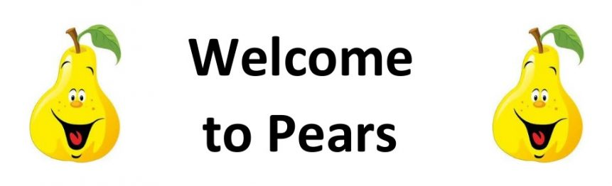

Pears Class – Summer 2025

**We are Artists**

The Pears Class Team

Pears Class are taught by Miss Ellis and supported by Mrs London, Miss Bayman, Miss Victors and Miss Bruno.

On Thursday when Miss Ellis is busy planning Mrs Butler teaches.

Reading

In Pears class, we enjoy a positive reading environment in which books are enjoyed and shared by all. Pupils are given daily opportunities to listen to stories and read independently with an adult. Every child takes part in Read Write Inc Guided Reading and Whole Class Guided Reading sessions. Please encourage your child to read at home daily with an adult. Having the opportunity to reread books helps the children develop their fluency and to read with a storyteller’s voice. All children have a Home Reading books and will be provided with reading books to enjoy at home each week. These books are closely matched the Phonics level each child is working at. Please return books on a Monday to be swapped. All children have a reading chart to encourage reading at home – please remember to issue a sticker each time they read at home and remember that there are prizes for every reading chart completed throughout the year. If your child has completed a chart, please post a photograph on Tapestry.

Phonics

In Pears Class we follow Read Write Inc to teach Phonics. In Year 1, the children will be recapping the sounds covered throughout the Read Write Inc Phonics programme before moving on to the Read Write Inc Spelling programme. In Year 2, the children we will be following the Read Write Inc Spelling programme.

For further information on how to support your child with Read Write Inc Phonics at home, please take a look at:

https://home.oxfordowl.c.uk/reading/reading-schemesoxford-levels/read-write-inc-phonics-guide/

In Pears Class, we enjoy playing games to practise our Phonics learning. We use Phonics Play (https://www.phonicsplay.co.uk/) and ICT Games (https://ictgames.com/mobilePage/literacy.html) which have lots of fun interactive games and activities that you can enjoy at home.

Writing

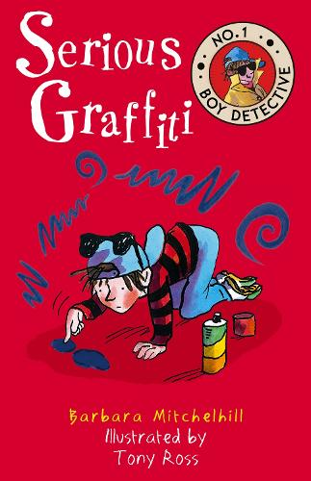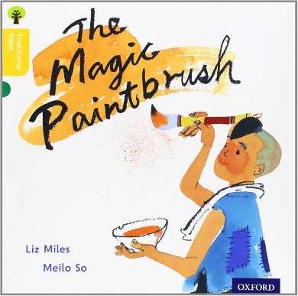Our Key Books:

**Narrative:** Class Texts: ‘The Magic Paintbrush’ by Liz Miles and ‘Serious Graffiti' by Barbara Mitchelhill**.**

* Description writing.

**Non-fiction:**

Recount Writing:

* Write first person recounts, re-telling, using adverbs of time to aid sequencing and maintaining consistency in tense and person.

Instruction Writing:

* Write a series of instructions ie ‘How to create graffiti art.’

**Poetry:**

* Slam Poetry/Rap - Write and perform own versions and focus on hidden messages/meanings and word selection

Maths

Our maths topics this term will be:

Year 1- Multiplication and division, fractions, place value, position and direction, money and time.

Year 2- fractions, time, statitics and position and direction.

PE: PE will be on a Monday and Thursday.

Session 1: Fitness

Session 2: Athletics

On these days, your child should come to school in their PE kit, which should include a waterproof coat.

RE: Understanding Christianity:

* Who is Jewish and how do Jewish people live?
* What do Christians believe God is like?

PSHE: Health and Wellbeing:

* How do I keep safe in different places?
* What can I do with money?

Computing:

**Programming and Controlling:** Use the beebot IPAD app to navigate onscreen around a course or grid, combining sequences of instructions.

**Using Data:** Supported creation of graphs and pictograms (e.g. in Maths)

We are artists

**Primary Provocation: ‘Graffiti is Vandalism’**

Children will have the opportunity this term to investigate the following provocation and will use a focus embedded through colour mixing, rap and lyrical knowledge to help us work out if graffiti can have positive connotations. This will allow children to understand whether graffiti should be legalised whist learning the key and fundamental skills needed to create flourishing pieces of artwork and music composition.

**Art:**

* use a range of materials creatively to design and make products
* use drawing, painting and sculpture to develop and share their ideas, experiences and imagination
* develop a wide range of art and design techniques in using colour, pattern, texture, line, shape, form and space about the work of a range of artists, craft makers and designers, describing the differences and similarities between different practices and disciplines, and making links to their own work.

**Music:**

* use their voices expressively and creatively by singing songs and speaking chants and rhymes
* play tuned and untuned instruments musically
* listen with concentration and understanding to a range of high-quality live and recorded music
* experiment with, create, select and combine sounds using the inter-related dimensions of music

**ENJOYING LEARNING TOGETHER AT HOME**

This term our home learning tasks will link to art and music. The following grid contains some suggestions of activities your child may like to complete at home to support them with the work we do in class. We would love to see any completed tasks and they will have an opportunity to share them in class.

You could help your child at home by …

|  |  |  |
| --- | --- | --- |
| **Listening carefully to a piece of contemporary music. How does the music make you feel? Can you create a contemporary dance piece.** | **Create an art piece on a large scale, e.g. outside, large paper or a big box etc.** | **Practice 2s,3s,5s and 10 timetables.** |
| **Learn a tune using a instrument.** | **Create transient art outside using natural resources.** | **Read daily at home. Write your own story based on this.** |
| **Write a fact file of a famous artist. E.g. Piet Mondrian, Kandinsky, Mark Mothko etc** | **Recreate a famous piece of artwork.** | **Useful websites:**  [**KS1 Art and Design - BBC Bitesize**](https://www.bbc.co.uk/bitesize/subjects/zmyvcxs)  [**KS1 Music - BBC Bitesize**](https://www.bbc.co.uk/bitesize/subjects/zsbxqfr) |
| **Write a musical review or an art review.** | **Photograph a person/place that inspires you and draw a landscape picture.** | **Make a collage using shapes and colours.** |