TEAMWORK TIGERS – Autumn 2025

In Teamwork Tigers, the children are taught by

Miss Lewis

**Welcome to Teamwork Tigers termly letter! You will find everything you need to know about the learning that is happening in our classroom this half term here.**

**Reading:** In Tigers we enjoy a positive reading environment in which books are enjoyed and shared by all. Pupils are given daily opportunities to read independently and some pupils will read with an adult. In Tigers class we will have a weekly 1-hour lesson using VIPERS (found at the bottom of this document) skills to explore a text. This term our guided reading texts will be:



Please encourage your child to read at home daily although at this age it does not have to be with an adult.

We encourage the sharing of books that have been enjoyed so when your child has finished reading a book, they can bring it into school to share/swap with another child. We also love to hear about any reading recommendations.

Reader of the Week: Each week, teachers nominate a child who has shown a real ‘love of reading’ to visit our very own North Rigton Book Shop to choose a book.

**Spellings:** Spellings will continue to be learned in school, where we can give more support to methods used, allowing the spellings to be more embedded. We use Read, Write Inc. to support this. You can also find the Year 5/6 common exception word list at the bottom of this document.

**Writing:**

Non-Fiction

* Non-choronological report on natural disatsters

Poetry

* Christmas poems
* Remembrance Day poems

Fiction

* WW2 Diary entries
* Persuasive writing piece for WW2 enlistment
* Writing pages to go along side the book ‘Flood’

For more detail, please see link to whole school English document.

**Maths:** Our central maths topics this term will be:

Number

* Place value
* Addition and subtraction
* Multiplication and division
* Fractions

For more detail, please see link to whole school maths document.

**Times Table Rockstars:** All children in Tigers have access to Times Table Rockstars. This platform is used to support fluency in times tables and can be accessed on a laptop or iPad. TTRS-Parent-Guide.pdf

**PE:** PE will be on a Tuesday and Thursday.

Autumn 1 –

Session 1: Football

Session 2: Dance

Autumn 2 –

Session 1: Tchoukball

Session 2: Gymnastics

On these days, your child should come to school in their PE kit.

**French**:

* Portraits
* Meet my French family

**RE:**

* What does it mean if God is holy and loving?
* Why do some people believe in God and some people not?

**PSHE:**

* What does discrimination mean?
* What are Human Rights?

**COMPUTING:**

* Using a computer to aid touch typing skills
* Creating and publishing through Word and Office
* E-safety – using the internet safely

**We are EXPLORERS**

***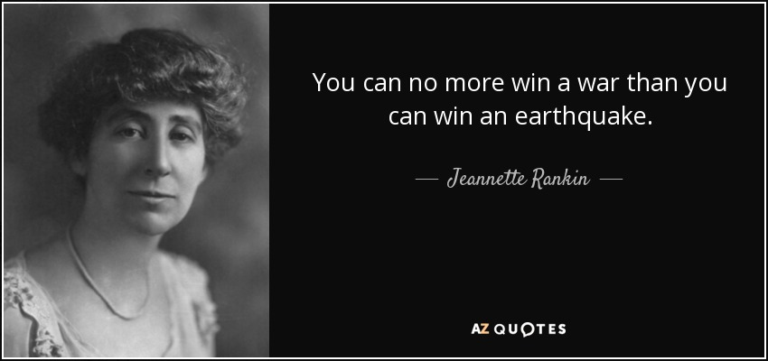*PRIMARY PROVOCATION:**

**Jeannette Rankin – American Politician and Women’s Rights Advocate.**

**OUR HISTORY OBJECTIVES:**

* What do you already know about WW2?
* What were the root causes for the outbreak of war?
* What was the great evacuation?
* What was rationing?
* What was the role of women during the war?
* What was the Holocaust?
* What were the key events of WW2?

**OUR GEOGRAPHY OBJECTIVES:**

* What is the world like beneath our feet?
* How are volcanoes formed and what is the impact of an eruption?
* What is the story of Pompeii and Herculaneum?
* How are earthquakes formed and what is the impact?
* What is a tsunami?
* How do tornadoes form?

**ENJOYING LEARNING TOGETHER AT HOME**

This term our home learning tasks will link to maths, history and geography. The following grid contains some suggestions of activities your child may like to complete at home to support them with the work we do in class. We would love to see any completed tasks and they will have an opportunity to share them in class.

You could help your child at home by …

|  |  |  |
| --- | --- | --- |
| **Practice and recap Year 5/6 common exception words from the word list below.** | **Helping them to write a biography on a significant individual from WW2.** | **Continue with Times Table Rockstars at home to aid mathematical fluency.** |
| **Supporting them to bake or cook a wartime recipe, weighing and measuring the ingredients accurately.** | **Researching old British currency and helping them to write some of their own wartime maths problems.** | **Read daily at home.**  **This could be with an adult or be independently using our VIPERS skills.** |
| **Supporting them to write a WW2 song which would have helped to boost morale.** | **Making a mini model volcano.** | **Helping them to write a message to you using morse code.**  **https://www.codebug.org**  **.uk/learn/step/540/morse-code-alphabet/** |

