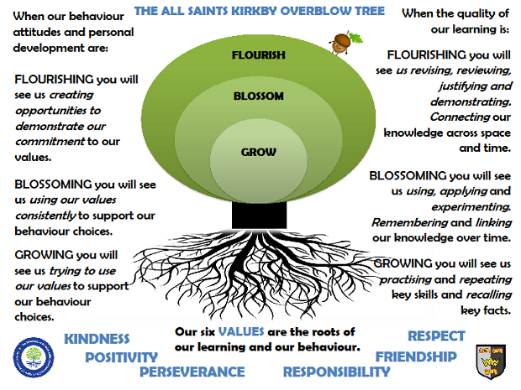Jupiter ClassAutumn Term 2025

**Reading**

In Jupiter class, we enjoy a positive reading environment in which books are enjoyed and shared by all. Pupils are given daily opportunities to listen to stories and read independently with an adult. Every child takes part in Read Write Inc Phonics and Whole Class Guided Reading sessions. Please encourage your child to read at home daily with an adult. Having the opportunity to reread books helps the children develop their fluency and to read with a storyteller’s voice. Some children will independently choose their reading book, whereas others will have a Home Reading Book pack and will be provided with two reading books to enjoy at home each week. These books are closely matched the Phonics level each child is working at. Reading books are swapped every Tuesday by Miss Lauren.

**Writing**

**Our Key Books:**

One Plastic Bag and Jack Slater: Monster Investigator

This term we will be exploring the above books. We explore a range of fiction and non-fiction writing opportunities including letter writing, non-chronological reports, and instructions.

**Maths**

Our maths topics this term will be:

Number & Place Value, Addition & Subtraction

Please use the TT Rockstars app/website to aid your child’s development of times tables. At the end of Year 4, there will be the Multiplication Check and Progress Assessment.

**Science**

**Animals including Humans**

* identify that animals, including humans, need the right types and amount of nutrition, and that they cannot make their own food; they get nutrition from what they eat
* identify that humans and some other animals have skeletons and muscles for support, protection and movement.
* describe the simple functions of the basic parts of the digestive system in humans
* identify the different types of teeth in humans and their simple functions
* construct and interpret a variety of food chains, identifying producers, predators and prey.

**PE**

In the Autumn Term, we will be doing Football, Hockey, Gymnastics and Tag Rugby.

Please come in PE kit on **Wednesdays** and **Thursdays**.

Plenty of sporting clubs and competitions will also be taking place – keep an eye out for emails!

**Art**

We will be exploring sculpture. This study will be enhanced by exploring the work of our artists for this term – ***Henry Moore and*** ***Barbara Hepworth***. The teaching of Art will be led by Miss Lauren.

**RE**

Spirituality

What does it mean to be a Hindu in Britain today?

Incarnation – What is the trinity?

**PSHE**

* Safe Relationships
* Respecting Self and Others

**DT**

Levers and Linkages

**Computing**

* E-safety and Technology in Our Lives
* Handling Data

**Topic**

Our provocation this term is:

Plastic Pollution

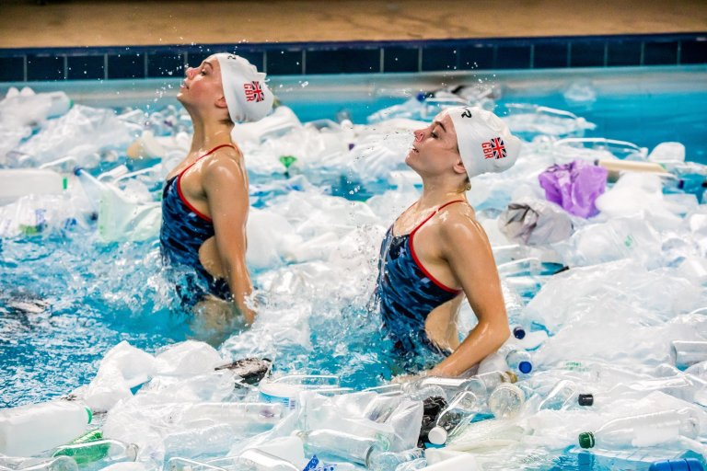

(School Branch – Protecting Our Planet)

We will be exploring the book ‘One Plastic Bag’ during our learning.

**The children will be exploring the following areas:**

* Understand the different journeys a piece of plastic may go on once finished with by the consumer
* What consequences may happen if plastic pollution is allowed to happen
* How humans can make a difference in the fight against unnecessary plastic use

The following grid contains some suggestions of activities your child may like to complete at home to support them with the work we do in class. I would love to see any completed tasks and they will have an opportunity to share them in class.

|  |  |  |
| --- | --- | --- |
| Can you recycle plastic to make something interesting? | Design a product that uses sustainable resources. | Write a persuasive letter to the manager at a supermarket. |
| Prepare school lunches or snacks that have less plastic packaging. | Create your own map of the world. Can you identify the seas and oceans? | Make a poster that shows people the impact of their plastic pollution. |
| Go on a rubbish hunt! Collect any litter and put it into the correct place. | Interview three adults and find out how they try and use less plastics**.** | Create a campaign for school! How can you make an impact at All Saints? |