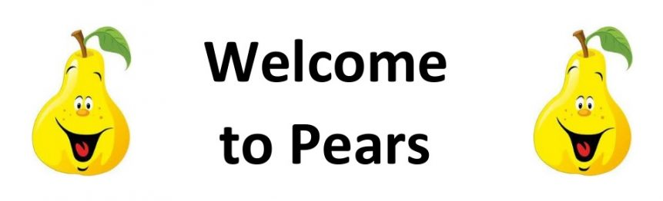

Pears Class – Autumn 2025

**We are Scientists**

The Pears Class Team

Pears Class are taught by Miss Ellis and supported by Mrs London and Miss Vickers.

On Thursday morning when Miss Ellis is busy planning Mrs Holder teaches.

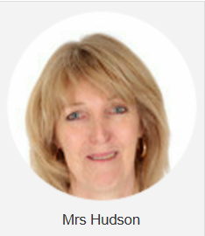

Reading

In Pears class, we enjoy a positive reading environment in which books are enjoyed and shared by all. Pupils are given daily opportunities to listen to stories and read independently with an adult. Every child takes part in Read Write Inc Guided Reading sessions. Please encourage your child to read at home daily with an adult. Having the opportunity to reread books helps the children develop their fluency and to read with a storyteller’s voice. All children have a Home Reading books and will be provided with reading books to enjoy at home each week. These books are closely matched the Phonics level each child is working at. Please return books on a Monday to be swapped. All children have a reading chart to encourage reading at home – please remember to issue a sticker each time they read at home and remember that there are prizes for every reading chart completed throughout the year. If your child has completed a chart, please post a photograph on Tapestry.

Phonics

In Pears Class we follow Read Write Inc to teach Phonics. In Year 1, the children will be recapping the sounds covered throughout the Read Write Inc Phonics programme before moving on to the Read Write Inc Spelling programme. In Year 2, the children we will be following the Read Write Inc Spelling programme.

For further information on how to support your child with Read Write Inc Phonics at home, please take a look at:

https://home.oxfordowl.c.uk/reading/reading-schemesoxford-levels/read-write-inc-phonics-guide/

In Pears Class, we enjoy playing games to practise our Phonics learning. We use Phonics Play (https://www.phonicsplay.co.uk/) and ICT Games (https://ictgames.com/mobilePage/literacy.html) which have lots of fun interactive games and activities that you can enjoy at home.

Writing

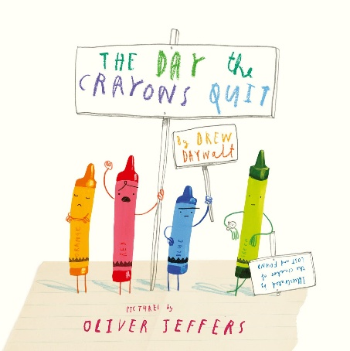Our Key Books:

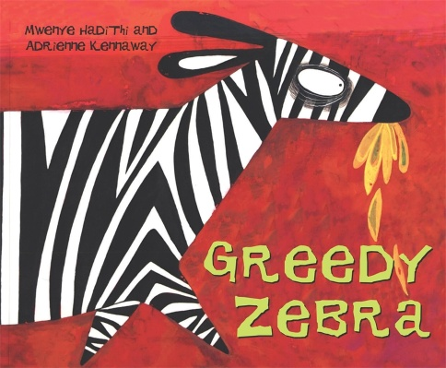

**Narrative:** Class Texts: ‘The day the crayons quit’ by Drew Daywalt and ‘Greedy Zebra’ by Mwenye Hadithi and Adrienne Kennaway.

* Planning a story (story mountain)
* Retelling of a story from the viewpoint of a made-up character (Indigo)
* Writing a letter/postcard

**Non-fiction:**

• Non-chronological report of an animal (linked to project)

• Assemble information on a subject (animal), sorting and categorising information, use comparative language to describe and differentiate)

**Poetry:**

* Harvest acrostic poems
* Christmas poetry, rhyming couplets.

Maths

Our maths topics this term will be:

Place value, addition and subtraction, place value and shape.

PE: PE will be on a Tuesday and Wednesday. On these days, your child should come to school in their PE kit, which should include a waterproof coat.

Autumn 1

Session 1: Dance

Session 2: Ball skills (football focus)

Autumn 2

Session 1: Multi skills (coordination focus)

Session 2: Yoga

RE: Understanding Christianity:

* How should we care for the world and why does it matter?
* Why does Christmas matter?

PSHE: Health and Wellbeing:

* How can our values help us make the right choices?
* What is bullying?

Computing:

Technology around us and creating medial- digital photography.

We are Scientists

**Primary Provocation: HUMANS ARE THE GREATEST CREATURES.**

In this topic, children will have the freedom to explore the similarities and differences between humans and animals, including learning about adaptation, inheritance and the concept of ‘survival of the fittest’. We will learn about the senses, including investigating whether the senses are more prominent in humans or animals, and look at habitats too. We will explore the idea of ‘what keeps us healthy?’ including making links to the 30:30 initiative. With this, children will be able to form their own questions and areas of enquiry, provoking independent learning attitudes. This will allow pupils to explore the provocation ‘Humans are the greatest creatures’ and draw their own conclusions based on what they have learned.

Key science objectives taught:

•explore and compare the differences between things that are living, dead, and things that have never been alive

•identify that most living things live in habitats to which they are suited and describe how different habitats provide for the basic needs of different kinds of animals and plants, and how they depend on each other

•describe how animals obtain their food from plants and other animals, using the idea of a simple food chain, and identify and name different sources of food.

•identify and name a variety of common animals including fish, amphibians, reptiles, birds and mammals

•identify and name a variety of common animals that are carnivores, herbivores and omnivores

•describe and compare the structure of a variety of common animals (fish, amphibians, reptiles, birds and mammals, including pets)

•identify, name, draw and label the basic parts of the human body and say which part of the body is associated with each sense.

•notice that animals, including humans, have offspring which grow into adults

•find out about and describe the basic needs of animals, including humans, for survival (water, food and air)

• describe the importance for humans of exercise, eating the right amounts of different types of food, and hygiene.

DT key objectives taught:

* I can follow verbal instructions
* I can say what I am making and identify features of the design which make it fit for purpose.
* I can select appropriate materials and tools and explain why.
* I can use a range of techniques safely, and adapt techniques as ideas are developed.
* I can say what I like/do not like about the finished product, talk about changes made to the design and how closely it matches the design.

**ENJOYING LEARNING TOGETHER AT HOME**

This term our home learning tasks will link to science and DT. The following grid contains some suggestions of activities your child may like to complete at home to support them with the work we do in class. We would love to see any completed tasks and they will have an opportunity to share them in class.

You could help your child at home by …

|  |  |  |
| --- | --- | --- |
| You could help your child at home by visiting the library and allowing them to research more about the human body or animals as this is what we are looking at as part of our project this term. | You could help your child at home by investigating all of our senses, for example, making and preparing a meal where you would touch, taste, smell and see. | You could help your child at home by practicing counting and reciting the 2s, 3s, 5s and 10s timetables. Can the children write these down? |
| You could help your child at home by looking at different animal habitats when out and about. | You could help your child at home by playing ‘I Spy’. Can you spot any interesting creatures? | Please try to read as often as you can at home with your family and complete your reward chart.  Books are changed weekly in school – please bring them in on a Monday if you wish to get new ones. |
| You could help your child at home by encouraging them to count forwards and backwards in lots of exciting ways! Think about creating an unusual number line. | You could help your child at home by using the RWI Sound Book for the sounds/spelling rules we are covering this term. These will always be dated for your information so you know when we have covered each one. In Year 2, speed spell words will be noted so you can see the sorts of words we are learning in school. | There are some fantastic free interactive websites for English and Maths which can be used on the iPad or computer. You may wish to enjoy using them together:  Topmarks  <https://www.topmarks.co.uk>  ICT Games  <https://www.ictgames.com>  BBC Numberblocks  <https://www.bbc.co.uk/cbeebies>  /shows/numberblocks |