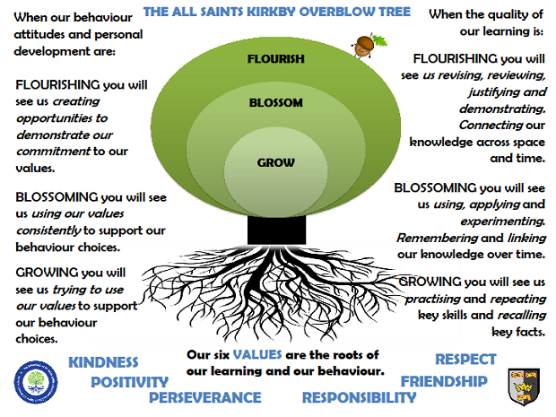Saturn ClassAutumn Term 2025

**Reading**

In Saturn class, we enjoy a positive reading environment in which books are enjoyed and shared by all. Pupils are given daily opportunities to listen to stories and read independently with an adult. Every child takes part in Read Write Inc Guided Reading and Whole Class Guided Reading sessions. Please encourage your child to read at home daily with an adult. Having the opportunity to reread books helps the children develop their fluency and to read with a storyteller’s voice. All children have a Home Reading Book pack and will be provided with two reading books to enjoy at home each week. These books are closely matched the Phonics level each child is working at. Please ensure reading books are returned every **Monday** ready to be swapped. You can access further reading eBooks at home through the Oxford Owl eBook Library (<https://www.oxfordowl.co.uk/for-home/find-a-book/library-page/>).

**Phonics**

In Saturn Class we follow Read Write Inc to teach Phonics. In Year 1, the children will be recapping Set 1 and introduced to Set 2. In Year 2, the children we will be recapping Set 2 and Set 3. For further information on how to support your child with Read Write Inc Phonics at home, please take a look at: <https://home.oxfordowl.co.uk/reading/reading-schemes-oxford-levels/read-write-inc-phonics-guide/>

In Saturn Class, we enjoy playing games to practise our Phonics learning. We have access to Phonics Play (<https://www.phonicsplay.co.uk/>) which has lots of fun interactive games and activities that you can enjoy at home.

**Writing**

**Our Key Books:**

Jack and the Jellybean Stalk and On Sudden Hill

This term we will be exploring the above books. We explore a range of fiction and non-fiction writing opportunities including traditional and twisted tales, descriptive writing and persuasive texts.

**Maths**

Our maths topics this term will be:

Number & Place Value, Addition & Subtraction and Shape

**Science**

**Animals**

* identify and name a variety of common animals that are birds, fish, amphibians, reptiles and mammals
* identify and name a variety of common animals that are carnivores, herbivores and omnivores.
* describe and compare the structure of a variety of common animals (birds, fish, amphibians, reptiles and mammals, and including pets)
* notice that animals have offspring which grow
* find out about and describe the basic needs of animals for survival (water, food and air)

**PE**

In the Autumn Term, we will be doing Multi-skills, Rugby (Throwing and Catching and Invasion Games) and Gymnastics.

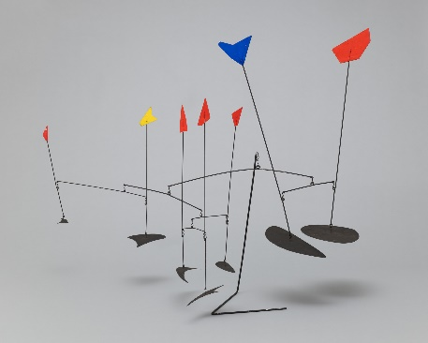Please come in PE kit on **Thursdays** and **Fridays**.

**Art**

We will be exploring sculpture. This study will be enhanced by exploring the work of our artists for this term:

***Alex Calder and*** ***Marialuisa Tadei***.

**RE**

* Who is a Muslim and what do they believe?
* Incarnation – Why does Christmas matter?

**PSHE**

* Safe Relationships
* Respecting Self and Others

**DT**

Structures – Freestanding Structures

**Computing**

* E-safety and Technology in Our Lives
* Handling Data

**Topic**

Our provocation this term is:

Looking After Our Local Area

(School Branch – Protecting Our Planet)

We will be exploring the following books to support our learning:

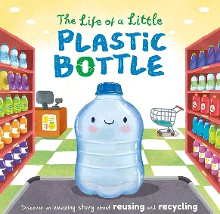 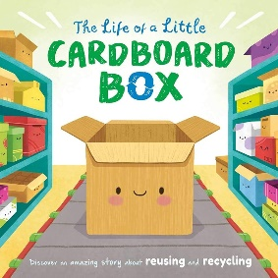

**The children will be exploring the following areas:**

* Understand the location of our local area and the features within it.
* Describe and understand the impact humans have had on our local area – Kirkby Overblow and Harrogate
* Describe and understand the difference we can make as humans to our local area.

The following grid contains some suggestions of activities your child may like to complete at home to support them with the work we do in class. I would love to see any completed tasks and they will have an opportunity to share them in class.

|  |  |  |
| --- | --- | --- |
| Can you use a map to find where you live? | Can you describe places within your local area? | Can you find out three facts about your local area? |
| Can you draw a picture to show how you can protect the planet at home and at school? | Can you create a musical instrument using recycled materials? | Make a collage of photographs of your favourite places. How do you look after them? |
| Do a traffic survey. How many different types of vehicles can you see that go pass your house? | Interview three adults and find out what things they do to care for the environment**.** | Design a poster to tell people why it's important to protect our planet. |

**Useful websites to support learning:**

BBC Bitesize:

<https://www.bbc.co.uk/bitesize/articles/z3hcr2p>

BBC Teach:

<https://www.bbc.co.uk/teach/school-radio/assemblies-ks1-ks2-recycle-week-plastic-pollution-recycling/zqscvwx>

BBC Bitesize:

<https://www.bbc.co.uk/bitesize/topics/zrssgk7/articles/z9w26sg>

DK Find Out!:

<https://www.dkfindout.com/uk/explore/learn-all-about-our-world-for-earth-day/>