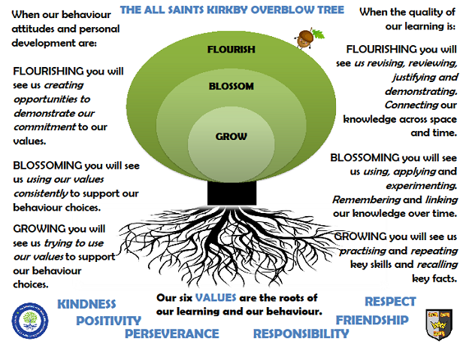
JUPITER CLASSSPRING TERM 2024
Rock Star Maths: In Jupiter Class, pupils take part in a daily Rock Star Maths challenge. They use the iPads to answer multiplication questions in a format that replicates the end of Year 4 multiplication check. Classic rock songs help them keep the pace! The aim is to answer questions correctly to earn coins and improve their avatars.
Reading: In Jupiter class, we enjoy a positive reading environment in which books are enjoyed and shared by all. Pupils are given daily opportunities to read independently and some pupils will read with an adult. If your child receives a school reading book, this will be changed on a Tuesday.
Every child will have two 45-minute sessions of guided reading a week. Our guided reading text this term will be:
The Creakers by Tom Fletcher | There’s a Viking in My Bed by Jeremy Strong
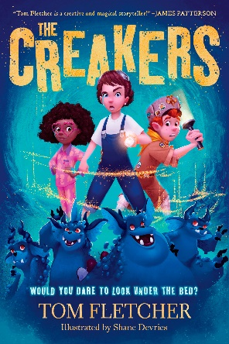 | 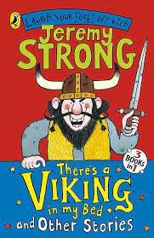

Please encourage your child to read at home daily. Having a love of reading and the ability to read for extended periods of time is the perfect preparation for progression throughout the school.
We encourage the sharing of books that have been enjoyed so when your child has finished reading a book they can bring it in to school to share/swap with another child.
Spellings: Spellings will continue to be learned in school, where I can give more support to methods used, allowing the spellings to be more embedded. You will be informed each week which spelling pattern we are focusing on so you can support your child at home.
Writing:
Poetry – Monologue from the viewpoint of a Viking.
Non-Chronological Reports – about the Vikings.
Myths, legends and fables – based upon the short film ‘The Saga of Biorn’.
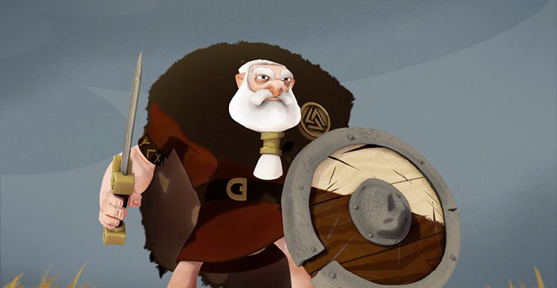

Maths: Our maths topics this term will be:
Multiplication
Division
Shape
PE: In spring term, PE will be on a Thursday and a Friday. The Friday session will be swimming in the morning at The Hydro.
Session 1: Netball
Session 2: Swimming
ART: We will be exploring the work of Norwegian Expressionist Edvard Munch.
SCIENCE: Materials
- compare and group materials together, according to whether they are solids, liquids or gases
- observe that some materials change state when they are heated or cooled, and measure or research the temperature at which this happens in degrees Celsius (°C)
- identify the part played by evaporation and condensation in the water cycle and associate the rate of evaporation with temperature.
RE
Our school bible story: The Sower
How do parables link to our values?
Salvation – Why do Christians call the day Jesus died ‘Good Friday’?
Salvation – Why do Christians remember the events of holy week?
What is the deeper meaning of festivals?
PSHE
Living in the Wider World - Money
Aspirations, work and career

Topic: The question we will be exploring this term is:
Who were the Vikings?
The children will be exploring the following areas:
Invasion
Way of Life
Travel
Britain during this period
The following grid contains some suggestions of activities your child may like to complete at home to support them with the work we do in class. I would love to see any completed tasks and they will have an opportunity to share them in class.
Research the Vikings and create a poster that contains at least 6 key facts about the Anglo-Saxon to Viking period in Britain. Think about any pictures that could be included. | Create a timeline of key events that happened between the start of the Anglo-Saxon era and the end of the Vikings. | Create a map of Britain showing the Anglo-Saxon kingdoms and how they changed when the Vikings invaded.
Select a famous figure from the Anglo-Saxon or Viking era. Draw or paint or collage a picture of them. It could be a king, soldier, God or someone else. | Build an Anglo-Saxon or Viking home. Think about the features of the home and write how it is different to our homes now. | Research what the Vikings thought about death. Where do they believe they go when they die? What rituals did they practice?
Identify locations of Viking settlements on a map. | Write a fact file about Viking travel or lifestyle. | Create an interesting collage of a Viking scene; stormy sea, long boat, a raid!
Design a Viking board game. How many players can play? What is the purpose of the game and how do you win? | Design a Viking meal. It could be fun to have a go at making a recipe or two!! Take pictures of you making it or bring some into school for us to taste. | Draw or print out a picture of yourself and a Viking child. Write about the similarities and differences between you both. Include information about their day, school, family, toys, pets, work.

Useful websites to support learning about Vikings:
BBC Bitesize: https://www.bbc.co.uk/bitesize/topics/ztyr9j6
School Learning Zone: https://school-learningzone.co.uk/key_stage_two/ks2_history/british_history_/the_vikings/the_vikings.html
DK Find Out: https://www.dkfindout.com/uk/history/vikings/

Places you might like to visit:
Royal Armouries
Jorvik Viking Museum

