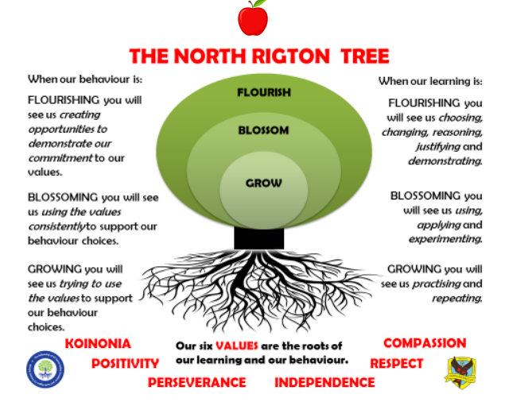

APPLES CLASS SPRING TERM 2026
Reading: In Apples class, we enjoy a positive reading environment in which books are enjoyed and shared together. Pupils are given daily opportunities to listen to stories and join in with songs and nursery rhymes. Children will take books home once a week, they will be carefully matched to their phonic ability. At the start of the year the books will be pictures only to encourage your child’s story telling abilities. Children will move on to worded books once we have introduced sounds and the individual child is ready.
We encourage you to read with your child every day, this could be them reading their schools books to an adult, or an adult reading a story book to the child. Having a love of reading is a crucial building block to support them in their phonics as they progress through school. We encourage sharing of books so when your child has particularly enjoyed a book, they can bring it in to school to share with the class.
Reading books are swapped every Friday, please return them to school on Thursday so that we have time to swap them. You can access further reading eBooks at home through the Oxford Owl eBook Library https://www.oxfordowl.co.uk/for-home/find-a-book/library-page/ Please ask Miss Burrow if you would like the Class Login.
Phonics: At North Rigton, we follow Read Write Inc to teach Phonics. In Reception, children will be introduced to the set 1 sounds in the autumn term and practise Fred talk. ‘Fred talk’ is sound blending – a crucial first step in both reading and writing, you can find out more information here: Parent video: Sound blending - YouTube
We will also be looking at the red words: I, the, of, my, to, no, into, your, said, you, he, she, are, me, go, all, like
In the spring term, children are introduced to the set 2 sounds.
You can practise the sounds at home using the green /yellow books provided to you by school. We encourage you to practise each day for a few minutes. We also encourage you to practise Fred talk each day. For further information on how to support your child with Read Write Inc Phonics at home, please take a look at: Parent guide to Read Write Inc. Phonics - Oxford Owl

Maths: In Apples Class, we will be recapping numbers 1– 5 and looking at numbers 6 – 10 this term. We will be learning the numerals, quantities and to subitise (recognise without counting) for these numbers. It is important that the children can recognise that numbers do not always look the same. For example, 3 can be represented in all the ways shown below (and many more).
 | 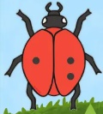 | 3 | 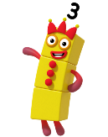 |  | 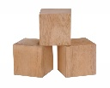 | 2 + 1 |  |  | 

We will also be looking at 2D & 3D shapes, one more and one less, comparing size, mass and capacity, ordering and sequencing time and exploring and continuing simple patterns.
PE: In Spring term, PE will be on a Monday and a Friday. This term we are focussing on dance and ball skills. Please come in PE kit on Mondays and Fridays.
Understanding The World (science):
We will be looking at growth and lifecycles in animals and plants. We will also be making observations on the seasonal changes that come in Spring.
Art:
We will be looking at the artist Andy Goldsworthy this term.

Topic: Pesky Pirates
The children will be exploring the following areas:
Read the following stories:
- The pirates next door
- Pirate girl
- Mrs Pirate
- Captain Pike looks after the baby
- My pirate papa

We will discuss what we already know about pirates and what we would like to know
We will look at different aspects of pirate life
We will learn about Grace O’Malley

The following grid contains some suggestions of activities your child may like to complete at home to support them with the work we do in class. We would love to see any completed tasks and they will have an opportunity to share them in class.

Make a pirate ship  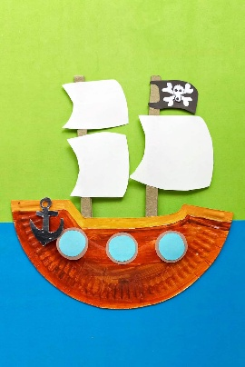 | Make a treasure map  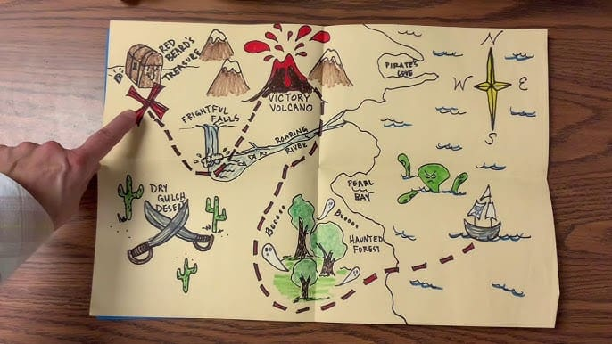 | Design a pirate  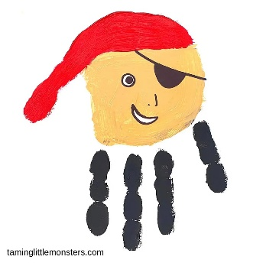
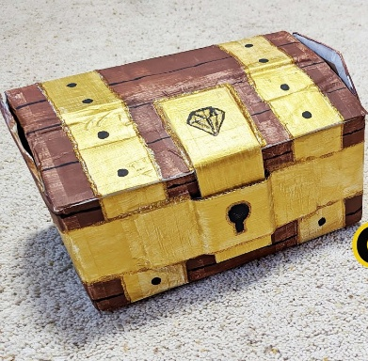  Make and decorate a treasure chest / box | 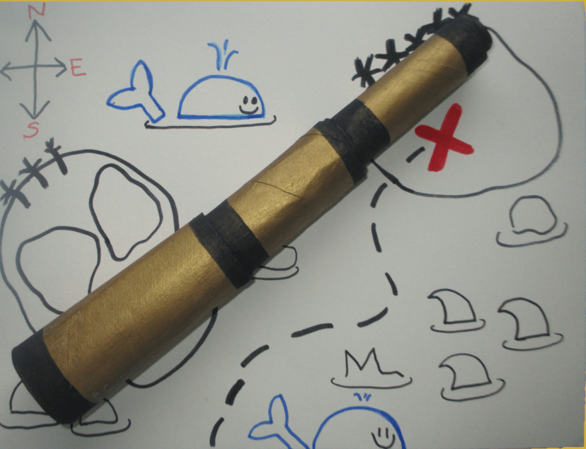  Make a telescope | Do some pirate baking  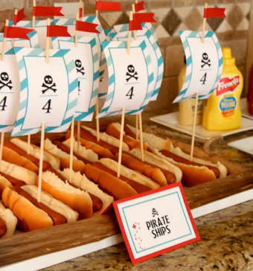  Fun Pirate Themed Recipes for Kids

Useful websites for Phonics and Maths
Home Time Ladybirds game (subitising numbers to 9)
https://www.ictgames.com/mobilePage/homeTimeLadybirds/

Teddy Numbers Game
https://www.topmarks.co.uk/learning-to-count/teddy-numbers

Adding to 10
https://www.topmarks.co.uk/addition/addition-to-10

Subtraction within 10
https://www.topmarks.co.uk/subtraction/subtraction-to-10

Underwater Counting game
https://www.topmarks.co.uk/learning-to-count/underwater-counting

Maths games for 3-5 year olds
https://www.topmarks.co.uk/maths-games/5-7-years/counting

Oxford Owl free Ebooks
https://www.oxfordowl.co.uk/for-home/find-a-book/library-page/

Read Write Inc free Ebooks
https://www.oxfordowl.co.uk/home/reading-site/find-a-book/library-page?view=image&query=&type=book&age_group=&level=&level_select=&book_type=&series=Read+Write+Inc.#

Speed sounds practice sheets
https://home.oxfordowl.co.uk/reading/reading-schemes-oxford-levels/read-write-inc-phonics-guide/
Please scroll down the page – look for Set 1 / Set 2 (downloadable as PDF)

Phonics play
https://www.phonicsplay.co.uk/
please ask the Class teacher for the username and password

