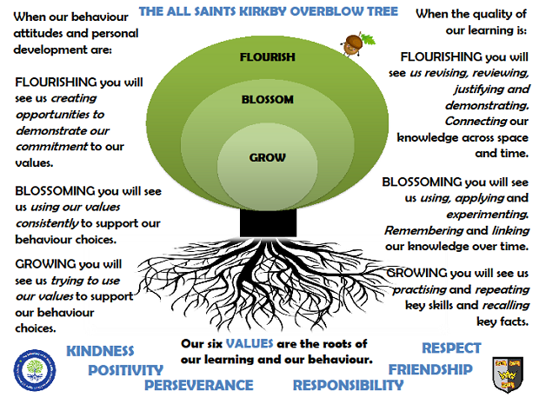Saturn ClassSpring Term 2026
Reading
In Saturn class, we enjoy a positive reading environment in which books are enjoyed and shared by all. Pupils are given daily opportunities to listen to stories and read independently with an adult. Every child takes part in Read Write Inc Guided Reading and Whole Class Guided Reading sessions. Please encourage your child to read at home daily with an adult. Having the opportunity to reread books helps the children develop their fluency and to read with a storyteller’s voice. All children have a Home Reading Book pack and will be provided with two reading books to enjoy at home each week. These books are closely matched the Phonics level each child is working at. Please ensure reading books are returned every Monday ready to be swapped. You can access further reading eBooks at home through the Oxford Owl eBook Library (https://www.oxfordowl.co.uk/for-home/find-a-book/library-page/).
Phonics
In Saturn Class we follow Read Write Inc to teach Phonics. In Year 1, the children will be introduced to Set 3. In Year 2, the children we will be moving on to the Year 2 spelling programme. For further information on how to support your child with Read Write Inc Phonics at home, please take a look at: https://home.oxfordowl.co.uk/reading/reading-schemes-oxford-levels/read-write-inc-phonics-guide/
In Saturn Class, we enjoy playing games to practise our Phonics learning. We have access to Phonics Play (https://www.phonicsplay.co.uk/) which has lots of fun interactive games and activities that you can enjoy at home.

Writing
Our Key Books:
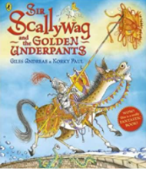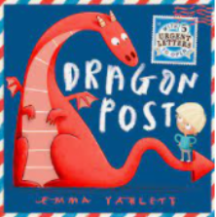
Sir Scallywag and the Golden Underpants and Dragon Post

This term we will be exploring the above books. We will be writing our own adventures of Sir Scallywag, writing letters and creating our own poems on the theme of castles and dragons.

Maths
Our maths topics this term will be:
Year 1 – Place value within 50, addition and subtraction and length, height, volume and mass
Year 2 – Money, multiplication and division, length, height, mass, capacity and temperature
Science
Everyday Materials and their uses
- distinguish between an object and the material from which it is made
- identify and name a variety of everyday materials, including wood, plastic, glass, metal, water, and rock
- describe the simple physical properties of a variety of everyday materials
- compare and group together a variety of everyday materials on the basis of their simple physical properties.
- identify and compare the suitability of a variety of everyday materials, including wood, metal, plastic, glass, brick, rock, paper and cardboard for particular uses
- find out how the shapes of solid objects made from some materials can be changed by squashing, bending, twisting and stretching.
PE
In the Spring Term, we will be doing Dance, Football and Gymnastics.
Please come in PE kit on Wednesdays and Thursdays.

Art
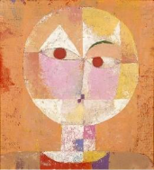
We will be exploring portraits and using a range of media to create their own. This study will be enhanced by exploring the work of our artist for this term – Paul Klee.
RE
- How should we care for the world and others and why does it matter?
- Salvation – why does Easter matter?

Music
Classical Music (dynamics and tempo) – Animals
Pulse and rhythm - All about me

PSHE
Money and Aspirations, Work and Careers.

Computing
To communicate – Multimedia
Topic
Our provocation this term is:
Who would live in a house like this?
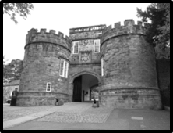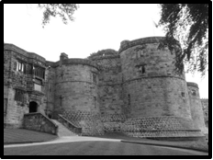

The children will be exploring the following areas:
- William the Conqueror
- Journey of William from France to England
- Bayeux Tapestry
- The Battle of Hastings, 1066
- Castles through time – sequence on timeline
- Geographical location of castles
- Parts of castles and their function
- Castle floor plans
- Castle life – banquets, jousting
- Castle defence and attack

The following grid contains some suggestions of activities your child may like to complete at home to support them with the work we do in class. I would love to see any completed tasks and they will have an opportunity to share them in class.
Design your ideal castle. Present your idea through drawings, sculpture or writing. | Visit your local library and find as many books about dragons/castles/knights/princesses. Make a list of all the fiction and non- fiction books. Read some of them too! | Design and make a shield.  Create your own coats of arms to go on your shield. Think about your name, hobbies, where you live etc.
Write a story of a Dragon’s Adventure. You may wish to make up your own story or re-tell a story you have read. | Visit a castle.  There are many castles to explore in our local area!  (We will be visiting Skipton Castle during the term). | Read a story that has a dragon, castle or knights in it. Draw a story map to show the different events in the story.
Design a costume for a King or Queen to wear to a ball. | Make a bridge to go over the moat. Use material strong enough to support 1kg weight. | Draw and label a map indicating famous castles in the UK.
Could you be a court jester? You need to perform tricks to entertain the king and his court. Entertain us with your tricks on Tapestry or in the classroom. | Research the different Castle building materials used i.e. wood, stone.  List the advantages and disadvantages for each material. | Using a well-known castle (fact or fiction) create a fairy tale. You could use existing characters or make up your own.

Useful websites to support learning about Castles:
BBC Bitesize:
https://www.bbc.co.uk/bitesize/articles/z6bpm39

English Heritage:
https://www.english-heritage.org.uk/members-area/kids/kids-castles/

DK Find Out!:
https://www.dkfindout.com/uk/history/castles/

BBC Castles and Knights:
https://www.bbc.co.uk/teach/class-clips-video/history-ks1-castles-and-knight-home/z2w4bqt

