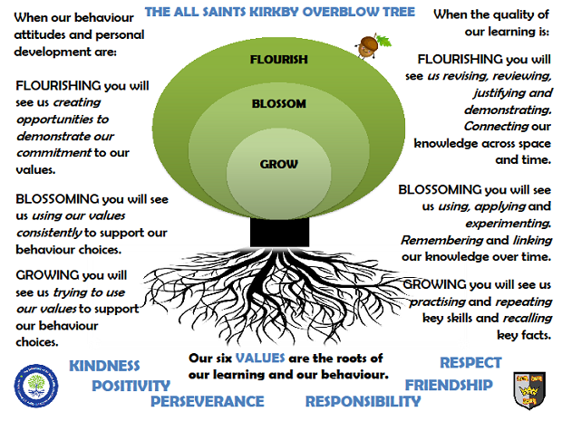
SUN CLASSSPRING TERM 2026
Reading: In Sun class, we enjoy a positive reading environment in which books are enjoyed and shared by all. Pupils are given daily opportunities to read independently, and some pupils will read with an adult. Every child will have two 45-minute sessions of guided reading a week. Our guided reading text this term will be:
The Silver Sword by Ian Serrallier
Please encourage your child to read at home daily although at this age it does not have to be with an adult. Having a love of reading and the ability to read for extended periods of time is the perfect preparation for the ‘reading SATs’.
We encourage the sharing of books that have been enjoyed so when your child has finished reading a book, they can bring it in to school to share/swap with another child.
Spellings: Spellings will continue to be learned in school, where we can give more support to methods used, allowing the spellings to be more embedded.
Writing:
Narrative, Diary writing, Letter writing, Script writing using a range of stimulus linked to our topic on World War Two.
1940s House: Non-chronological reports
The Blitz: Explanation text
War Poetry
Evacuation: Discussion text
Maths: Our maths topics this term will be:
Fractions
Decimals
Area and Perimeter
Percentages
PE: In spring term, PE will be on a Monday and a Friday. These sessions are taught by Mr R.
Session 1: Tchoukball
Session 2: Netball
ART: We will be exploring portraits and using a range of media to create their own. This study will be enhanced by exploring the work of our featured artists: Pablo Picasso (Cubism) and Fra Angelica and Tommaso Masaccio (Religious Icons).
SCIENCE: Materials
Properties of solids, liquids and gases
Comparing the properties of different materials
Exploring which materials will dissolve in water
Investigate which materials will freeze
Reversible and irreversible changes in matter
Separating materials
Magnetism

RE
Judaism
What does it mean for a Jewish person to follow God?

PSHE
Relationships

MUSIC
Songs of World War 2

Topic: The question we will be exploring this term is:
What was it like to live in Britain during World War Two?
The children will be exploring the following areas:
Evacuation
The Blitz
Rationing
Homes during World War 2 including air raid shelters and ‘the blackout’
The Home Front
The following grid contains some suggestions of activities your child may like to complete at home to support them with the work we do in class. I would love to see any completed tasks and they will have an opportunity to share them in class.
Research rationing and write a menu using only these ingredients. | Find out the cost of rationed items and work out how much you would spend on a week’s food for your family. | Make a ‘war time’ recipe.  Take photos or bring in for us to try!
Design a poster persuading people to join the army. | Make a model of ‘a blackout’ house during WW2 | Make a game that children could have played when in the air raid shelters. Write instructions for how to play the game.
Create a timeline of events that occurred in World War 2. | Label a map of the country showing the areas that were bombed. | Find out about the Enigma machine – what did it do and where was it based?
Design and make a parachute for a toy. | Make a model of an air raid shelter. | Research WW2 propaganda posters. Make your own poster in the same style.
Make a fact file or a power point presentation about World War 2. | Make a Top Trumps style game about WW2 airplanes or tanks. | Make a model of a WW2 airplane.

Useful websites to support learning about World War Two:
https://www.bbc.co.uk/teach/class-clips-video/history-ks2-world-war-two/zjnyscw.
https://www.iwm.org.uk/history/how-childrens-lives-changed-during-the-second-world-war.
https://www.keystagehistory.co.uk/primary-ww2/.
Places you might like to visit
Imperial War Museum North/London
Eden Camp
Imperial war Museum Duxford
Yorkshire Air Museum
The National Museum of Computing Bletchley Park

