

Teamwork Tigers – Spring 2026
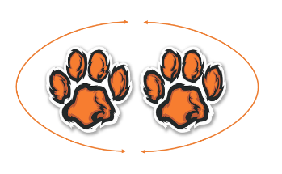
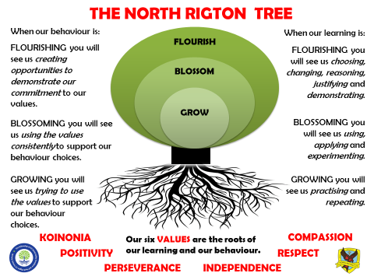
In Teamwork Tigers, the children are taught by
Miss Lewis and Mrs Gardiner



Welcome to Teamwork Tigers termly letter! You will find everything you need to know about the learning that is happening in our classroom this term here.

Reading: In Tigers we enjoy a positive reading environment in which books are enjoyed and shared by all. Pupils are given daily opportunities to read independently and some pupils will read with an adult. In Tigers class we will have a weekly 1-hour lesson using VIPERS (found at the bottom of this document) skills to explore a text which is linked to our project. This term our guided reading text will be:

Please encourage your child to read at home, although at this age it does not have to be with an adult.
We encourage the sharing of books that have been enjoyed so when your child has finished reading a book, they can bring it into school to share/swap with another child. We also love to hear about any reading recommendations.
Reader of the Week: Each week, teachers nominate a child who has shown a real ‘love of reading’ to visit our very own North Rigton Book Shop to choose a book.

Spellings: Spellings will continue to be learned in school using Read Write Inc, where we can give more support to methods used, allowing the spellings to be more embedded. I have sent a tapestry with our classes login to access the Read Write Inc portal at home for extra practice. You can also find the Year 5/6 common exception word list at the bottom of this document.
Writing:
Non-Fiction
- Instructional writing for how to use a piece of space equipment.
- Biography about Neil Armstrong or Tim Peake.
Poetry
- Space poems
Fiction
- Write a play script.
- Rewrite a chapter from our guided reading book – Cosmic.

For more detail, please see link to whole school English document.

Maths: Our central maths topics this term will be:
Number
- Fractions
- Decimals
- Fractions, decimals and percentages
Measurement
- Area
- Perimeter
- Volume
For more detail, please see link to whole school maths document.

Times Table Rockstars: All children in Tigers have access to Times Table Rockstars. This platform is used to support fluency in times tables and can be accessed on a laptop or iPad. TTRS-Parent-Guide.pdf

PE: PE will be on a Tuesday and Thursday.
Spring 1
Session 1: Tag rubgy
Session 2: Netball

Spring 2
Session 1: Orienteering
Session 2: Alternative sport (ultimate frisbee, archery or hall ball)

On these days, your child should come to school in their PE kit.

French:

- Clothes
- French weather

RE:
- What does it mean for a Jewish person to follow God?
- What difference does the Resurrection make for Christians?

PSHE:
- What makes a happy and healthy relationship?

COMPUTING:
- Computing systems and networks – systems and searching
- E safety – online reputation and online bulling.

We are Scientists

PRIMARY PROVOCATION:

GRAVITY IS NO MATCH AGAINST ONE WHO IS DETERMINED TO REACH THE STARS.

Matshone Dhliwayo – Canadian author and philosopher

OUR SCIENCE OBJECTIVES (FORCES):

LO – To identify different types of forces
LO – To explore how gravity was discovered (Issac Newton)
LO – To explain how gravity works on solid objects
LO – What is air resistance?
LO – To explore the effects of water resistance
LO – What is friction?
LO – To investigate different mechanisms which could help to allow a smaller force to have a greater effect.

OUR SCIENCE OBJECTIVES (SPACE):
LO – What is our prior knowledge of Earth and Space?
LO – To know about spherical bodies
LO – To know the names of the planets in our solar system
LO – Geocentric vs Heliocentric
LO – How does the sun move to create night and day?
LO – Does the moon move?

OUR DT OBJECTIVES:

LO – Key events and individuals in kite production
LO – To know the key parts of a kite
LO – To investigate different kite shapes and their effectiveness
LO – To plan my own kite using known research
LO – To build my kite, following and adapting my plan
LO – To evaluate my kite

ENJOYING LEARNING TOGETHER AT HOME
This term our home learning tasks will link to maths, science and design technology. The following grid contains some suggestions of activities your child may like to complete at home to support them with the work we do in class. We would love to see any completed tasks and they will have an opportunity to share them in class.
You could help your child at home by …

Practice and recap Year 5/6 common exception words from the word list below. | You could go outside on a clear night and explore space from your garden. | Continue with Times Table Rockstars at home to aid mathematical fluency.
You could help your child at home by allowing them to research a famous American and English Astronauts.  Who was the first female or male? | You could help your child at home by helping them to investigate rockets and space vehicles such as moon buggies.  Can you create your own 3D model of a space vehicle? | Read daily at home.  This could be with an adult or be independently using our VIPERS skills.
You could help your child at home by investigating the star constellations.  Can you find out their names and where in the world these can be spotted or seen? | You could help your child at home by supporting them to create their own space scene. You can create constellations or planets. These can be painted, drawn or completed on the computer.  Peter Thorpe's could be useful for inspiration. | You could help your child at home by supporting them to recap all their prior learning of Fractions, Decimals and Percentages.  What percentage of the population have been to the moon?!

