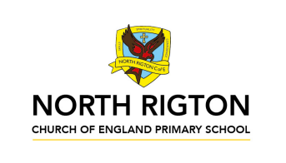

Teamwork Tigers – Summer 2026
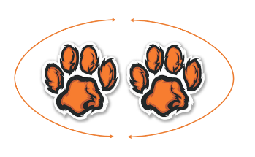
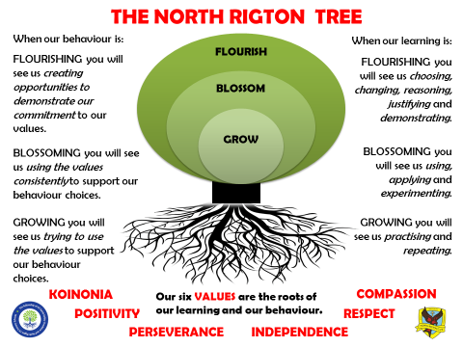
In Teamwork Tigers, the children are taught by
Miss Lewis and Mrs Gardiner



Welcome to Teamwork Tigers termly letter! You will find everything you need to know about the learning that is happening in our classroom this term here.
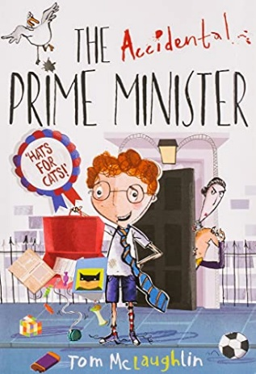
Reading: In Tigers we enjoy a positive reading environment in which books are enjoyed and shared by all. Pupils are given daily opportunities to read independently and some pupils will read with an adult. In Tigers class we will have a weekly 1-hour lesson using VIPERS (found at the bottom of this document) skills to explore a text which is linked to our project. This term our guided reading text will be:

Please encourage your child to read at home, although at this age it does not have to be with an adult.
We encourage the sharing of books that have been enjoyed so when your child has finished reading a book, they can bring it into school to share/swap with another child. We also love to hear about any reading recommendations.
Reader of the Week: Each week, teachers nominate a child who has shown a real ‘love of reading’ to visit our very own North Rigton Book Shop to choose a book.

Spellings: Spellings will continue to be learned in school using Read Write Inc, where we can give more support to methods used, allowing the spellings to be more embedded. I have sent a tapestry with our classes login to access the Read Write Inc portal at home for extra practice. You can also find the Year 5/6 common exception word list at the bottom of this document.
Writing:
Non-Fiction
- Report writing
- Balanced argument

Poetry
- Slam poetry
- Shape poems

Fiction
- Setting description

For more detail, please see link to whole school English document.

Maths: Our central maths topics this term will be:
Algerba
Ratio
Statistics

Geometery
- Shape
- Position and direction

Measument
- Converting units

For more detail, please see link to whole school maths document.
Times Table Rockstars: All children in Tigers have access to Times Table Rockstars. This platform is used to support fluency in times tables and can be accessed on a laptop or iPad. TTRS-Parent-Guide.pdf

PE: PE will be on a Tuesday and Thursday.
Summer 1
Session 1: Rounders
Session 2: Athletics track

Summer 2
Session 1: Tennis
Session 2: Athletics field

On these days, your child should come to school in their PE kit.

French:
- A French speaking world
- A French holiday

RE:
- Pilgrimage
- What kind of King was Jesus?

PSHE:
- How can we manage money?
- How can money effect us? What makes us enterprising?

COMPUTING:
- E-safety (Online relationships, online bullying and online reputation)
- Programming A – Selection in Physical Computing
- Programming A – Variables in Games

SCIENCE sub-units:
- Light
- Electricty

We are Artists
PRIMARY PROVOCATION:
ILLUSIONS
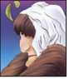
Dictionary Definition of ‘illusion’: an instance of a wrong or misinterpreted perception of a sensory experience



OUR MUSIC OBJECTIVES:
Dynamics, pitch and textures
- To understand the work of a classical composer (Felxi Mendelssohn)
- To improvise as a group using dynamics and pitch for waves.
- To improvise as a group using textures for waves.
- To use dynamics, texture and pitche to create a group compositon.
- To perform in a group composition.

Musical theatre
- To understand the history of musical theatre.
- To identify character songs and actions songs.
- To create a muscial theatre scene.
- To rehearse a musical theatre scene.
- To perform a musical theatre scene.

OUR ART OBJECTIVES:
- To understand what illusion art is.
- To explore how artists create perspective in their work.
- To be able to use perspective to create realistic interiors.
- To explore how artists use foreshortening to give perspective.
- To explore how artists use trompe I’oeil to create illusions.
- To explore how artists create illusions by playing with perspective.
- To create optical art.

ENJOYING LEARNING TOGETHER AT HOME
This term our home learning tasks will link to maths, science and design technology. The following grid contains some suggestions of activities your child may like to complete at home to support them with the work we do in class. We would love to see any completed tasks and they will have an opportunity to share them in class.
You could help your child at home by …

Practice and recap Year 5/6 common exception words from the word list below. | You could help your child at home by allowing them to research a famous illusion artists. Can you create a Publisher poster about their life? | Continue with Times Table Rockstars at home to aid mathematical fluency.
You could help your child at home by investigating pitch and notation. Can you create a simple melody and write the notations for this? | You could help your child at home by helping them to investigate Light and Electricity (our Science sub-units this term). Is there a famous scientist who you have discovered more about? | Read daily at home.  This could be with an adult or be independently using our VIPERS skills.
You could help your child at home by supporting them to make an illusion sculpture. Can you see things from different angles? Bonus points for using recyclable materials! | Can you create a scale replica of one of your favourite pieces of artwork? | You could help your child at home by helping them to create their own short story about a musical journey down the Amazon river. What do they hear? How does this make them feel?

