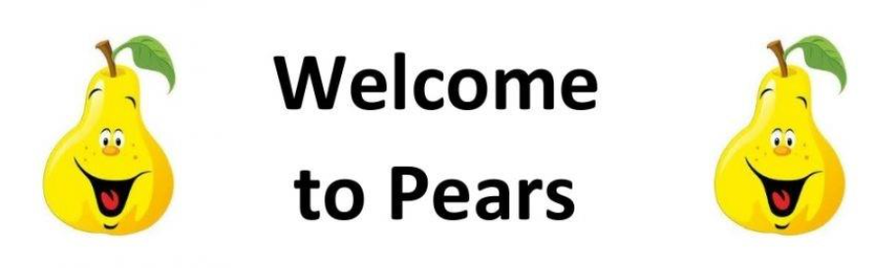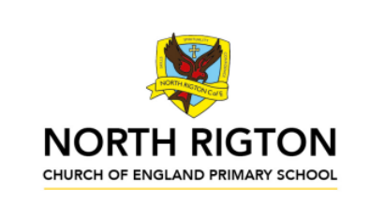
Pears Class – Summer 2026
We are Explorers

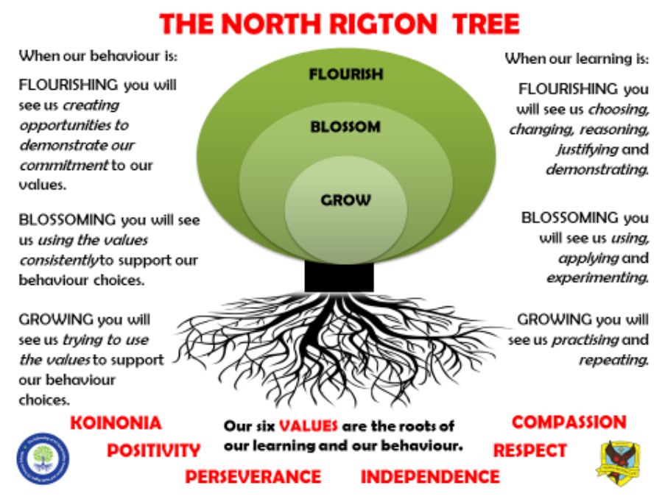

The Pears Class Team
Pears Class are taught by Miss Ellis and supported by Mrs London, Miss Vickers and Miss Owen.
On Thursday morning when Miss Ellis is busy planning Mrs Hudson teaches.
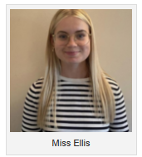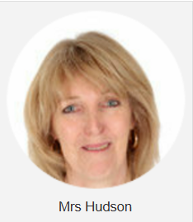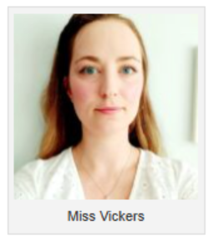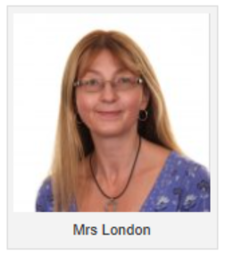
Reading
In Pears class, we enjoy a positive reading environment in which books are enjoyed and shared by all. Pupils are given daily opportunities to listen to stories and read independently with an adult. Every child takes part in Read Write Inc Guided Reading sessions. Please encourage your child to read at home daily with an adult. Having the opportunity to reread books helps the children develop their fluency and to read with a storyteller’s voice. Reading books and will be provided with reading books to enjoy at home each week. These books are closely matched the Phonics level each child is working at. Please return books on a Monday to be swapped. All children have a reading chart to encourage reading at home – please remember to issue a sticker each time they read at home and remember that there are prizes for every reading chart completed throughout the year. If your child has completed a chart, please post a photograph on Tapestry.

Phonics
In Pears Class we follow Read Write Inc to teach Phonics. In Year 1, the children will be recapping the sounds covered throughout the Read Write Inc Phonics programme before moving on to the Read Write Inc Spelling programme. In Year 2, the children we will be following the Read Write Inc Spelling programme.
For further information on how to support your child with Read Write Inc Phonics at home, please take a look at:
https://home.oxfordowl.c.uk/reading/reading-schemesoxford-levels/read-write-inc-phonics-guide/
In Pears Class, we enjoy playing games to practise our Phonics learning. We use Phonics Play (https://www.phonicsplay.co.uk/) and ICT Games (https://ictgames.com/mobilePage/literacy.html) which have lots of fun interactive games and activities that you can enjoy at home.

Writing
Our Key Books:
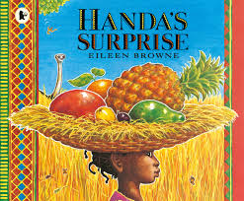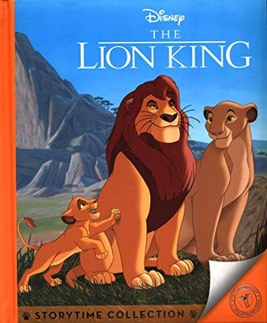
Narrative: Class Texts: ‘Handa’s Surprise’ and ‘The Lion king’ .
- Setting descriptions
- Character descriptions
- Retelling of a story from a different viewpoint (Timon or Pumbaa)
- Emotive language Non-fiction:
- Fact file /Leaflet
Poetry:
- African poetry
- Creating ‘songs’ in the form of African poetry

Maths
Our maths topics this term will be:
Money, fractions, time, mass and capacity and position and direction.

PE: PE will be on a Tuesday and Wednesday. On these days, your child should come to school in their PE kit, which should include a waterproof coat.
Summer 1
Session 1: Athletics (running, balancing and obstacle focus)
Session 2: Bat and ball (kwik cricket)
Summer 2
Session 1: Athletics (jumping and throwing)
Session 2: Bat and ball (tennis)
RE: Understanding Christianity:
- Who am I? What does it mean to belong?
- What makes some places sacred to believers?
PSHE: Health and Wellbeing:
- How do we show our feelings?
- How do we stay safe online?
Computing:
- Creating media – Digital writing
- Programming B - programming quizzes

We are Explorers
AFRICA IS A POOR CONTINENT.
In this topic children will have the opportunity to explore the provocation ‘Africa is a poor continent’ and decide whether this is an appropriate viewpoint or not in 2026. It will provoke a response that should illustrate key understanding of money, economics, historical influences and charity work alongside thinking about what does the word ‘poor’ actually mean?
We will learn about African climates, communities, Fairtrade and will look at influential historical figures across different aspects of learning such as Nelon Mandela and Mo Farrah.
Pupils will have the opportunity to make links between Africa and North Rigton and do research to find out about the similarities and differences.
Geography skills:
- Name and locate the world’s 7 continents and 5 oceans
- Understand geographical similarities and differences through studying the human and physical geography of a small area of the United Kingdom, and of a small area in a contrasting non-European country (North Rigton vs Kenya)
- Identify seasonal and daily weather patterns in the United Kingdom and the location of hot and cold areas of the world in relation to the Equator (which areas of Africa are over the equator?)
- Use basic geographical vocabulary to refer to:
key physical features, including: beach, cliff, coast, forest, hill, mountain, sea, ocean, river, soil, valley, vegetation, season and weather
key human features, including: city, town, village, factory, farm, house, office, port, harbour and shop
-Use world maps, atlases and globes to identify the United Kingdom and its countries, as well as the countries, continents and oceans studied at this key stage
- Use simple fieldwork and observational skills to study the geography of their school and its grounds and the key human and physical features of its surrounding environment (compare to an African school)
History skills:
- Understand changes within living memory. Where appropriate, these should be used to reveal aspects of change in national life (segregation movement)
- Events beyond living memory that are significant nationally or globally (apartheid)
- The lives of significant individuals in the past who have contributed to national and international achievements. Some should be used to compare aspects of life in different periods (Nelson Mandela)
- Understand significant historical events, people and places in their own locality (Nelson Mandela – I have a Dream Speech, Mo Farrah 2012 Olympics

ENJOYING LEARNING TOGETHER AT HOME
This term our home learning tasks will link to Art and Music. The following grid contains some suggestions of activities your child may like to complete at home to support them with the work we do in class. We would love to see any completed tasks and they will have an opportunity to share them in class.
You could help your child at home by …
You could help your child at home by allowing them to play on TTRockstars. This will help them with their fluency of times tables. | You could help your child at home by looking at the different continents and oceans on a globe or a map. | You could help your child at home by writing about the similarities and differences between the UK and Africa.
You could help your child at home by taking note of measurements around you. Can you create a lego tower which is:  - 10cm tall  - 30cm tall  - 50cm tall  - As tall as you! | You could help your child at home by researching a famous African person. What are they famous for? Why are they an important person to learn about? | Please try to read as often as you can at home with your family and complete your reward chart.  Books are changed weekly in school – please bring them in on a Monday if you wish to get new ones.
You could help your child at home by going for a walk and tracking your route on a map. | You could help your child at home by learning about Water Aid. | There are some fantastic free interactive websites for English and Maths which can be used on the iPad or computer. You may wish to enjoy using them together:  Topmarks  https://www.topmarks.co.uk  ICT Games  https://www.ictgames.com  BBC Numberblocks  https://www.bbc.co.uk/cbeebies  /shows/numberblocks

