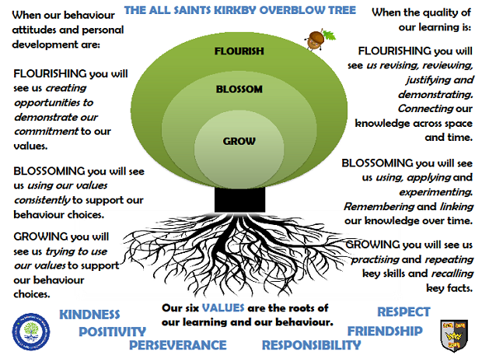Saturn ClassSummer Term 2026
Reading
In Saturn class, we enjoy a positive reading environment in which books are enjoyed and shared by all. Pupils are given daily opportunities to listen to stories and read independently with an adult. Every child takes part in Read Write Inc Guided Reading and Whole Class Guided Reading sessions. Please encourage your child to read at home daily with an adult. Having the opportunity to reread books helps the children develop their fluency and to read with a storyteller’s voice. All children have a Home Reading Book pack and will be provided with two reading books to enjoy at home each week. These books are closely matched the Phonics level each child is working at. Reading books are swapped every Monday.
Phonics
In Saturn Class we follow Read Write Inc to teach Phonics. In Year 1, the children are recapping the sounds they have learned from Set 2 and Set 3. In Year 2, the children we will be following the Read Write Inc spelling programme. For further information on how to support your child with Read Write Inc Phonics at home, please take a look at: https://home.oxfordowl.co.uk/reading/reading-schemes-oxford-levels/read-write-inc-phonics-guide/
In Saturn Class, we enjoy playing games to practise our Phonics learning. We have access to Phonics Play (https://www.phonicsplay.co.uk/) which has lots of fun interactive games and activities that you can enjoy at home.

Writing
Our Key Books:
Mrs Armitage On Wheels and Journey

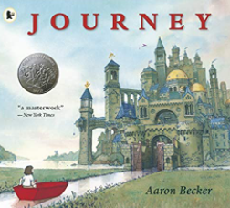

This term we will be exploring the above books. We will be writing our own adventures with Mrs Armitage, creating our fantasy journeys and writing instructions based on our topic ‘On the Move’.

Maths
Our maths topics this term will be:
Fractions, Money, Time, Statistics, Measure and Position and Direction.

Science
Living Things and their Habitats
- explore and compare the differences between things that are living, dead, and things that have never been alive
- identify that most living things live in habitats to which they are suited and describe how different habitats provide for the basic needs of different kinds of animals and plants, and how they depend on each other
- identify and name a variety of plants and animals in their habitats, including micro-habitats
- describe how animals obtain their food from plants and other animals, using the idea of a simple food chain, and I can identify and name different sources of food
PE
In Summer Term, PE will be on a Wednesday and a Thursday. We will be doing netball and athletics. Please come in PE kit on Wednesdays and Thursdays.
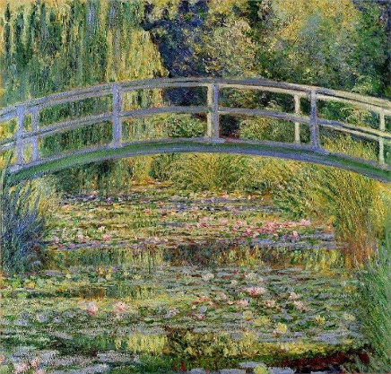
Art
We will be exploring landscapes and using a range of media to create their own artwork. This study will be enhanced by exploring the work of our artist for this term – Claude Monet.

RE
- God – What do Christians believe God is like?
- What makes some places sacred to believers?

PSHE
Mental Health and Healthy Lifestyles

DT
Wheels and Axles – On the Move

Topic
Our provocation this term is:
On Our Doorstep – On the Move

The children will be exploring the following areas:
- The world’s seven continents and five oceans
- The four countries and capital cities of the United Kingdom and its surrounding seas
- using simple compass directions (North, South, East and West) and locational and directional language [for example, near and far; left and right], to describe the location of features and routes on a map
- use aerial photographs and plan perspectives to recognise landmarks and basic human and physical features
- devising a simple maps as well as using and constructing basic symbols in a key
- exploring our local area (school, Kirkby Overblow, Harrogate and beyond)
- using simple fieldwork and observational skills to study the geography of their school and its grounds and the key human and physical features of its surrounding environment

The following grid contains some suggestions of activities your child may like to complete at home to support them with the work we do in class. I would love to see any completed tasks and they will have an opportunity to share them in class.
Use a map to find your house, school and other places you are familiar with. | Learn your address! Can you remember where you live? Where is it close to? | Create a map of your journey to school.
Create a map of the world using playdoh or globe using papier-mâché. | Design and/or complete a treasure hunt using directional and locational language. | Visit the library – what books can you find about maps and our local area?
Use a map or atlas to find the places that you have been on holiday. | Create a guide to one of your favourite places – what are the physical and human features of that place. | Go on a geography hunt – take photographs of all the physical and human features of a place when you are out and about.

Useful websites to support learning about Geography:
BBC Bitesize:
https://www.bbc.co.uk/bitesize/subjects/zcdqxnb

BBC Teach:
https://www.bbc.co.uk/teach/class-clips-video/geography-ks1--ks2-maps/zdwhpg8

Ordnance Survey:
https://www.ordnancesurvey.co.uk/mapzone/

