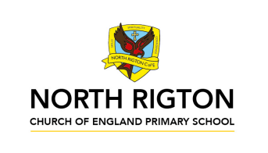

Busy Bees – Summer 2026
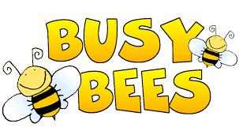
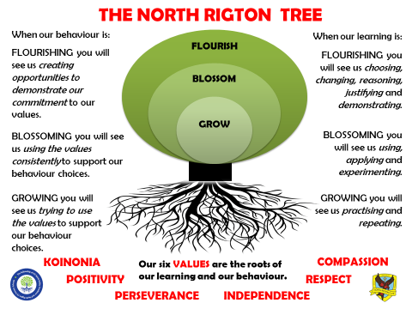
In Busy Bees, the children are taught by
Miss Ellis and Mrs Butler

Reading: In Busy Bees we enjoy a positive reading environment in which books are enjoyed and shared by all. Pupils are given daily opportunities to read independently, and some pupils will read with an adult. Every child will have one 1 hour session of guided reading each week. This term our guided reading text will be:
Phantom Tollbooth by Norman Juster
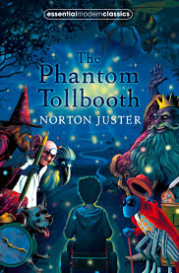
Please encourage your child to read at home daily. This can either be with an adult or independently depending on your child. At this age, the focus is on helping your child to decode new words and asking questions to ensure comprehension of the text.
We encourage the sharing of books that have been enjoyed so when your child has finished reading a book, they can bring it into school to share/swap with another child. We also love to hear about any reading recommendations.
Reader of the Week: Each week, teachers nominate a child who has shown a real ‘love of reading’ to visit our very own North Rigton Book Shop to choose a book.

Spellings: Spellings will continue to be learned in school, where we can give more support to methods used, allowing the spellings to be more embedded. We use Read, Write Inc. to support this.

Writing:
Grammar and Punctuation
- Use of fronted adverbials and commas with a fronted adverbial
- Quantifiers
- Use of inverted commas
- Starting a sentence with an -ing verb
- Possessive apostrophes
- Specific determiners
- Implementation of Coordinating and Subordinating conjunctions to join clauses.
Fiction
- Poetry writing – Kennings
- Descriptive and Persuasive writing linked to Tudors
Non-Fiction
- Explanations texts linked to Inventions and Tudors
For more detail, please see link to whole school English document.

Maths: Our central maths topics this term will be:
Number
- Decimals
Measures
- Money
- Mass and Capacity
- Time
Statistics
Geometry
- Properties of shape
- Position and Direction
For more detail, please see link to whole school maths document.

TTRockstars: All children in Busy Bees have access to TTRockstars. This platform is used to support fluency in times tables and can be accessed on a laptop or iPad. TTRS-Parent-Guide.pdf

SCIENCE:
- Electricity
- Rocks and Soils

PE: PE will be on a Monday and Friday

Session 1: Orienteering and Rounders
Session 2: Athletics
On these days, your child should come to school in their PE kit, which should include a waterproof coat.

French:

- Bon Appetit
- Shopping for French food

RE:
- Kingdom of God – When Jesus left, what was the impact of Pentecost?
- How and why do believers show commitment during the journey of life?

PSHE:
- How can we keep safe in our local area?
- Celebrating differences

Computing:
- Programming and Control – Using Scratch
- Sequencing sound and Events and actions in programs
- Repetition in games
WE ARE Explorers (History and Geography)
PRIMARY PROVOCATION: A Kennings poem about Tudors
English ruler
Able dueller
French-speaker
Over-eater
Church-topper
Wife-swapper
Lute-player
Queen-slayer
Heir-yearner
Stomach-turner
Over-spender
Rule-bender
Head-chopper
Tudor rotter!

KEY KNOWLEDGE (Geography)
- Name and locate counties and cities of the United Kingdom, geographical regions and their identifying human and physical characteristics, including hills, mountains, cities, rivers, key topographical features and land-use patterns; and understand how some of these aspects have changed over time.
- Name and locate the countries of Europe and identify their main physical and human characteristics.

KEY SKILLS (Geography)
- Ask and answer geographical questions about the physical and human characteristics of a location.
- Use maps, atlases, globes and digital/computer mapping to locate countries and describe features
- Explain own views about locations, giving reasons.
- Use the eight points of a compass, four figure grid references, symbols and key to communicate knowledge of the United Kingdom and the wider world.

KEY KNOWLEDGE (History)
Knowledge and understanding of events, people and changes in the past.
- Use evidence to describe what was important to people from the past.
- Use evidence to show how the lives of rich and poor people from the past differed.
- Describe similarities and differences between people, events and artefacts studied.
- Describe how some of the things studied from the past affect/influence life today

Chronological understanding
- Order significant events and dates on a timeline.
- Describe the main changes in a period in history

KEY SKILLS (History)
Historical enquiry
- Use documents, printed sources (e.g. archive materials) the Internet, databases, pictures, photographs, music, artefacts, historic buildings, visits to museums or galleries and visits to sites to collect evidence about the past.
- Ask questions and find answers about the past.

Historical interpretation
- Look at different versions of the same event in history and identify differences.
- Know that people in the past represent events or ideas in a way that persuades others.

Organisation and Communication
- Communicate ideas about from the past using different genres of writing, drawing, diagrams, data-handling, drama role-play, storytelling and using ICT.

SEQUENCE

- British Timeline – Where does Tudor Britain sit on the timeline?
- Countries or Europe and Counties of England – Which countries and counties are involved in Tudor times?
- War of the Roses/Battle of Bosworth – When and how did the Tudor period begin?
- King Henry VIII and his wives – Who was Henry VIII and how did his reign impact Britain?
- King Edward VI and Tudor Illnesses – Who was Edward VI? What was it like to be living in Tudor times?
- Queen Mary I and Tudor Crime and Punishment - Who was Queen Mary I? What was it like to be living in Tudor times?
- Sir Francis Drake and famous explorers – Who was Francis Drake and what impact did Tudor exploration have on the World?
- Spanish Armada – What were the issues between England and neighbouring countries? How powerful was Tudor Britain?
- Queen Elizabeth I – Who was Queen Elizabeth and how did Tudor Britain come to an end?

ENJOYING LEARNING TOGETHER AT HOME
This term our home learning tasks will link to Geography, Science and History. The following grid contains some suggestions of activities your child may like to complete at home to support them with the work we do in class. We would love to see any completed tasks and they will have an opportunity to share them in class.
You could help your child at home by …
Writing  This term, we will be writing ‘Explanation texts’ in Literacy. Choose an object/machine at home and write a explanation text to explain how it works or draw an annotated explanation of the object/machine | Be Geographical  Go for a walk at home or whilst on holiday. Draw a map of the route you have taken. Make sure that you use appropriate symbols and give it a key so that other people could use it | Be Creative  Can you design and build a throne fit for a King?! Design a Tudor throne for King Henry VIII and then you could make it out of square wooden dowelling!
Reading  Encourage your child to read regularly at home. Support them with their reading by asking questions about what they have read.  Oxford owl has free e-books to use at home with your child,  (u/n: nrigtonbusybees / p/w: bees)  https://www.oxfordowl.co.uk/login | Be Geographical  Label a map of England of counties that are important to you and why e.g. member of family or friends live there. Include the names of cities or towns in each county.  Label a map of Europe with names of countries and capital cities. Can you learn them off by heart? Can you research their flags? Could you complete a map of places you have visited in Europe on holiday? | Be Historical  This half term we are learning about Tudor Britain. Do a mini-project on part of Tudor life that interests you e.g. schooling, illnesses, crimes and punishments, music, food or entertainment.
TTrockstars  You could help your child at home by allowing them to play on TTRockstars. This will help them with their fluency of times tables.  https://play.ttrockstars.com/auth/school/student | Spelling  You could Support your child to learn their common exception words - Red words (Years 1 and 2) and Orange (Years 3 and 4)  Oxford owl has an Extra Practice Zone to help your child learn the spelling patterns from Read Write Inc that we are learning in class. (u/n: nrigtonbusybees / p/w: bees)  https://www.oxfordowl.co.uk/login | Typing skills  You could help your child to develop their touch-typing skills by accessing their account on  https://northrigton.typingclub.com/  You can also access Dance Mat Typing Dance Mat Typing for 7 - 11 year olds - BBC Bitesize
Maths  Support your child with their Maths learning with White Rose Maths Home Learning videos  Maths home learning | Home learning | White Rose Education | Writing  This term, we will be writing ‘Persuasive texts’ in Literacy.  Write a letter to your parents to persuade them to allow you to do something during the summer holidays! | Useful websites  KS2 - England - BBC Bitesize  Free eBook library | Oxford Owl from Oxford University Press  Homework-and-Learning-at-Home-Sept-2022-.pdf

