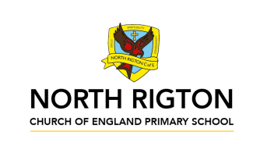

Teamwork Tigers – Autumn 2026
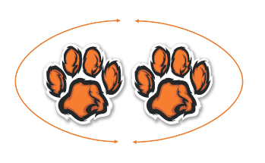
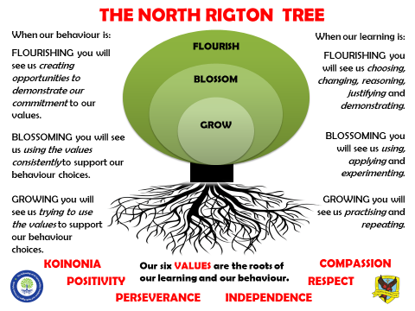
In Teamwork Tigers, the children are taught by
Miss Lewis


Welcome to Teamwork Tigers termly letter! You will find everything you need to know about the learning that is happening in our classroom this term here.
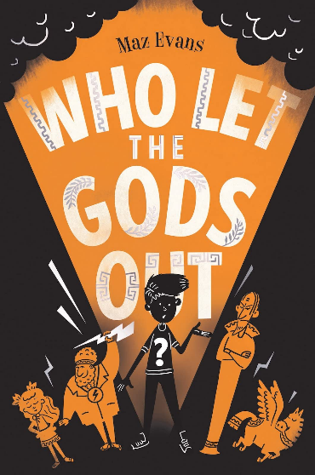
Reading: In Tigers we enjoy a positive reading environment in which books are enjoyed and shared by all. Pupils are given daily opportunities to read independently and some pupils will read with an adult. In Tigers class we will have a weekly 1-hour lesson using VIPERS (found at the bottom of this document). This term our guided reading text will be:

Please encourage your child to read at home, although at this age it does not have to be with an adult.
We encourage the sharing of books that have been enjoyed so when your child has finished reading a book, they can bring it into school to share/swap with another child. We also love to hear about any reading recommendations.
Reader of the Week: Each week, teachers nominate a child who has shown a real ‘love of reading’ to visit our very own North Rigton Book Shop to choose a book.

Spellings: Spellings will continue to be learned in school using Read Write Inc, where we can give more support to methods used, allowing the spellings to be more embedded. I have sent a tapestry with our classes login to access the Read Write Inc portal at home for extra practice. You can also find the Year 5/6 common exception word list at the bottom of this document.

Writing:
Non-Fiction
- Non-chronological report
- Persuasive writing piece for ‘Why you should become an Olympian’
Poetry
- Rememberance day poetry
Fiction
- 3rd person narrative
- Author auto-biography of Maz Evans

For more detail, please see link to whole school English document.

Maths: Our central maths topics this term will be:

- Place value
- Additon and subtration
- Multiplication and division
- Fractions

For more detail, please see link to whole school maths document.

Times Table Rockstars: All children in Tigers have access to Times Table Rockstars. This platform is used to support fluency in times tables and can be accessed on a laptop or iPad. TTRS-Parent-Guide.pdf

PE: PE will be on a Tuesday and Wednesday.
Autumn 1
Session 1: Tag rugby
Session 2: Football

Autumn 2
Session 1: Netball
Session 2: Gymnastics

On these days, your child should come to school in their PE kit.

French:

- French transport
- In my French house

RE:
- Why do some people believe in God and some people not?
- Incarnation – Was Jesus the Messiah?

PSHE:
- Safe relationships
- Respecting self and others

COMPUTING:
- Creating Media – Video production
- E-safety – Manging online information
- Creating media – Web page creation
- E-safety – Health, wellbeing and lifestyle

We are Explorers
PRIMARY PROVOCATION:
Η σοφία του Σωκράτη αρχίζει με κατάπληξη
Wisdom begins in Wonder: How did the Ancient Greeks influence the way we live today?

OUR HISTORY OBJECTIVES:
LO: Creating an Ancient Greek timeline
LO: Who were the Ancient Greeks?
LO: To understand Alexander the Great’s Empire
LO: To know about what daily life was like in Ancient Greece?
LO: Athens and Sparta
LO: Discovering the Ancient Olympics
LO: To compare the Olympics (then and now)
LO: To learn about Greek God’s and Goddesses
LO: What was the Trojan war?

OUR GEOGRAPHY OBJECTIVES:
LO: What is my prior knowledge?
LO: To plot Greece on a map and talk about its locality within the wider world
LO: To discover physical features of Greece (past and present)
LO: To discover human features of Greece (past and present)
LO: To explore the climate and environment of Greece and how this has changed over time
LO: Greek landmarks and points of interest

ENJOYING LEARNING TOGETHER AT HOME
This term our home learning tasks will link to maths, science and design technology. The following grid contains some suggestions of activities your child may like to complete at home to support them with the work we do in class. We would love to see any completed tasks and they will have an opportunity to share them in class.
You could help your child at home by …

Practice and recap Year 5/6 common exception words from the word list below. | Design a Greek vase out of junk modeling. | Continue with Times Table Rockstars at home to aid mathematical fluency.
Hold a mini olympics. | Research the Greek alphabet and try writing a few code-cracked secret messages to family members. | Read daily at home.  This could be with an adult or be independently using our VIPERS skills.
Cook a traditonal Greek meal. | Research an Ancient Greek god and create their family tree. | Create a holiday brochure with all the best things Greece has to offer!

