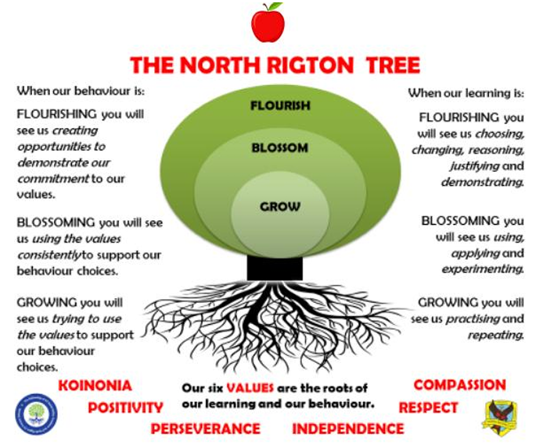

APPLES CLASSAUTUMN TERM 2026
Reading: In Apples class, we enjoy a positive reading environment in which books are enjoyed and shared together. Pupils are given daily opportunities to listen stories and join in with songs and nursery rhymes. Children will take books home once a week, they will be carefully matched to their phonic ability. At the start of the year the books will be centred around developing sounding and blending. Children will move on to worded books once we have introduced sounds and the individual child is ready.
We encourage you to read with your child every day, this could be them reading their schools books to an adult, or an adult reading a story book to the child. Having a love of reading is a crucial building block to support them in their phonics as they progress through school. We encourage sharing of books so when your child has particularly enjoyed a book, they can bring it into school to share with the class.
Reading books are swapped every Friday, please return them to school on Thursday so that we have time to swap them. You can access further reading eBooks at home through the Oxford Owl eBook Library https://www.oxfordowl.co.uk/for-home/find-a-book/library-page/ Please ask Miss Brown if you would like the Class Login.
Phonics: At North Rigton, we follow Read Write Inc to teach Phonics. In Reception, children will be introduced to the set 1 sounds in the autumn term and practise Fred talk. ‘Fred talk’ is sound blending – a crucial first step in both reading and writing, you can find out more information here: Parent video: Sound blending - YouTube
We will also be looking at the red words: I, the, of, my, to, no, into, your, said, you, he, she
In the spring term, children are introduced to the set 2 sounds.
You can practise the sounds at home using the green book provided to you by school. We encourage you to practise each day for a few minutes. We also encourage you to practise Fred talk each day. For further information on how to support your child with Read Write Inc Phonics at home, please take a look at: Parent guide to Read Write Inc. Phonics - Oxford Owl

Maths: In Apples Class, we will be looking at numbers 1– 5 this term. We will be learning the numerals, quantities and to subitise (recognise without counting) for these numbers. It is important that the children can recognise that numbers do not always look the same. For example, 3 can be represented in all the ways shown below (and many more).
 | 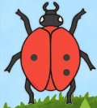 | 3 | 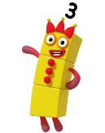 | 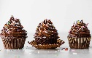 | 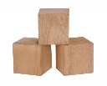 | 2 + 1 |  |  | 

We will also be looking at 2D shapes, one more and one less, comparing size, mass and capacity and exploring and continuing simple patterns.
PE: In Autumn term, PE will be on a Tuesday. This term we are focussing on Gross motor skills and gymnastics. Please come in PE kit on Tuesdays.
Understanding The World (science):
We will be looking at body parts and our 5 senses. We will also be making observations on the seasonal changes that come in Autumn and Winter.

Topic: Celebrations
The children will be exploring the following areas:
- Weddings
- Birthdays
- Christmas
- Christenings
- Bonfire night
- Other festivals e.g. Diwali, Day of the dead, Thanksgiving, Holi, Carnival

We will be reading the following stories:
- Celebrations around the world
- Maisy goes to a wedding
- The Scarecrow’s wedding
- My baptism book
- Kipper’s birthday
- Merry whatmas?
- Joy to the world
What are celebrations?
What do we celebrate?
Does everyone celebrate the same way?
The following grid contains some suggestions of activities your child may like to complete at home to support them with the work we do in class. We would love to see any completed tasks and they will have an opportunity to share them in class.

  Look through old photos – share memories and celebrations you have had in the past. (e.g. pictures from Grandparent’s childhood) |   Look into a different celebration that you do not celebrate. How do people celebrate it? Why? | Make a salt dough Diya for Diwali  DIY Salt Dough Diyas For Diwali – Craft Gossip  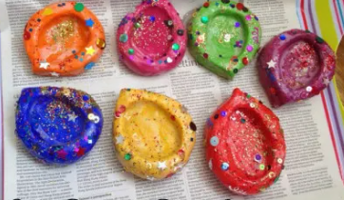
Bonfire night  Make some bonfire / firework art.  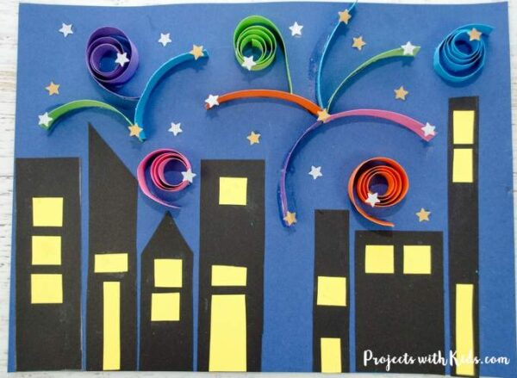 | Thanksgiving themed baking  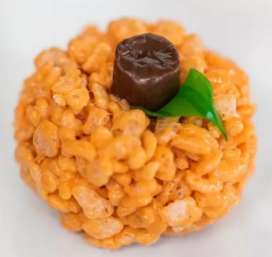  54 Thanksgiving Desserts for Kids - Eating on a Dime | Christmas  Make a nature Christmas wreath  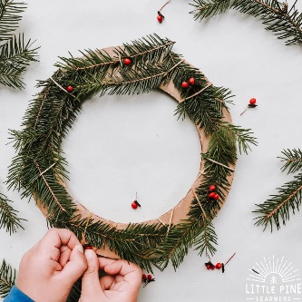

Useful websites for Phonics and Maths
Home Time Ladybirds game (subitising numbers to 9)
https://www.ictgames.com/mobilePage/homeTimeLadybirds/

Teddy Numbers Game
https://www.topmarks.co.uk/learning-to-count/teddy-numbers

Adding to 10
https://www.topmarks.co.uk/addition/addition-to-10

Subtraction within 10
https://www.topmarks.co.uk/subtraction/subtraction-to-10

Underwater Counting game
https://www.topmarks.co.uk/learning-to-count/underwater-counting

Maths games for 3-5 year olds
https://www.topmarks.co.uk/maths-games/5-7-years/counting

Oxford Owl free Ebooks
https://www.oxfordowl.co.uk/for-home/find-a-book/library-page/

Read Write Inc free Ebooks
https://www.oxfordowl.co.uk/home/reading-site/find-a-book/library-page?view=image&query=&type=book&age_group=&level=&level_select=&book_type=&series=Read+Write+Inc.#

Speed sounds practice sheets
https://home.oxfordowl.co.uk/reading/reading-schemes-oxford-levels/read-write-inc-phonics-guide/
Please scroll down the page – look for Set 1 / Set 2 (downloadable as PDF)

Phonics play
https://www.phonicsplay.co.uk/
please ask the Class teacher for the username and password

