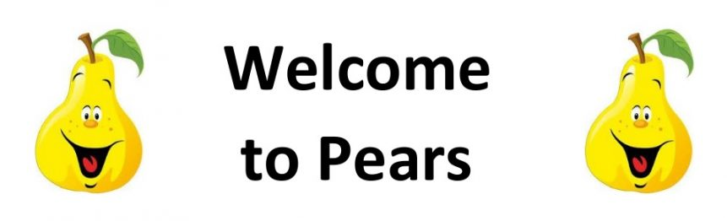
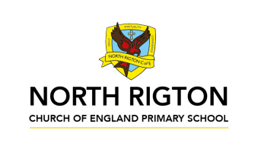

Pears Class – Autumn 2026
We are Scientists

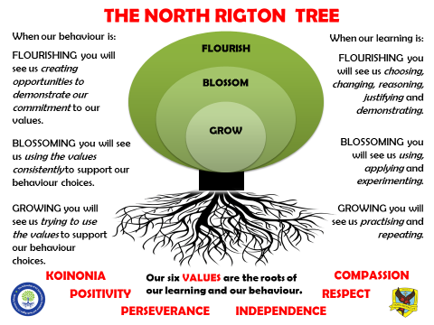
The Pears Class Team
Pears Class are taught by Miss Ellis and supported by Mrs London and Miss Vickers.
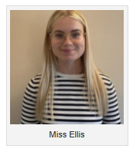
On Tuesday morning when Miss Ellis is busy planning Mrs Hudson teaches.
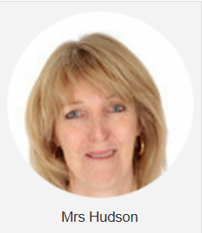
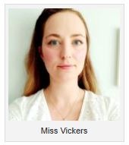

Reading
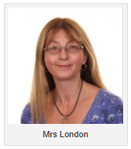
In Pears class, we enjoy a positive reading environment in which books are enjoyed and shared by all. Pupils are given daily opportunities to listen to stories and read independently with an adult. Every child takes part in Read Write Inc Guided Reading sessions. Please encourage your child to read at home daily with an adult. Having the opportunity to reread books helps the children develop their fluency and to read with a storyteller’s voice. All children have a Home Reading books and will be provided with reading books to enjoy at home each week. These books are closely matched the Phonics level each child is working at. Please return books on a Monday to be swapped. All children have a reading chart to encourage reading at home – please remember to issue a sticker each time they read at home and remember that there are prizes for every reading chart completed throughout the year. If your child has completed a chart, please post a photograph on Tapestry.

Phonics
In Pears Class we follow Read Write Inc to teach Phonics. In Year 1, the children will be recapping the sounds covered throughout the Read Write Inc Phonics programme before moving on to the Read Write Inc Spelling programme. In Year 2, the children we will be following the Read Write Inc Spelling programme.
For further information on how to support your child with Read Write Inc Phonics at home, please take a look at:
https://home.oxfordowl.c.uk/reading/reading-schemesoxford-levels/read-write-inc-phonics-guide/
In Pears Class, we enjoy playing games to practise our Phonics learning. We use Phonics Play (https://www.phonicsplay.co.uk/) and ICT Games (https://ictgames.com/mobilePage/literacy.html) which have lots of fun interactive games and activities that you can enjoy at home.

Writing
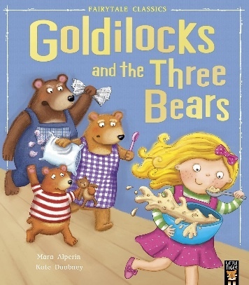
Our Key Books:
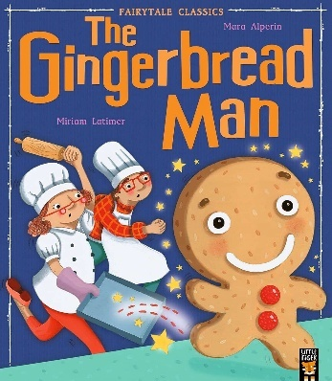
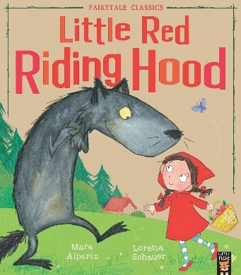
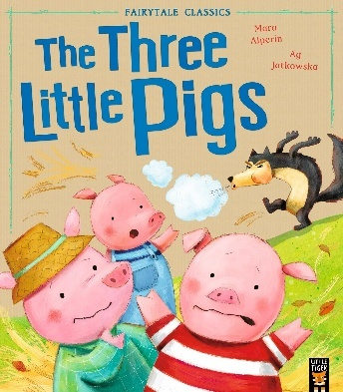
Narrative: Class Texts: ‘Three Little Pigs’, ‘Little red riding hood’, ‘The gingerbread man’ and Goldilocks and the three bears’.
- Planning a story (story mountain)
- Retelling of a story from the viewpoint of a made-up character
- Writing a letter/postcard
Non-fiction:
- Write labels for the identifiable materials
- Focus on techincal language and spellings/phonic sounds and application
- Create lists of the items the characters have

Poetry:
- Harvest acrostic poems
- Christmas poetry, rhyming couplets.

Maths
Our maths topics this term will be:
Place value, addition and subtraction, place value and shape.

PE: PE will be on a Thursday. This term Pears PE sessions will be forest school. On these days, your child should come to school in old clothes/clothes you don’t mind getting dirty. Please provide your child with waterproofs and wellies.
RE: Understanding Christianity:
- Who made the world?
- Why does Christmas matter?

PSHE: Health and Wellbeing:
- How can we help?
- What is bullying?
Computing:
- Computing systems and networks – IT around us
Managing Online Information
- Creating media – Digital painting
Health, Wellbeing and Lifestyle

We are Scientists
“FAIRYTALE CHARACTERS HAVE ALWAYS GOT IT WRONG!”
In this topic, children will have the freedom to explore properties and changes of everyday materials alongside using the key skills of working scientifically to test concepts. We will learn about how to group and classify different materials, whether alternative materials are more/less suitable for different situations EG Little Red Riding Hood’s coat, and children will be able to form their own questions and areas of enquiry, provoking independent learning attitudes. All of the project will link closely to these core fairytale stories: The Three Little Pigs, Little Red Riding Hood, The Gingerbread Man and Goldilocks and the Three Bears which will be read together and enjoyed over the two half terms in our guided reading sessions.
This will allow pupils to explore the provocation ‘Fairytale characters have always got it wrong’ and draw their own conclusions based on what they have learned. They will have the opportunity to follow a DT cycle so that products can be designed, made, tested and applied before being evaluated for their purpose.
Five Fantastic Facts
At the end of this project, children will have the understanding and confidence to say:
I can name different materials (wood, metal, plastic, glass, brick, rock, paper and cardboard), I can identify different materials, I can group materials based on their properties, I can explain how the shapes of solid objects made from some materials can be changed and how this is done, I can explain which materials are most effective for a given purpose and say why.

Key science objectives taught:
Everyday Materials Year 1:
- distinguish between an object and the material from which it is made
- identify and name a variety of everyday materials, including wood, plastic, glass, metal, water, and rock
- describe the simple physical properties of a variety of everyday materials
- compare and group together a variety of everyday materials on the basis of their simple physical properties
Use of Everyday Materials Year 2:
- identify and compare the suitability of a variety of everyday materials, including wood, metal, plastic, glass, brick, rock, paper and cardboard for different uses
- compare how things move on different surfaces
- find out how the shapes of solid objects made from some materials can be changed by squashing, bending, twisting and stretching
DT objectives taught:

Design
- design purposeful, functional, appealing products for themselves and other users based on design criteria
- generate, develop, model and communicate their ideas through talking, drawing, templates, mock-ups and, where appropriate, information and communication technology

Make
- select from and use a range of tools and equipment to perform practical tasks
- select from and use a wide range of materials and components, including construction materials, textiles and ingredients, according to their characteristics

Evaluate
- explore and evaluate a range of existing products
- evaluate their ideas and products against design criteria

Technical Knowledge
- build structures, exploring how they can be made stronger, stiffer and more stable
- explore and use mechanisms, in their products.

Cooking & Nutrition
- use the basic principles of a healthy and varied diet to prepare dishes
- understand where food comes from

ENJOYING LEARNING TOGETHER AT HOME
This term our home learning tasks will link to science and DT. The following grid contains some suggestions of activities your child may like to complete at home to support them with the work we do in class. We would love to see any completed tasks and they will have an opportunity to share them in class.
You could help your child at home by …
You could help your child at home by visiting the library and allowing them to research more about materials or find traditional tale books as this is what we are looking at as part of our project this term. | You could help your child at home by investigating materials. Can you go on a hunt to find materials made of wood, glass, metal, rock and plastic. Could you classify these into groups. | You could help your child at home by practicing counting and reciting the 2s, 3s, 5s and 10s timetables. Can the children write these down or use objects to represent this. E.g. 10 pairs of two socks are twenty.
You could help your child at home by baking gingerbread men or making porridge. Can you child write a list of ingredients they will need and instructions to make them. | You could help your child at home by going on season walks. Can you spot signs of Autumn? What do you notice? Could you record these signs in a list or find objects to count such as conkers, acorns etc. | Please try to read as often as you can at home with your family and complete your reward chart.  Books are changed weekly in school – please bring them in on a Monday if you wish to get new ones.
You could help your child at home by encouraging them to count forwards and backwards in lots of exciting ways! Think about creating an unusual number line. E.g. 2, 12, 22, 32, 42. Can your child spot the number patterns. | You could help your child at home by using the RWI Sound Book for the sounds/spelling rules we are covering this term. These will always be dated for your information so you know when we have covered each one. In Year 2, speed spell words will be noted so you can see the sorts of words we are learning in school. | There are some fantastic free interactive websites for English and Maths which can be used on the iPad or computer. You may wish to enjoy using them together:  Topmarks  https://www.topmarks.co.uk  ICT Games  https://www.ictgames.com  BBC Numberblocks  https://www.bbc.co.uk/cbeebies  /shows/numberblocks

