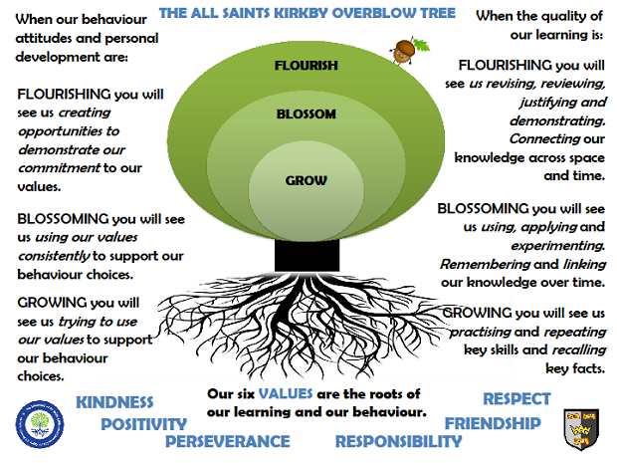Saturn ClassAutumn Term 2026
Reading
In Saturn class, we enjoy a positive reading environment in which books are enjoyed and shared by all. Pupils are given daily opportunities to listen to stories and read independently with an adult. Every child takes part in Read Write Inc Guided Reading and Whole Class Guided Reading sessions. Please encourage your child to read at home daily with an adult. Having the opportunity to reread books helps the children develop their fluency and to read with a storyteller’s voice. All children have a Home Reading Book pack and will be provided with two reading books to enjoy at home each week. These books are closely matched the Phonics level each child is working at. Please ensure reading books are returned every Monday ready to be swapped. You can access further reading eBooks at home through the Oxford Owl eBook Library (https://www.oxfordowl.co.uk/for-home/find-a-book/library-page/).
Phonics
In Saturn Class we follow Read Write Inc to teach Phonics. In Year 1, the children will be recapping Set 1 and introduced to Set 2. In Year 2, the children we will be recapping Set 2 and Set 3. For further information on how to support your child with Read Write Inc Phonics at home, please take a look at: https://home.oxfordowl.co.uk/reading/reading-schemes-oxford-levels/read-write-inc-phonics-guide/
In Saturn Class, we enjoy playing games to practise our Phonics learning. We have access to Phonics Play (https://www.phonicsplay.co.uk/) which has lots of fun interactive games and activities that you can enjoy at home.

Writing
Our Key Books:
Vlad and the Great Fire of London and The Day the Crayons Quit
This term we will be exploring the above books. We explore a range of fiction and non-fiction writing opportunities including traditional tales, descriptive writing and diary writing.

Maths
Our maths topics this term will be:
Number & Place Value, Addition & Subtraction and Shape

Science
Humans
- identify, name, draw and label the basic parts of the human body and say which part of the body is associated with each sense
- notice that animals, including humans, have offspring which grow into adults
- find out about and describe the basic needs of animals, including humans, for survival (water, food and air)
- describe the importance for humans of exercise, eating the right amounts of different types of food, and hygiene.

Light
- Recognise that we see with our eyes and that light helps us see things
- Identify a variety of sources that give out light
- Recognise that light sources vary in colour and brightness
- Recognise that without light it is dark
- Recognise that the sun gives us daylight and it is dangerous to look at the Sun

PE
In the Autumn Term, we will be doing Multi-skills, Rugby (Throwing and Catching and Invasion Games) and Gymnastics.
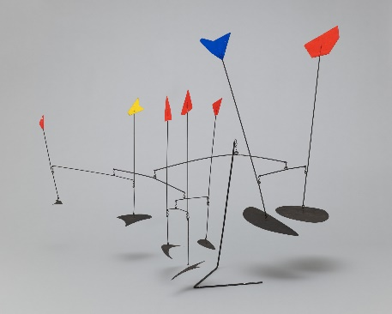
Please come in PE kit on Wednesdays and Fridays.

Art
We will be exploring colour, pattern and shape. This study will be enhanced by exploring the work of our artist for this term:
Wassily Kandinski

RE
- Creation – who made the world?
- Incarnation – Why does Christmas matter to Christians?

PSHE
- Families and Close Relationships
- Friendships and managing hurtful behaviour

Computing
- Technology in our lives

Topic
Our provocation this term is:
What happened during the Great Fire of London?

The children will be exploring the following areas:
- Key individuals involved in the fire
- Why the fire spread so quickly
- How long the fire lasted

The following grid contains some suggestions of activities your child may like to complete at home to support them with the work we do in class. I would love to see any completed tasks and they will have an opportunity to share them in class.
Can you draw a fire safety poster? | Can you build a 1666 house? | Can you find out three interesting facts about the fire of London?
Can you write a diary entry as if you are Samuel Pepys? | Can you draw a portrait of King Charles II? | Can you make a map of London in 1666?
Can you bake some bread? | Can you film a news report about what happened in 1666? | Can you use playdough or clay to make a candle holder?

Useful websites to support learning:
BBC Bitesize:
The Great Fire of London | KS1 Topics | Ages 5-7 - BBC Bitesize

