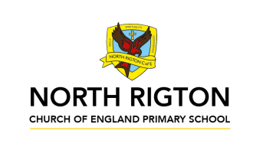

Busy Bees – Autumn 2026
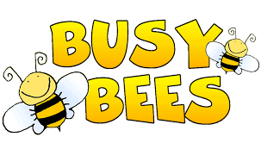
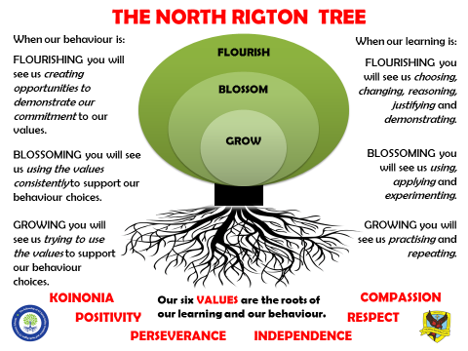

In Busy Bees, the children are taught by Miss Ellis and Mrs Turner
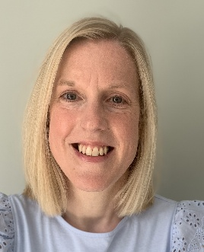

Reading: In Busy Bees we enjoy a positive reading environment in which books are enjoyed and shared by all. Pupils are given daily opportunities to read independently, and some pupils will read with an adult. Every child will have one 1 hour session of guided reading each week. This term our guided reading text will be:
The BFG by Roald Dahl
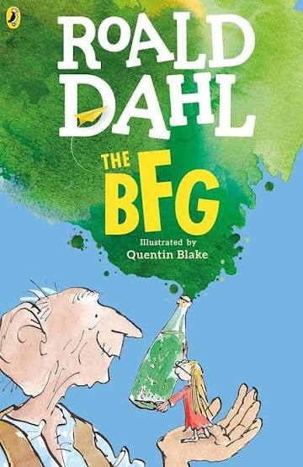
Please encourage your child to read at home daily. This can either be with an adult or independently depending on your child. At this age, the focus is on helping your child to decode new words and asking questions to ensure comprehension of the text.
We encourage the sharing of books that have been enjoyed so when your child has finished reading a book, they can bring it into school to share/swap with another child. We also love to hear about any reading recommendations.
Reader of the Week: Each week, teachers nominate a child who has shown a real ‘love of reading’ to visit our very own North Rigton Book Shop to choose a book.

Spellings: Spellings will continue to be learned in school, where we can give more support to methods used, allowing the spellings to be more embedded. We use Read, Write Inc. to support this.

Writing:
Grammar and Punctuation
- Exploring language used to describe – expanded noun phrases, powerful verbs and tenses, prepositions and adverbs/adverbials.
Fiction
- Writing a descriptive recount
- Poetry
Non-Fiction
- Writing a diary
For more detail, please see link to whole school English document.

Maths: Our central maths topics this term will be:
Number
- Place value
- Addition and subtraction
- Multiplication and Division

For more detail, please see link to whole school maths document.

TTRockstars: All children in Busy Bees have access to TTRockstars. This platform is used to support fluency in times tables and can be accessed on a laptop or iPad. TTRS-Parent-Guide.pdf

SCIENCE:
- States of Matter including the Water Cycle

PE: PE will be on a Monday and Friday

Session 1: Invasion Games - Rugby and Ball Skills
Session 2: Invasion Games – Netball and Basketball
On these days, your child should come to school in their PE kit, which should include a waterproof coat.

French:

- This is me
- School days

RE:
- What does it mean to be a Buddhist in Britain today?
- Incarnation – What is the Trinity?

PSHE:
- Safe Relationships
- Respecting Self and Others

Computing:
- Computing Systems and Networks – Connecting Computers
- Computing Systems and Networks – The Internet
- Touch Typing
- Esafety

WE ARE Explorers (History and Geography)
PRIMARY PROVOCATION: A quote by Howard Carter
‘I think at that moment we did not even want to break the seal, for a feeling of intrusion had descended heavily upon us.... we felt that we were in the presence of the dead King and must do him reverence’ Howard Carter

KEY KNOWLEDGE (Geography)
- Name and locate the main country of the project, its continent and identify their main physical and human characteristics; , including hills, mountains, cities, rivers, key topographical features and land-use patterns; and understand how some of these aspects have changed over time.
- Describe and understand key aspects of physical geography, including climate zones, biomes and vegetation belts, rivers and the water cycle.
- Name and locate the Equator, Northern and Southern Hemisphere, the Tropics of Cancer and Capricorn, the Arctic and Antarctic circles and date time zones.
- Describe the characteristics of some of these geographical areas.
- Describe geographical similarities and differences between countries.

KEY SKILLS (Geography)
- Ask and answer geographical questions about the physical and human characteristics of a location.
- Use maps, atlases, globes and digital/computer mapping to locate countries and describe features
- Explain own views about locations, giving reasons.

KEY KNOWLEDGE (History)
Knowledge and understanding of events, people and changes in the past.
- Use evidence to describe what was important to people from the past.
- Use evidence to show how the lives of rich and poor people from the past differed.
- Describe similarities and differences between people, events and artefacts studied.
- Describe how some of the things studied from the past affect/influence life today

Chronological understanding
- Understand a timeline can be divided into BC and AD
- Order significant events and dates on a timeline.
- Describe the main changes in a period in history

KEY SKILLS (History)
Historical enquiry
- Use documents, printed sources (e.g. archive materials) the Internet, databases, pictures, photographs, music, artefacts, historic buildings, visits to museums or galleries and visits to sites to collect evidence about the past.
- Ask questions and find answers about the past.

Historical interpretation
- Look at different versions of the same event in history and identify differences.
- Know that people in the past represent events or ideas in a way that persuades others.

Organisation and Communication
- Communicate ideas about from the past using different genres of writing, drawing, diagrams, data-handling, drama role-play, storytelling and using ICT.

SEQUENCE

- Where is the tomb? (Study of Egypt – Modern and Ancient – including the River Nile)
- When were people buried in these tombs? (Look at the timeline history of the Ancient Egyptians)
- Why were these people buried in tombs – were they religious? (Focus on teaching about Gods and Goddesses)
- Who was buried in these tombs? (Study of the famous pharaohs and where they were buried; including the pyramids. Also examine the social hierarchy in Ancient Egyptian times.)
- Who was Howard Carter and what did he find? What is an Archaeologist? (Investigate the job of an archaeologist and introduce Howard Carter)
- What did Howard Carter find in the tomb? (King Tutankhamun, Hieroglyphics, artefacts, wall paintings and mummification/afterlife.)
- Should Howard Carter have excavated the tomb? (Reasons for and against excavation)

ENJOYING LEARNING TOGETHER AT HOME
This term our home learning tasks will link to Geography, Science and History. The following grid contains some suggestions of activities your child may like to complete at home to support them with the work we do in class. We would love to see any completed tasks and they will have an opportunity to share them in class.
You could help your child at home by …

Writing  This term, we will be writing ‘Diaries’ in Literacy. Write your own diary either about yourself or you could pretend to be someone else. It could be real or it could be imaginary. | Be Historical  You could visit and explore an Egyptian museum to find out more about Ancient Egyptians e.g. the Pump Rooms in Harrogate, Bolton Museum, Manchester Museum or the British Museum in London. You could interview someone that has been to Egypt on their holiday and find out about the places they visited. | Be Scientific  In Science, we are learning about changing states. Find examples and take photographs of examples of Evaporation and Condensation.
Reading  Encourage your child to read regularly at home. Support them with their reading by asking questions about what they have read.  Oxford owl has free e-books to use at home with your child,  (u/n: nrigtonbusybees / p/w: bees)  https://www.oxfordowl.co.uk/login | Be Geographical  This half term we are learning about rivers. In particular, we are focussing on the River Nile. You could choose to explore other rivers e.g. local rivers in your area (maybe even visit one!) or famous rivers in the world. Find out more about the countries/places it travels through, where it started (source) and where it ends (mouth). | Be Historical  This term we are learning about the Ancient Egyptians. Do a mini-project on one aspect of Ancient Egyptians that you wish to explore further. You could make a model, do a PowerPoint, writing, drawings, cooking – the choice is yours!
TTrockstars  You could help your child at home by allowing them to play on TTRockstars. This will help them with their fluency of times tables.  https://play.ttrockstars.com/auth/school/student | Spelling  You could Support your child to learn their common exception words - Red words (Years 1 and 2) and Orange (Years 3 and 4)  Oxford owl has an Extra Practice Zone to help your child learn the spelling patterns from Read Write Inc that we are learning in class. (u/n: nrigtonbusybees / p/w: bees)  https://www.oxfordowl.co.uk/login | Typing skills  You could help your child to develop their touch-typing skills by accessing their account on  https://northrigton.typingclub.com/  You can also access Dance Mat Typing Dance Mat Typing for 7 - 11 year olds - BBC Bitesize
Maths  Support your child with their Maths learning with White Rose Maths Home Learning videos  Maths home learning | Home learning | White Rose Education | Gardening  Grow your own vegetables at home. Spinach, Kale, Radish and Broad Beans are good to grow in Autumn.  Month by month guide to food growing autumn term / RHS Gardening | Useful websites  KS2 - England - BBC Bitesize  Free eBook library | Oxford Owl from Oxford University Press  Homework-and-Learning-at-Home-Sept-2022-.pdf

